Introduction to basic Ballet Terminology

Barre Exercises
All dancers begin their day with class, during which they warm up their bodies and perfect technical exercises. All ballet classes begin with approximately 30 minutes of barre exercises. The barre - a horizontal rail fixed to the wall of a dance studio or free-standing on two parallel bars - is used as a balance-check.

Positions of the feet
All ballet exercises and variations begin and end with one of the five basic positions of the feet; there are also complementary arm positions. These positions are executed with the legs and feet turned out from the hip socket. The positions allow for greater flexibility and range of movement and also for a beautiful and long line of the body.
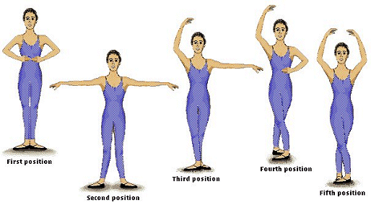
First Position
In the first position, the feet are in what we call a turned-out position, forming a line perpendicular to the rest of the body with the heels touching. Ideally, the feet should be as close to 180 degrees as possible keeping the knees directly over the toes.

Second Position
In second position, the feet form the same line as they do in first position, but this time the heels are about a foot apart.

Third Position
In third position, one foot is placed directly in front of the other, turned out, with its heel touching the middle of the other.

Fourth Position
In an open fourth position, the feet are turned out, one in front of the other, and separated by about a foot, with the heel of one foot opposite the toe of the other.

Fifth Position
This is the position from which most dancers begin and end variations and dances. It is a clean, tidy and secure position and gives the body its greatest possible height when taking off for jumps. In fifth position both legs are turned out, with the heel of one foot touching the toe of the other.

Pliés (plee-yays)
Pliés at the barre are the basic introductory exercises of any ballet class. These are essentially knee bends that warm up the legs and ankles and provide elasticity; their aim is to assist the dancer in turns, pointe work and in landing from jumps. A demi-plié is a knee bend only half way down and the heels do not come off the ground. A grand plié is a full knee bend.
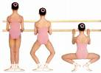

Tendus (ton-doos)
Tendus are leg and foot stretches that help to elongate and strengthen the muscles of the legs and torso. Tendus, as well as all extended leg exercises, are executed to the front, side and back with the foot brushing along the floor through half-pointe to a full extension. While executing numerous variations of tendu exercises, the dancer is also continually working on the proper turn-out of the legs and feet.
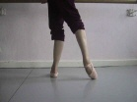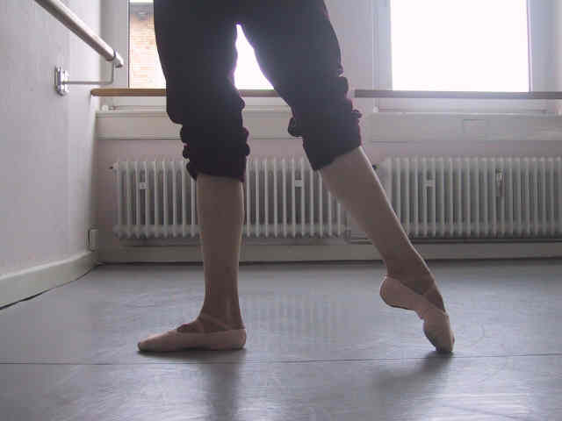

Rond de jambe (ron-da-jom)
This exercise is designed to increase the turn-out of the legs. The dancer traces a semi-circle on the floor around his or her body. The working leg moves steadily with the toe on the ground from the front to side, side to back and then past the stationary heel.

Arabesque (ara-besk)
At the end of the exercises, dancers test their balance by letting go of the barre and rising on their toes. There are many positions dancers can take to test their balance. One of the most common body positions for the dancer is the arabesque. In an arabesque, one leg is stretched behind the body. The leg can be on the ground or in the air at a 90-degree angle or higher, and the weight of the body is on the supporting leg. Arabesques can also be seen while the dancer is executing small or large jumps with the back leg fully extended in the air. In all tendu and grand battement exercises, an arabesque is instantly created whenever the leg is extended behind the body. The arabesque shows off the body at its longest and most extended line from the fingers to the toes.

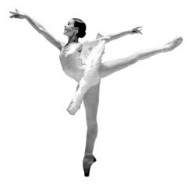

Attitude
A variation on the arabesque. The extended leg is raised in front or behind the body but bent at the knee at an angle of 90 degrees.
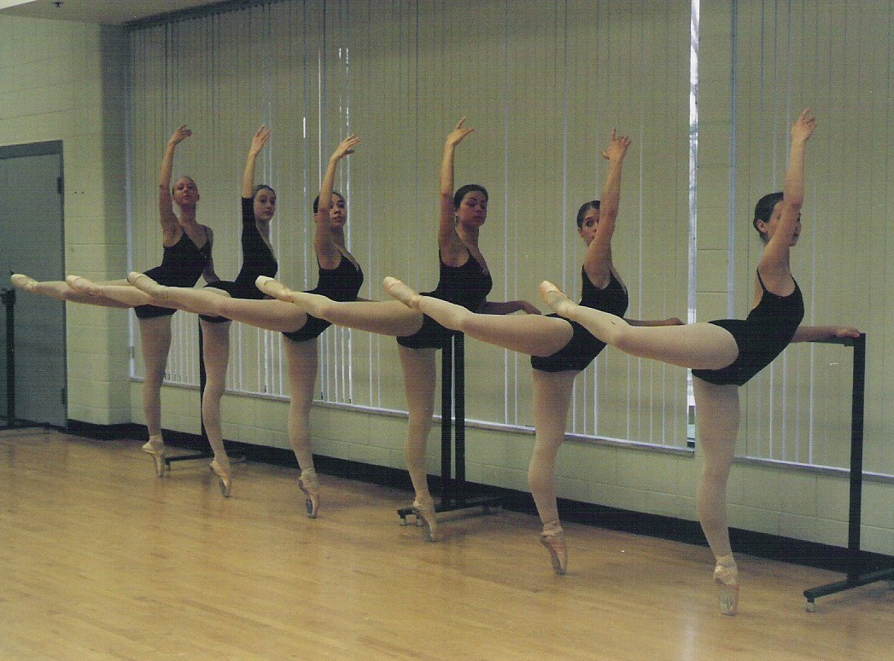

Grand Battement (grond bat-mon)
Free, high kicks of the leg are called grand battement. The leg is thrown in the air and then brought down to a tendu position with great control and with as little movement as possible in the upper body. These exercises loosen the hip joints and assist in keeping the legs flexible.

Centre Work
The barre exercises are always followed by centre work, which lasts from 45 minutes to an hour, so what you will see is a condensed version of what happens in daily class. Many exercises executed at the barre are performed during centre work without the support of the barre. These exercises include pliés, tendus and others. New exercises are also introduced in centre work, including pirouettes, adage exercises and allegro exercises.

Adage Exercises
Adage means slow, soft, lyrical and sustained movements. A series of steps are combined in adage exercises to develop these special qualities in the dancer's body. Adage creates the illusion that the positions flow one into one another.

Allegro
As in music, allegro in ballet involves brisk and lively movements, usually jumping steps and sequences. What is essential in both small and large jumps is that the legs are fully stretched and the feet are pointed, creating a sharpness and length to the jump. Jumps begin and end from a plié. The plié serves a multitude of purposes; most importantly, it prevents injury and allows for height in the jump.

Pirouettes
Pirouette is the name given to the many kinds of turning steps in ballet. To execute proper turns, a dancer must begin with a strong preparation, a plié and a pulled-up body. The head must quickly snap to the front while spotting (focusing on a spot in front of the body at all times) in order to prevent dizziness. The dancer must then spring up to half pointe or full pointe on the supporting leg, while the second leg springs to a turned-out relevé position under the knee. The arms are also strongly positioned in front of the body at waist level to keep the body balanced and assist with the turn.

Pas de Deux
A pas de deux is a dance for two people. In classical ballets like The Sleeping Beauty the lead couple usually performs a grand pas de deux in the final act. The grand pas de deux begins with the couple dancing together, then the male dancer performing a solo, followed by the female dancer performing a solo and then the couple finishes by dancing together again.

Pointe Work
Pointe shoes were developed in the early 19th century to enable female dancers to dance on the tip of their toes and achieve a more ethereal look. Early dancers floated on their toes for a just a moment, but as dancers became more comfortable dancing on their toes the choreography became more demanding. Challenging pointe work is used in most ballets today.

