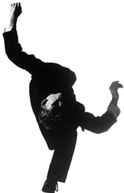
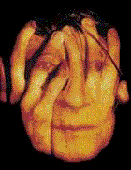

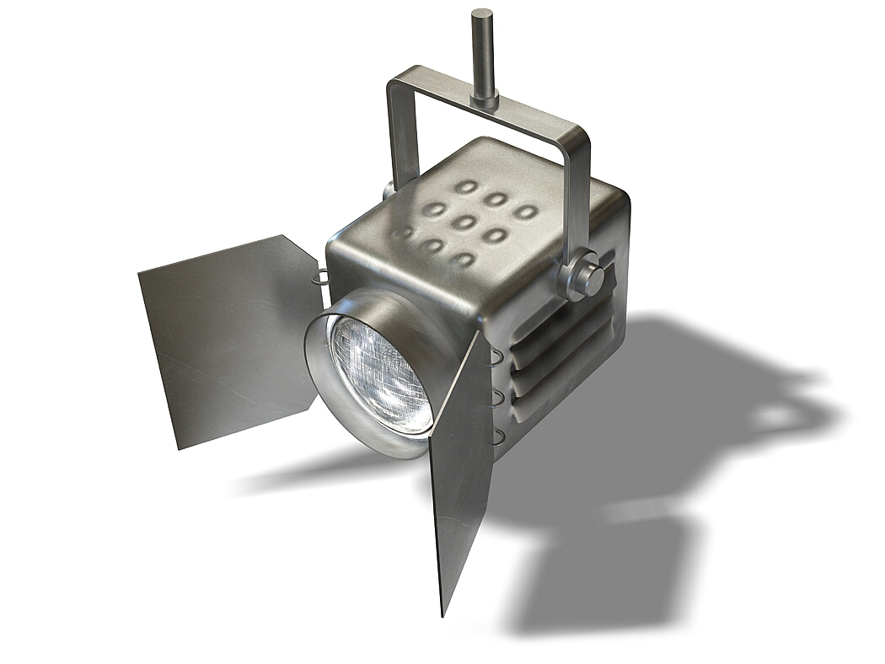
Performing Arts

Performance Preparation
These need to be considered at the time of preparation for your Induction Performance.
What Space are you working in?
What type of theatre is this?

Tick If You Know What The Following Theatre Layouts are Like
Proscenium Arch
Thrust Stage
In The Round
Traverse
Promenade
Ensure you understand what the actor/audience relationship is for each of these spaces

Tick If You Know What The Following Terms Mean
Stage Right
Stage Left
Centre Stage
Up-Staging
Open It Up To The Audience
Up Stage / Down Stage
Ensure you understand your way ‘around’ these stage directions

THE CONTROL BOX
Tick If You Have Seen and Had BRIEF Over-view / Introduction to
Lighting Control Desk
Sound Control Desk
The Rig
The different lights in the rig
How you would Cue a Show

FOH
Tick If You Have Looked at and then considered
Where the Box Office Is
What you might use the FOH call system for
What would you have to check FOH if you had an audience arriving?
What sort of questions might you have to answer from the audience

SCENE DOCK
Tick If You Have Looked at and then considered
Where the Scene Dock Is
If you were painting scenery in there, what would you have to consider
Do you know where the props are, and where the term props comes from
In a production company who might have to access the scene dock

REHEARSAL ROOM / DRESSING ROOM
Tick If You Have Looked at and then considered
How to use the dress room tables
On average how many weeks would a professional drama production rehearse for?
How do you sign up to book this and other rooms
Who might need to access this room from a production company

THEN have a look through the PLANNING FOR AN EVENT EXERCISE for this venue. You are to keep this paperwork and put it at the back of your UNIT 1 FOLDER OF WORK.

UNIT 2 Planning For An Event
(A Health and Safety and Risk Assessment Exercise)

You are planning a small scale informal performance in STUDIO 816. Below is a description of the event and technical requirements.

- Discuss what health and safety features and risks you will have to be aware of. How will you deal with them to minimise risk and ensure the event is safe for audience and performers?
- What will you have to be aware of and do before, during and after the event.

You are not selling tickets to the event, and there will be no charge on the door. You are expecting some wheel chair users in the audience and in the performance company. You are going to use rostra (a raised platform) to put some of the audience’s seats on so they get a better view. You will be blocking one of the fire exits with curtains that act as a back-drop to the event.

You will be responsible

The performance itself includes the use of candles for a particular dance.

The performance uses a small scaffolding tower on wheels.

The performers will change in a room attached to the main performance area.

- Then complete a risk assessment for the above event.

The book AN ESSENTIAL GUIDE TO STAGE MANAGEMENT, LIGHTING AND SOUND is available and will help with this task

Chapter 10 and 8 from PRACTICAL THEATRE Edited by Sally Mackey will help here

(Mini Risk Assessment For The Above Event)

TASK | What Are The Hazards? | Who is at Risk? | Controls in Place | Risk Grading  1= High 5 = Low | Further Action
Not selling tickets to this event

Using Rostra for raising some of the audience’s seating

Blocking the back fire exit by hanging a curtain in front of it

Ensuring access for all audience members and performers

Candles will be used in this performance

A scarf tower will be used

Cast changing in changing room attached to main space

