7 Secrets of Super Performers
(Improving Your Performance Skills)
The following is taken from an article by Nichelle Strzepek on her website http://danceadvantage.net/2009/02/08/7-secrets-of-super-performers/. Read her tips for improving performance – can you identify where your strengths and weaknesses as a performer lie?
If you are a dance student, chances are you are probably preparing for a performance right now. You’re working hard to learn the steps and remember the sequence so that, by the time you get on stage in front of an audience, the dance will be second nature. But performance, as you probably know, is more than steps and sequence. These things could be perfect and the presentation will still bore an audience if the performers are not engaging and enjoyable.
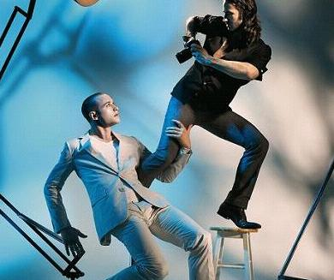
Some students seem like natural performers. They know how to “work a crowd,” they dance with energy, and seem to move with joy. Certainly, experience as a performer plays a big part in this. Like anything else, practice in performance allows one to learn what works and what doesn’t. “Natural” performers, however, seem to know something that others do not. Here’s a list of some of these secrets. Actually, some of them may not seem that secret (I really couldn’t resist the alliteation), but perhaps you haven’t put much thought into them before. As you work toward your final performance be sure to put these skills into practice with as much (or more) diligence as learning the steps.
Never dance alone, even in a solo  When you dance, your purpose is not to get to a certain place on the floor. It’s to enjoy each step along the way. ~ Wayne Dyer ~  The word performance implies that a dance is not only being executed but witnessed as well. Including the audience in your performance first and foremost means that you must not forget or ignore that they’re there. If this makes you nervous, it may be useful to know that according to The Anxiety Treatment Center (Chicago area), involving the audience can actually lessen your anxiety or stage fright. (You might also read this article by Sanna Carapellotti offering tips for managing negative thoughts in performance.) The second application of this principle is being aware as you dance with others in a group. Involving the audience or the other dancers on stage with you can be manifested in different ways including making eye contact, directing your energy to one person within the audience or offering your energy to the others around you, and using or responding to the energy of others. None of these are things that you DO so much as things you FEEL and THINK as you perform. | Super performers are secretive  This also relates to the idea of dancer as actor. Although acting is about revealing something to an audience, a good performer knows that playing one’s hand all at once is not a good idea. As a dance performer, you don’t always have control over the content of your performance. The choreographer ultimately is responsible for this. However, it helps, as you perform, to imagine you are keeping a secret from the audience. Think about how it feels to withhold something you want to share with someone else and apply that type of contained excitement or knowledge to your dancing. There may be natural points in the choreography in which you might build toward or reveal portions of this secret — like opening birthday presents one at a time. This may seem like a somewhat abstract idea, however, I’ve found this imagery to be useful for depicting the fun in dance without relying solely on happy or joyful sentiments. After all, not every dance is happy but they can all have their secrets and the use of this technique has made for some compelling performances.  Remember that dance has a dimension beyond the physical. The body-as imperfect as it always is-is only part of the picture. Your energy, the quality of your movement, your feeling about the world, your dance spirit-that is what we see under the lights ~ Dance Magazine 3/05 ~ | Super performers are actors as well as dancers  Just as musicians understand the music, actors understand the context within which they are performing. Dancers, therefore, are familiar with the time period or origin of the dance, they understand the emotions of a piece or what the choreographer is trying to express or intend. Like actors, engaging performers, also “suspend disbelief” or, make the audience believe something even if it is not true or actual. Dancers pretend to be happy, curious, confused, or angry even when they are not. Much of being a convincing performer is making something seem real even to yourself - evoking emotions that were not present a second ago. Being real in acting also involves discovering what is natural or of human nature. In acting this might be conveyed by not ignoring a prop as it accidentally falls to the floor. In dance, it may be finding that natural smile as mentioned above. Becoming an excellent performer requires investigation of and experimentation with behavior (guided or otherwise).  Long experience has taught me that the crux of my fortunes is whether I can radiate good will toward my audience. There is only one way to do it and that is to feel it. You can fool the eyes and minds of the audience, but you cannot fool their hearts.  ~ Howard Thurston ~
Super performers know… the eyes have it  Facial expression is important in dance but often people talk only about smiling in a performance. While a smile can be important during certain types of dances, not all dances warrant that expression. In fact, facial expression often has more to do with the eyes than with the mouth. So, rather than focusing on smiling, I prefer students to practice an “open” expression with their face. Although THINKING or FEELING this concept is at least half the battle, there are some things you can DO in this case. As you perform, engage the muscles in the face by slightly lifting the eyebrows - not to a comical extreme, but in a way that is comfortable and easy to maintain. It is the same expression most humans use when making eye contact and really listening to a friend or speaking excitedly in conversation. This is why audiences respond well to performers who utilize this technique. Also, truly see, look, and take in the world through your eyes as you dance. As for the rest of the face, be natural. Relax the lower jaw. This will facilitate a smile that comes easily but is not plastered to your face, or aid any expression befitting the mood of your dance. | 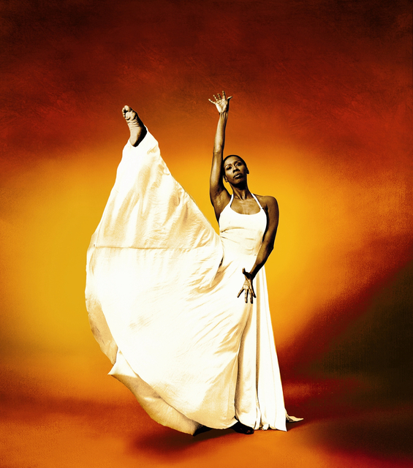  People come to see beauty, and I dance to give it to them. ~ Judith Jamison ~  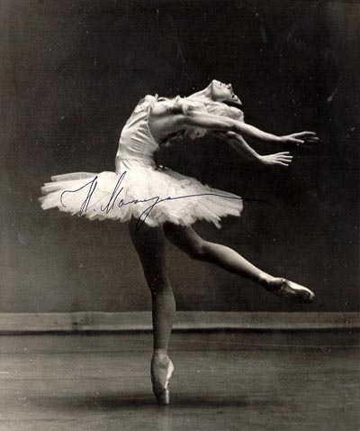  Even the ears must dance.  ~ Natalia Makarova ~ | Super performers dance beyond their kinesphere  Kinesphere is a word used in dance that describes the space surrounding the body. It is the imaginary bubble that encircles your frame in stillness and as you move. Again, dancing beyond this bubble is something that you must IMAGINE as you dance, not necessarily something that you DO. Moving with a sense of directing or expanding your energy beyond your kinesphere will not only make you a more engaging performer. If practiced throughout your classes as well, projecting energy beyond your fingertips and toes, out through the top of the head, from your eyes, or even from every cell in your body, can improve your execution of the movement as well.  When it comes to the requirements for pleasing an audience, all the knowledge and instruction and apparatus in the world is worth less than one ounce of soul. ~ Ottawa Keyes ~
Super performers understand musicality

The concept of musicality can be quite elusive, everyone has a different way of thinking about musicality. While counting can be important sometimes for finding moments of precision in a dance, musicality in performance is expressed through more than just counting beats. In fact, while counting, it is easy to forget that a beat includes not only the sharp “tap” of a particular rhythm but also the space between those taps, just as all movements include transitions and shifts of weight between desired “shapes” of the body. Exciting and musical performers fill these spaces in the music and movement, not letting the energy or intent drop between shapes or between counts. Enjoyable performers also utilize dynamics in their performance. Resisting “sameness,” as they dance, they incorporate crescendo and decrescendo, sudden or gradual changes in the quality of the movement, that often reflect or work within the accompanying music or score. Choreographers utilize music in different ways and a good performer will seek to understand what part of the music (rhythm, melody, counterpoint, etc.) the dance-maker is using as inspiration in the movement. To do so, it is always helpful to have at least a basic understanding of music composition or theory but THINKING about what you FEEL and HEAR in music and applying these to your dance practice is the first step in bringing musicality to your performance. In fact, a performer can be musical even without dancing to music!

The more you understand the music, the easier you can dance. ~ Orlando Gutinez ~

The audiences ears hear the music, and their eyes see you being that music. Dance is the music made visible. You ARE the music! ~ Morocco ~

Super performers ooze confidence

Some confuse attitude with confidence. Attitude is something which is acted or portrayed. Just as any role would, attitude requires a level of confidence to be played well but, it is simply a layer or a persona the performer wears in his/her performance. Confidence is trust in yourself and in the situation but, it is not centered on the self. Trust in yourself and your fellow dancers is the practical side of confidence and comes from preparation and experience. The work you put into the dance steps and sequence, the time and effort you put into class and technique, the build up of experience on stage or of situations in which you must improvise or think on your feet. These things allow a performer to trust. The more conceptual aspect of confidence lies in the idea that exuding confidence does not require one to act in a self-centered manner. In fact often it is quite the opposite. Dancers with confidence give a lot of themselves without dwelling on what the audience is thinking of them. This allows the performer to focus on making good use of all that preparation, overcome mistakes when they arise, and concentrate fully to the performance itself. I hope this demonstrates that confidence is not something that someone either has or hasn’t. You can actually discover your confidence with many of the same techniques used to reduce performance anxiety or fear.

Don’t be afraid to be amazing. ~ Andy Offutt Irwin ~

