Taking a Gap Year?

When planning a gap year think about:
- What you want to do.
- Why you want to do it
- What you are hoping to gain from it.

During a gap year you could:
- Travel, independently or as part of an organised project
- Gain work experience – paid or unpaid
- Do voluntary work
- Improve language skills.

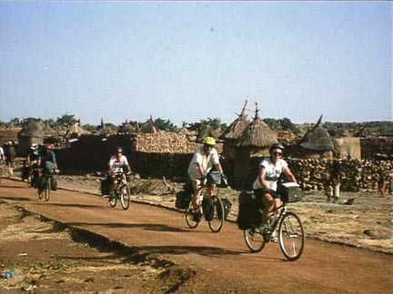

If you are not sure what to do in your gap year, it is worth doing some research into what options are available. A good starting point is to check out some of the information available on the internet.

Look at www.yearoutgroup.org this is a portal website with links to 35 gap year organisations, then complete the activities below.

Tick the options which you might consider:

 | Travel abroad |  |  | Paid work abroad
 | Voluntary work in UK |  |  | Expeditions/adventure
 | Voluntary work abroad |  |  | Interest/study courses
 | Paid work in UK

List the advantages and disadvantages of taking a year out.

ADVANTAGES | DISADVANTAGES
e.g. broaden my horizons | e.g. difficult to return to study

Whatever you choose to do with your year out, future employers and college tutors will want to know your reasons for your decision. This is particularly important if you plan to apply for deferred entry to higher education.

The chart below gives some of the ways young people spend their year out. Complete it by giving the advantages and disadvantages of spending a year in this way. Add any other situations that you can think of.

Activity | Advantages | Disadvantages
Paid work in the UK,  E.g. Working in a supermarket | Can afford to run a car.  Can save for University. | Boring.  Want to leave home.
Paid work overseas, e.g. working as an English assistant in a school or in an American holiday camp.
Voluntary work in this country, e.g. working for Age Concern.
Voluntary work overseas, e.g. working for GAP.
Back packing abroad.

