BTEC yr2

**Distinction criteria extension task**

*If you are pushing for MERIT or DISTINCTION criteria, then it is important that you attempt this task.*

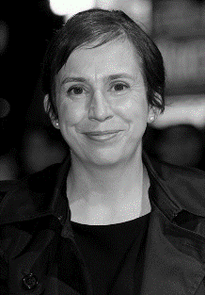i From the different types of famous writers you’ve previously researched

David Koepp Abi Morgan Charlie Kaufman

American – commercial British – independent American – independent

**Give TWO examples of Legal and Ethical considerations your chosen writers had to work to**. For example, you could refer to:

* DAVID KOEPP – **BBFC**: *Death Becomes Her*, *Jurassic Park* and *Spiderman*. **Copyright**: *War of the Worlds*, *Jurassic Park* and *Angels and Demons*.
* ABI MORGAN – **Watershed:** *River* and *Sex Traffic*. **Representation:** *The Iron Lady* and *White Girl*.
* Charlie Kaufman – **Copyright:** *Adaptation*. and *Confessions of a Dangerous Mind* **Representation:** *Adaptation.* and *Being John Malkovich*

This task will of course require you to do some additional reading, find interviews with them discussing, watch some clips, talk to me etc.

Create a new slide (or slides) in your PowerPoint template. Writing TWO detailed paragraphs should be enough to cover desired criteria.

**DEADLINE: Friday 21st Oct**