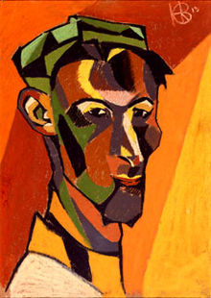Key work: Henri Gaudier-Brzeska ‘Red Stone Dancer’

**Life dates:** 1891-1915

**Works:** Self Portrait, Boy with a rabbit, Red stone dancer

**Scope of works:** Influenced by ‘primitivism’; human figure sculpture,

**Style**: The London Group

**Key quote:** "When I face the beauty of nature, I am no longer sensitive to art, but in the town I appreciate its myriad benefits—the more I go into the woods and the fields the more distrustful I become of art and wish all civilization to the devil; the more I wander about amidst filth and sweat the better I understand art and love it; the desire for it becomes my crying need."

1. What date did he move to London?
2. Which group (led by Ezra Pound and Wyndham Lewis) does he join?
3. 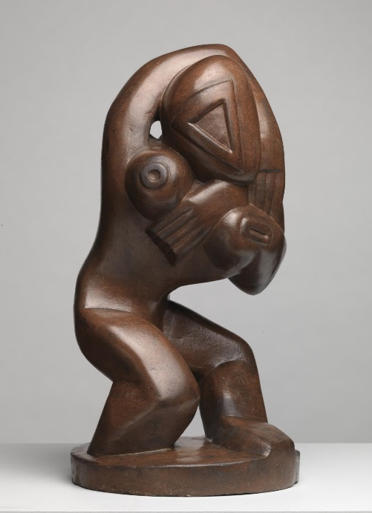Research the characteristics, aims and influences of this group?
4. What does the phrase ‘direct caving’ mean?
5. Where were the best places in London to see ‘primitive artefacts’?
6. Explore the range of non-Western influences on him? Make sure you have specific detail and sources and can link the ideas to the work.
7. Ezra Pound described his ‘Red Stone Dancer’ as ‘almost a thesis of his ideas upon the use of pure form’. Read abouot him and his ideas more widely and then explain what Pound means by this in your own words.
8. Read the Kett;e’s Yard website: <http://www.kettlesyard.co.uk/handfulofobjects/red-stone-dancer/> This website also has some good comments for and about this work which you should add to your key quotes list.
9. Compare this work to others on the same subject: Derain ‘Dance’ (1906) Matisse’s The Dance (1910) Why is this subject so evocative for early Modernists, particularly those who are interested in the appeal of primitivism?
10. If you are interested in film, you might like to research this Ken Russell production about the sculptor ‘The Savage Messiah’. <http://www.iainfisher.com/russell/ken-russell-article-gaudier.html>
11. Watch this BBC documentary on British sculpture through this period, presented by Alistair Sooke ‘Romancing the Stone’ <http://estream.godalming.ac.uk/View.aspx?id=6420~4m~m5FVpfbk>. It explains the appeal of primitivism on British Modernist artists. Make sure you take good notes as you watch: the first part will be good for your broader understanding of our current module on Modernism, but the later parts will also help you revise your Identities and War thematic modules so please watch to the end! Make different sets of notes for each module though so you can file them in the appropriate place and use them for your final revision. (NB You could choose to use Epstein’s Rock Drill as an alternative or additional key work: it would qualify as a Human figure sculpture by a non-French artist. Although born in the USA, Epstein took British nationality and is therefore valiad for this module.)

*Sample 5 mark questions:*

1. Explain the ways in which one work has been affected by the interest in ‘primitive’ artefacts.
2. Explain the use and effect of the artist’s choice of material/s in one sculpture produced during this period.
3. Explain the ways in which one sculpture, representing the human figure, conveys meaning.