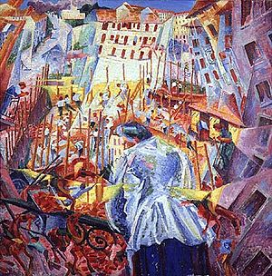Key work: Boccioni

The Street Enters The House

**Style:** Futurism

**Date:** 1912

**Scope of works:** Modern urban life by an Italian painter

**Size:** 100 x 100cm

**Materials:** oil on canvas

1. Describe the aims of the Italian Futurist movement?
2. List five members of the group?
3. When and where and by whom was their manifesto written and published?
4. Give three quotes from the manifesto that particularly relate to modern urban life and/or its representation in art?
5. Describe the subject matter of this work as briefly as possible, but with sufficient specific detail to impress your examiner!
6. Explain the ways in which this painting shows the influence of Cubism?
7. What were Roentgen rays and how are they relevant to this work?
8. How might you be able to use Bergson’s theories in relation to this work? Give the appropriate quote and specific link to this work.
9. List, in as much detail as you can, the ways in which this work explores the modern city?
10. Is this presentation positive or negative? Justify your opinion?
11. Where was this work first displayed?
12. What was the reaction to it?
13. What are the dates of Futurism and to which part of the movement does this work belong? Explain your decision?
14. Now make an image sheet of some of Boccioni’s other works: including The City Rises and the sculpture, Unique Forms of Continuity in Space. You should also include some works by other Futurist artists so that you are able to see the differences between the individuals in the group: look at Russolo, Carra and Balla as well as Severini.

*Sample 5 mark questions:*

* Explain the ways in which one work is associated with Futurism?
* Explain the ways in which one work presents the modern city?
* Explain the ways in which one work by a non-French artist uses colour?