Task 1 create an A3 page similar to below exploring different techniques with your name: splitting text, adjusting the kerning between individual characters and leading between lines of text, warping, scribble, adjusting individual nodes, text with filters etc.
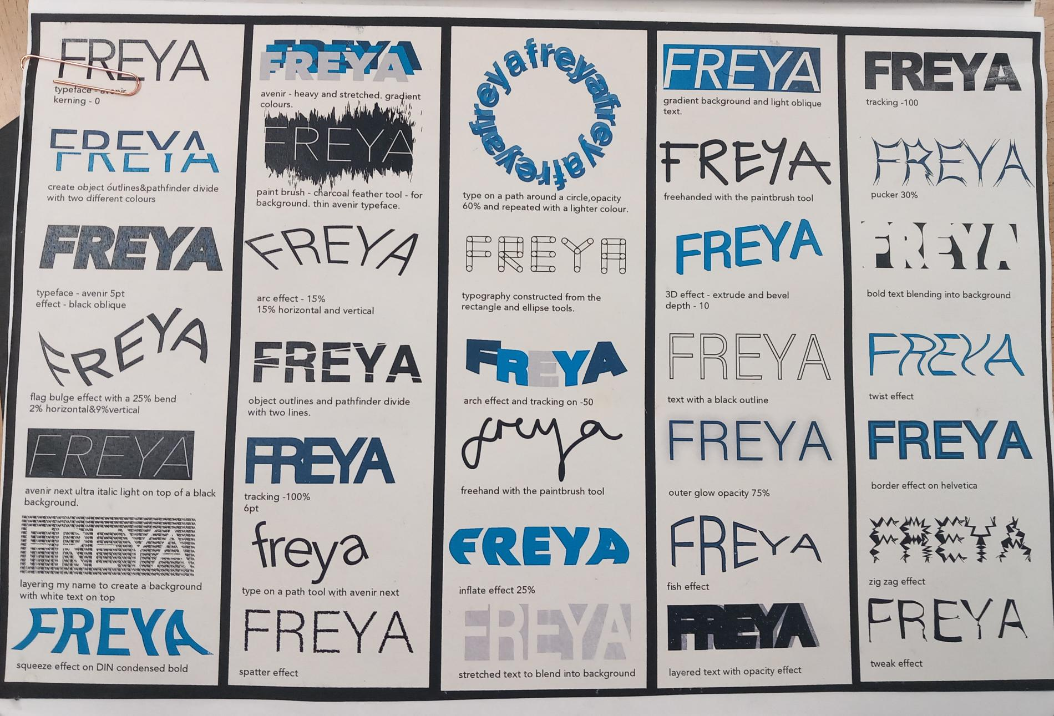
Task 2 – on a strip of tracing paper experiment with off screen hand drawn techniques for creating your first initial as below. (scribble effect, straight lines, different shapes, circles etc)
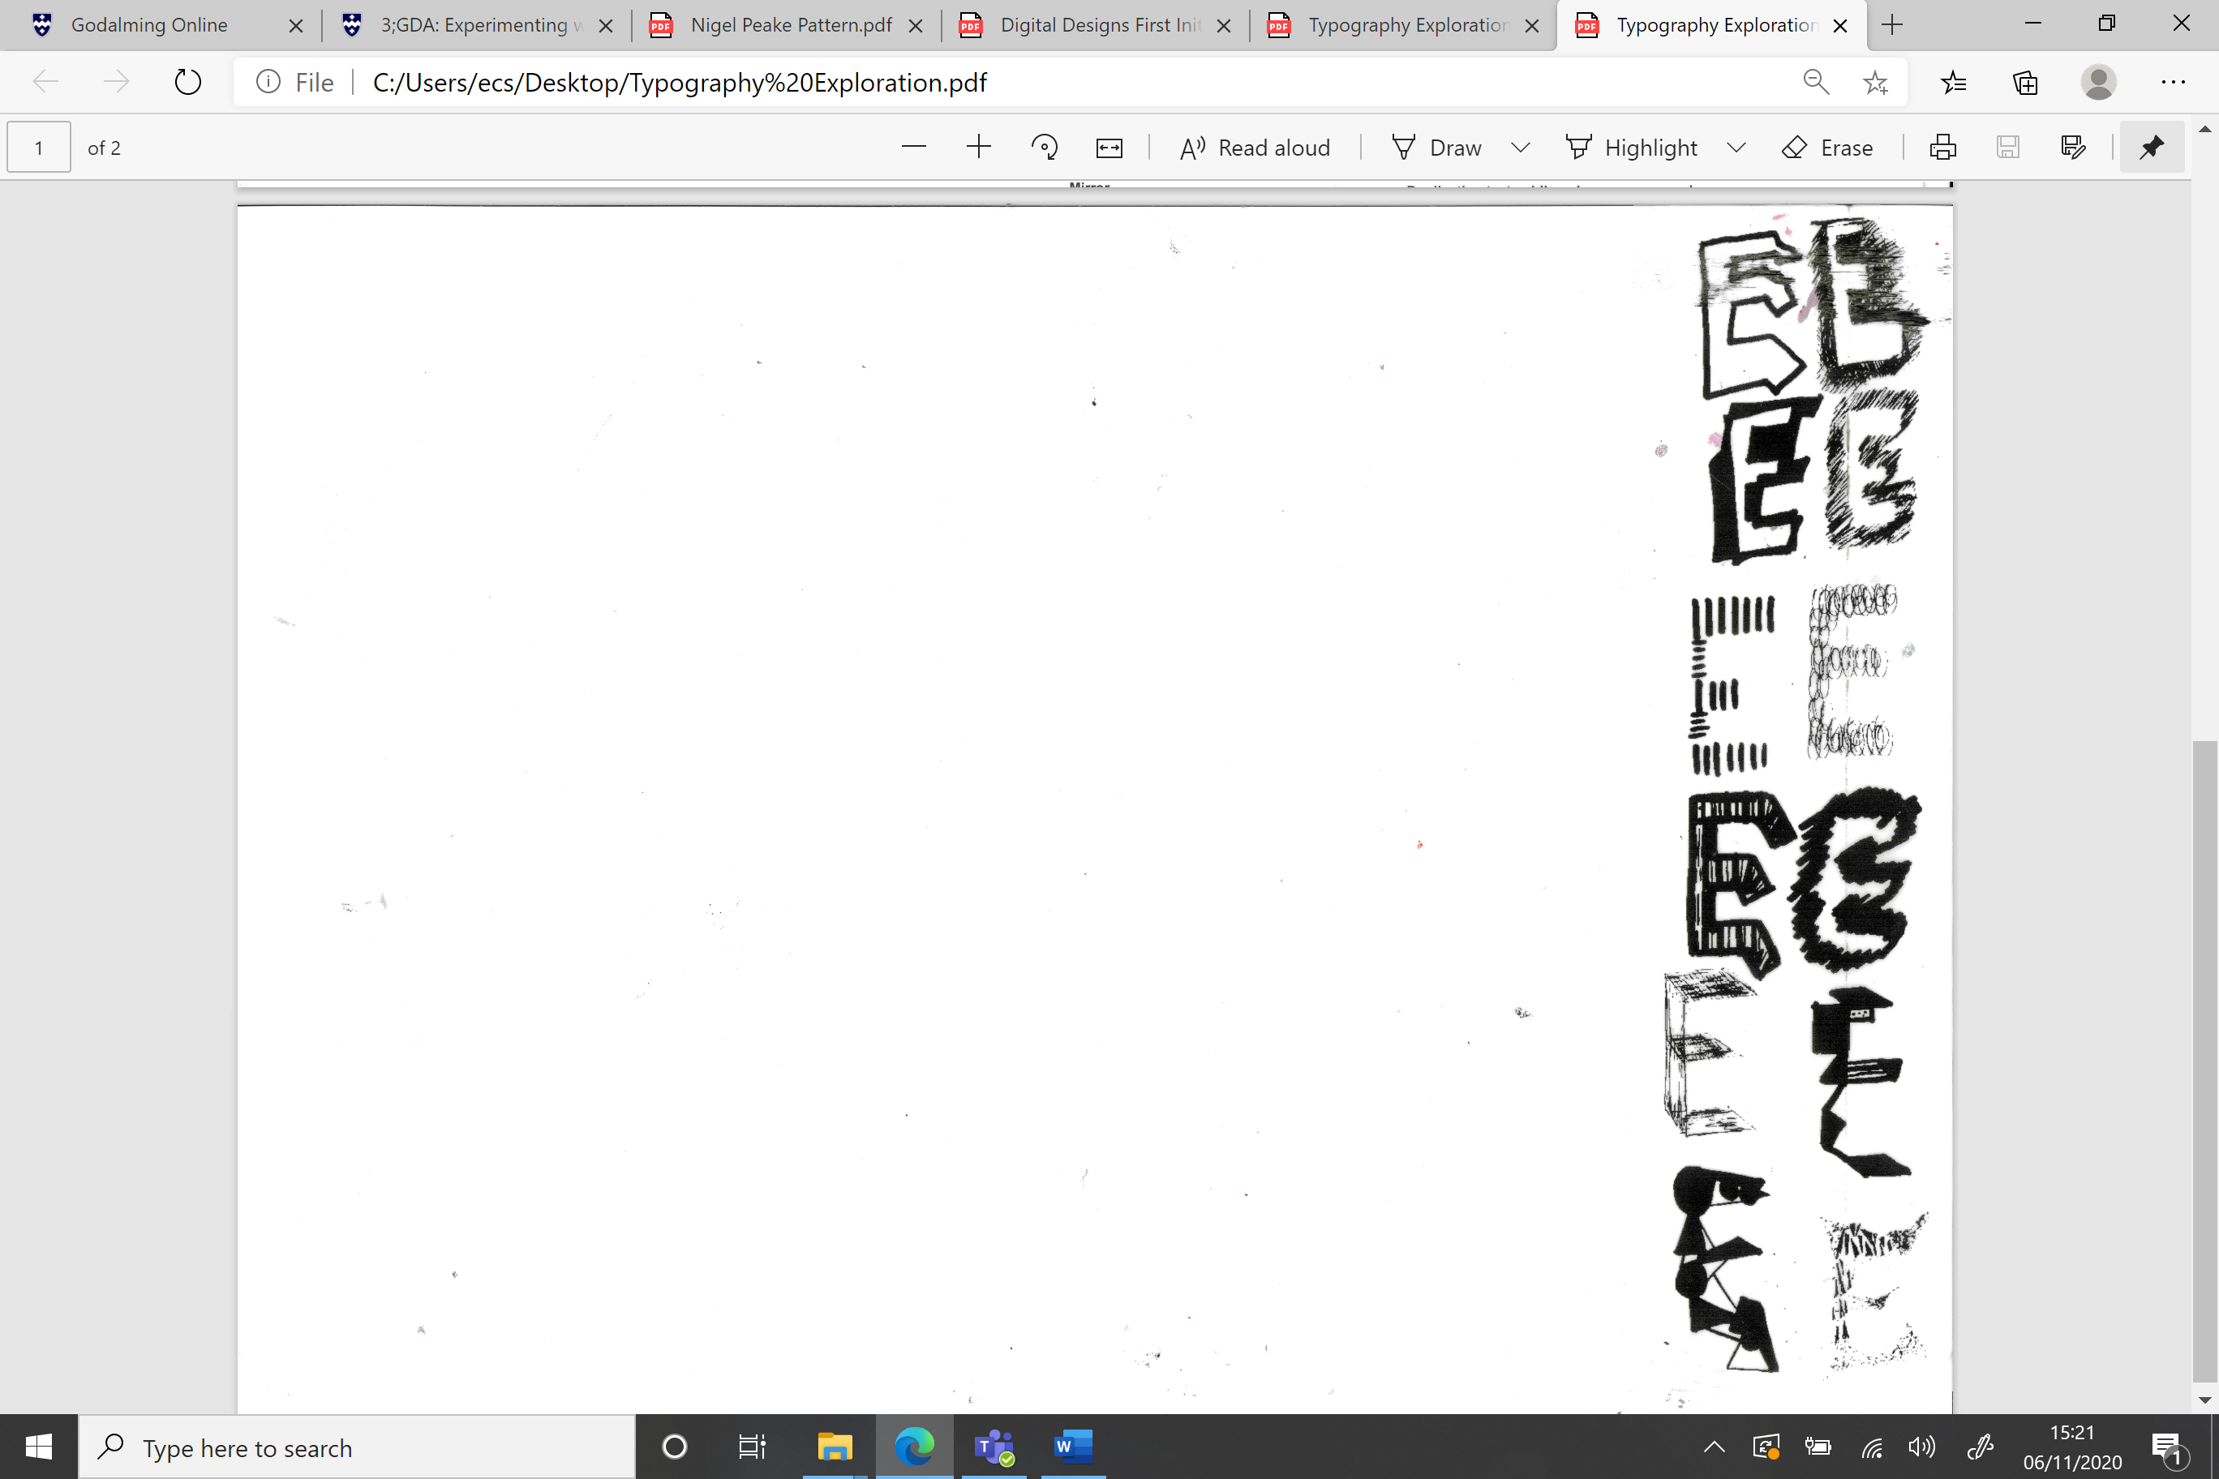

Task 3 – on A6 cartridge paper create a pattern design in the style of Nigel Peake that you are going to clipping mask into one of your typography designs.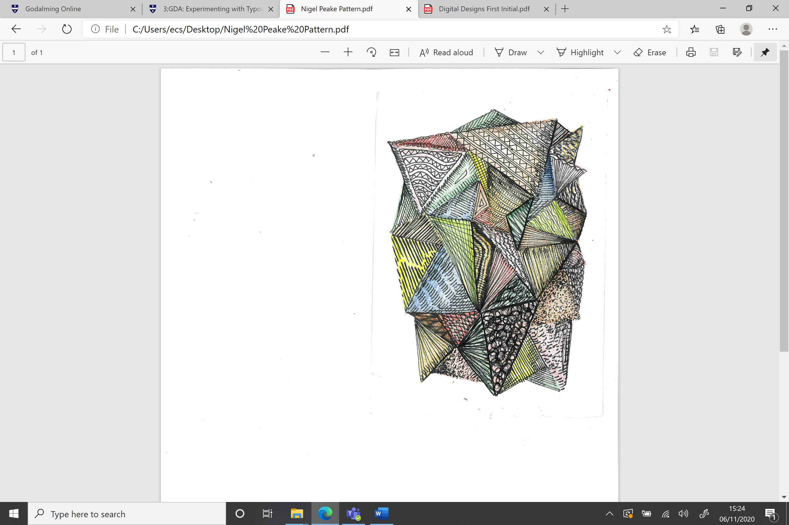
Task 4 On a new A3 document start re-creating 4 of your hand drawn first initials digitally e.g. the left hand column below. For one of your designs clipping mask your Nigel Peake pattern into the letter. Then I would like you to create your first initial in the style of Mondrain, Kandinsky, Miro and Michel Beirut, examples underneath

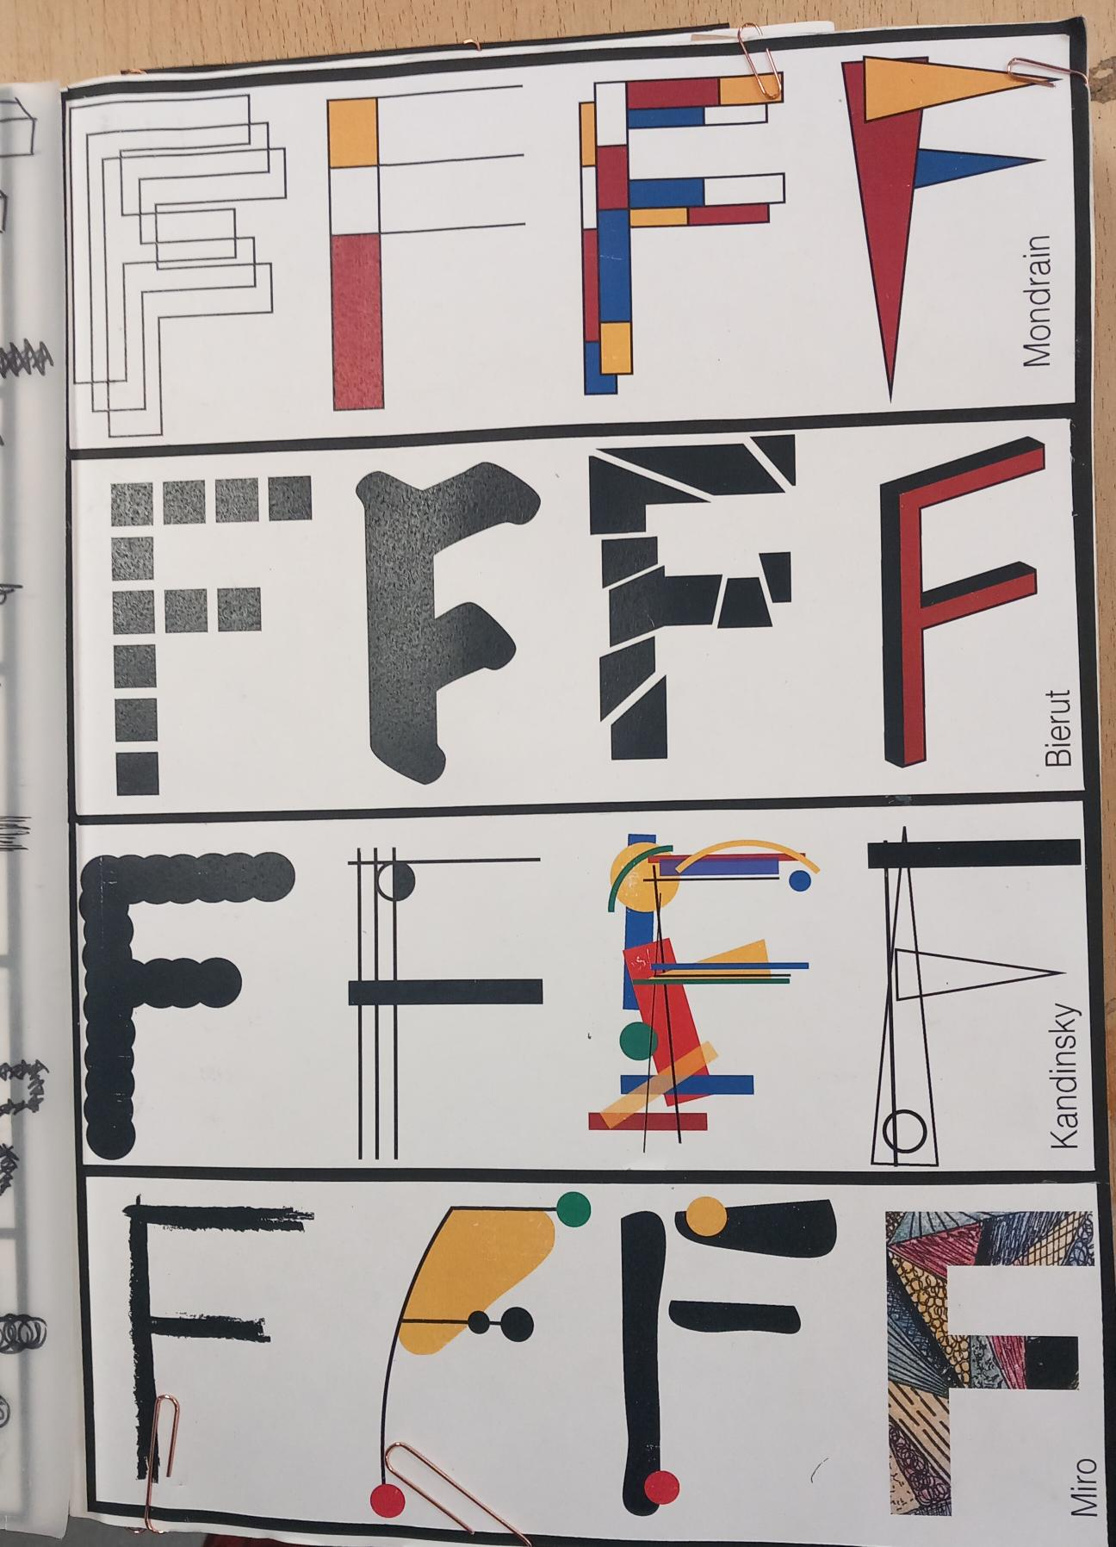
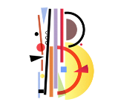Kandinsky 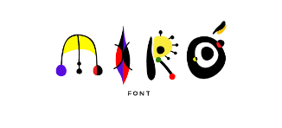 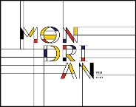 Michel Bierut
Task 5 create numerous hand made letters for your first initial, try to create 20 so don’t make these too big. 2 must be laser cuts. Be sensitive to the materials you are using as per example below. (use wires, painted sticks, card, stitched acetates, threads, staples etc)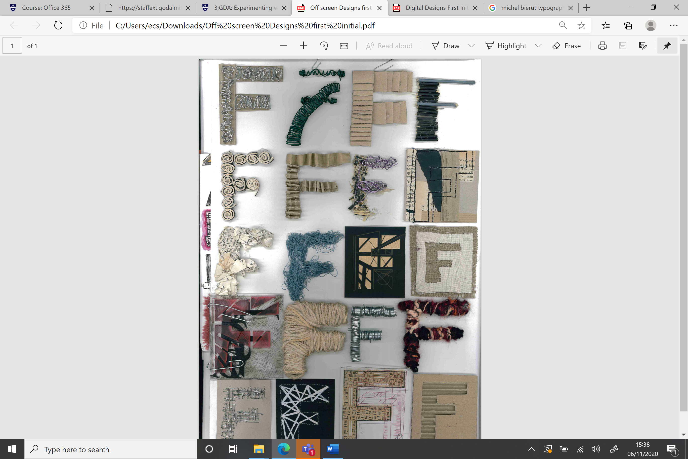

Task 6 – Photoshop edit your off screen designs as per example below.


