Jérôme and Claire are shocked when their daughter, Camille, who was killed in a bus accident four years earlier, returns home unharmed and unaware that anything has happened to her. [](http://www.google.co.uk/url?sa=i&rct=j&q=&esrc=s&source=images&cd=&cad=rja&uact=8&ved=2ahUKEwijs9y6vvneAhUN1BoKHewvAT0QjRx6BAgBEAU&url=http://aarondouglasfans.com/2014/08/06/the-returned-aaron-douglas-has-joined-the-cast-of-new-ae-television-series/&psig=AOvVaw0HzdVoNWS_FihfSnMrXvzR&ust=1543576970193972)  

Simon attempts to find his fiancée, Adèle, not knowing that he died ten years earlier.

 [](http://www.google.co.uk/url?sa=i&rct=j&q=&esrc=s&source=images&cd=&cad=rja&uact=8&ved=2ahUKEwjEpOvRvvneAhVM-YUKHRxsCy0QjRx6BAgBEAU&url=http://lesrevenants.wikia.com/wiki/Ad%C3%A8le_Werther&psig=AOvVaw0hpFJc8saTT5VeTJx32tkI&ust=1543577016823499)

Monsieur Costa is deeply disturbed when his wife (Viviane), who died 30 years earlier, shows up at their home. He hides her from his nurse, Julie, and later burns down his home with Madame Costa tied inside, before committing suicide by jumping from the dam.

[](https://vignette.wikia.nocookie.net/lesrevenants/images/2/21/Mrs_Costa.jpeg/revision/latest?cb=20160223023732) [](https://vignette.wikia.nocookie.net/lesrevenants/images/d/d8/Julie.jpg/revision/latest?cb=20160223043801)

Julie is followed home by a young boy who refuses to speak. When her neighbour, Mademoiselle Payet, questions the boy's presence, Julie pretends he is her nephew, Victor. Lucy, a waitress who claims to be a medium, is stabbed on her way home from the bar.

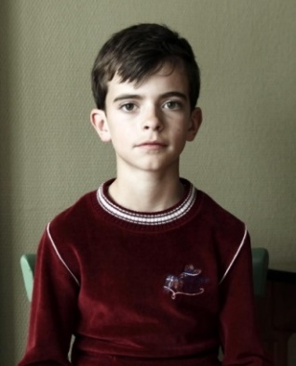 

[](http://www.google.co.uk/url?sa=i&rct=j&q=&esrc=s&source=images&cd=&cad=rja&uact=8&ved=2ahUKEwiEq9SkwPneAhUDyIUKHSppARoQjRx6BAgBEAU&url=http://lesrevenants.wikia.com/wiki/L%C3%A9na_S%C3%A9guret&psig=AOvVaw2_bWUCdAiBGeDqNk17g9Fb&ust=1543577461565586)In a flashback to the day of the bus accident, it is revealed that Camille's twin, Léna, pretended to be sick in order to avoid the school trip. Her boyfriend, Frédéric, sneaked into her bedroom and Camille becomes distressed when she "senses" her twin's first sexual encounter. As Camille tried to get the bus to stop, the distracted driver noticed Victor standing in the middle of the road and swerved to avoid him, causing the bus to plummet over the cliff's edge.