[**Susan Chitwood**](https://dance-teacher.com/community/schitwood)

Jul. 17, 2009 11:07AM EST

**Dance History: Loie Fuller**

Loie Fuller dons one of her famous costumes. Photo courtesy of The Dance Collection, NY Public Library for the Performing Arts

Before there was Martha Graham or Isadora Duncan, there was Loie Fuller (1862–1928), the toast of Paris nicknamed “La Loïe." Poets like William Butler Yeats lauded her, Henri de Toulouse-Lautrec painted her and sculptor Auguste Rodin allegedly captured her in marble. Although plump, plain-faced and untrained (not a tall and lovely sylph as she was often depicted), La Loïe, born Mary Louise Fuller, was so popular during her time that a disappointed spectator once pulled a gun when she failed to perform as scheduled. “She literally hypnotized a whole generation of audiences," says world-renowned Fuller expert [Jody Sperling,](http://www.dance-teacher.com/face-face-jody-sperling-2392826005.html) artistic director of Time Lapse Dance. But despite having been a catalyst for modern dance and pioneering the use of theatrical special effects, Fuller is largely forgotten in her native America.

Fuller grew up outside of Chicago and eked out a living in musical theater, touring the country with entertainers like Buffalo Bill. At the time, there was little classical dance training in America, and music hall “ballet girls" were considered immoral. So Fuller tweaked the late 19th-century dance craze called skirt dancing with the development of her *Serpentine Dance*—America's first modern work. (It was originally a skirt dance for a failed play called *Quack M.D.*, in which she'd been cast.) She created her own style of “natural dancing"—nontechnical movements that involved her body's spontaneous response to music—and abandoned the typical accordion-pleated costume for a voluminous silk skirt that she manipulated with bamboo wands and flooded with abstract patterns of light. (She may have gotten this idea while acting in New York City's *Arabian Nights* [1887], which boasted the most spectacular lighting.)

Fuller auditioned her routine at the Casino Theatre in NYC, making her career-cinching appearance in February 1892. While some considered it suggestive, it was her synthesis of the play of light on fabric with her formations of images—including breaking waves, a rose falling to pieces and a giant lily—that seized onlookers. There were more than 30 technicians in her crew, enhancing her effect with slide-projection magic lanterns and telescopic images of the moon. The *New York Spirit of the Times* likened her to a fairy, adding that the audience could scarcely believe “the lovely apparition" was human. One reviewer remarked on the audience's “breathless silence," followed by thunderous applause. Another pronounced it “infinitely more artistic than the toe-dancing of the greatest prima ballerina." The dance immediately spawned a raft of followers.

Captured in one of modern dance's most powerful photographs, Graham dramatically cantilevers forward, and, wrist to forehead, she kicks up her shimmering skirt into a vertical half-moon shape, à la La Loïe. And while Duncan is generally credited as the first modern dancer, Fuller not only invited Duncan into her Parisian company, Loie Fuller and Her Muses, but she also sponsored Duncan's first continental tour, before the two split due to artistic differences.

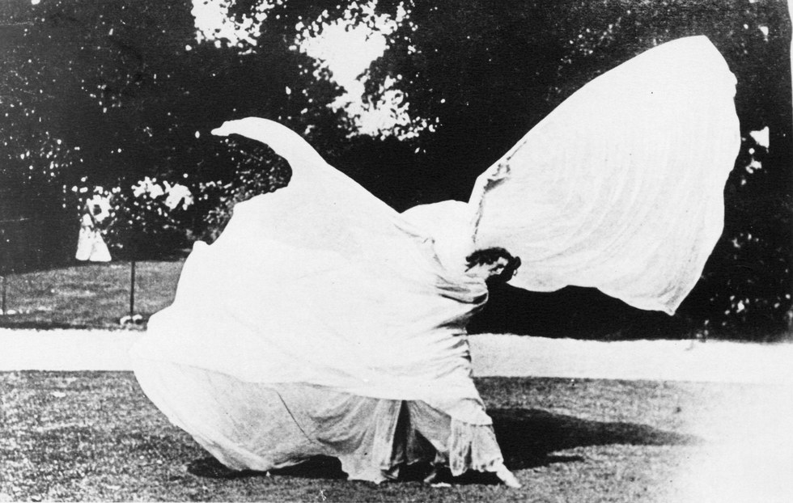

* + [Share using Facebook](http://www.facebook.com/sharer/sharer.php?u=https%3A%2F%2Fwww.dance-teacher.com%2Floie-fuller-2392287731.html%3Fxrs=RebelMouse_fb%2370023&picture=https%3A%2F%2Fassets.rbl.ms%2F9905419%2F980x.jpg)
  + [Share using Twitter](https://twitter.com/intent/tweet?url=https%3A%2F%2Fwww.dance-teacher.com%2Floie-fuller-2392287731.html%3Fxrs=RebelMouse_tw%2370023&text=%40Dance_Teacher)
  + [Share using Pinterest](http://pinterest.com/pin/create/button/?url=https%3A%2F%2Fwww.dance-teacher.com%2Floie-fuller-2392287731.html%2370023&media=https%3A%2F%2Fassets.rbl.ms%2F9905419%2F980x.jpg&description=)
  + [Share using Tumblr](http://www.tumblr.com/share?s=&t=&u=https%3A%2F%2Fwww.dance-teacher.com%2Floie-fuller-2392287731.html%2370023&v=3)
  + [Share using Email](mailto:?subject=undefined&body=%0AHey%2C%20found%20this%20on%20's%20Front%20Page%20and%20thought%20you%20would%20like%20it%3A%20https%3A%2F%2Fwww.dance-teacher.com%2Floie-fuller-2392287731.html%2370023%0A)
* [Close sharing options](https://www.dance-teacher.com/dance-costumes-2600475914.html)
* [Show sharing options](https://www.dance-teacher.com/dance-costumes-2600475914.html)

Loie Fuller. Photo courtesy of The Dance Collection, NY Public Library for the Performing Arts

Unfortunately, Fuller's run at the Casino was short-lived. She quit after never receiving a promised raise, and then sued the theater for hiring another dancer while continuing to use her posters. After losing the lawsuit, Fuller decided to take her act to Europe, in a Josephine Baker–like exodus. Suffering a rocky start in Berlin, Fuller left for Paris in October 1892, and successfully petitioned the Folies-Bergère manager for a chance to perform. The local paper called hers “an act all Paris will rush to see," which may have been responsible for the city's La Loïe mania, as well as the attendance of a number of Europe's prominent intellectuals and royalty at her debut.

Often characterized as the embodiment of the Art Nouveau movement, Fuller's mixed-media choreography set an important precedent. Her innovative use of colored lighting with music and movement profoundly altered the visual arts and theater of her day—and ours. One of the first artists to drape the stage in black, she also patented an arrangement of devices, including angled, lighted mirrors, a floor fixture allowing illumination from below and a glass-topped pedestal that “suspended" its occupant when lit from below.

Her personal life was equally colorful. Fuller was long separated from “husband" Col. William Hayes, a shyster who was prone to sporting diamonds and claimed to be the nephew of former President Rutherford B. Hayes. He had two other wives, which landed him in Sing Sing. According to Marcia Ewing Current, who wrote *Loie Fuller: Goddess of Light* with Richard Nelson Current, Hayes was “a husband in name only," and Fuller eventually took a younger woman, Gabrielle Bloch, a member of her company, as her lifelong companion. Fuller may also have had an affair with her close friend, the Queen of Romania. However, some of Fuller's personal facts remain a mystery, as she was known to tell tall tales to compensate for her modest upbringing.

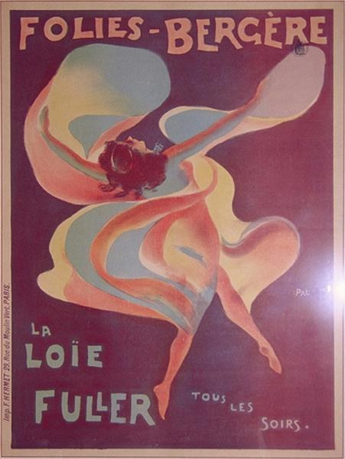

* + [Share using Facebook](http://www.facebook.com/sharer/sharer.php?u=https%3A%2F%2Fwww.dance-teacher.com%2Floie-fuller-2392287731.html%3Fxrs=RebelMouse_fb%2340734&picture=https%3A%2F%2Fassets.rbl.ms%2F9905426%2F980x.jpg)
  + [Share using Twitter](https://twitter.com/intent/tweet?url=https%3A%2F%2Fwww.dance-teacher.com%2Floie-fuller-2392287731.html%3Fxrs=RebelMouse_tw%2340734&text=%40Dance_Teacher)
  + [Share using Pinterest](http://pinterest.com/pin/create/button/?url=https%3A%2F%2Fwww.dance-teacher.com%2Floie-fuller-2392287731.html%2340734&media=https%3A%2F%2Fassets.rbl.ms%2F9905426%2F980x.jpg&description=)
  + [Share using Tumblr](http://www.tumblr.com/share?s=&t=&u=https%3A%2F%2Fwww.dance-teacher.com%2Floie-fuller-2392287731.html%2340734&v=3)
  + [Share using Email](mailto:?subject=undefined&body=%0AHey%2C%20found%20this%20on%20's%20Front%20Page%20and%20thought%20you%20would%20like%20it%3A%20https%3A%2F%2Fwww.dance-teacher.com%2Floie-fuller-2392287731.html%2340734%0A)
* [Close sharing options](https://www.dance-teacher.com/dance-costumes-2600475914.html)
* [Show sharing options](https://www.dance-teacher.com/dance-costumes-2600475914.html)

An 1896 PAL poster of Loie Fuller at the Folies-Bergère. Photo courtesy of The Dance Collection, NY Public Library for the Performing Arts

Once one of the highest paid performers of her generation, Fuller consistently mismanaged her funds and had little when she died of breast cancer in 1928 at a friend's apartment at the Plaza Athenée in Paris. Her ashes, near those of Maria Callas, rest at the Père-Lachaise cemetery, home to famous denizens Jim Morrison and Oscar Wilde. But Fuller may finally be making a well-deserved comeback in her own country, says Sperling, who receives e-mails from around the world asking how to make a Loie Fuller costume. “Her legacy is ascending," Sperling believes. “Her work has relevance. We're at a point where we're experiencing tremendous changes because of technology, and I think there was a similar change at the end of the 19th century."

In addition to a surge in scholarship, there's renewed interest in La Loïe's work. When Sperling performs her Fuller-based work, the response is “universally positive," she says. “People love it." And the experience for Sperling? “When I don the silk, it becomes my other skin," she explains. “You become something other than yourself. Add the element of light and it's magical—like painting with color."