**UNIT 10: EDUBLOGS CHECKLIST**

**Have you included all of the following in your production diary?**

|  |  |
| --- | --- |
| **Content** | **Is it in your production diary?** |
| Date for each entry |  |
| At least 1 entry per week |  |
| **Camera Techniques** |  |
| Shot types (Close up, long shot etc) |  |
| Camera Movement (Pan, track etc) |  |
| Camera Angles (Low, high, etc) |  |
| **Filming Process** |  |
| Set up |  |
| Scenes |  |
| Takes |  |
| **Professional Practice** |  |
| Organisation |  |
| Professionalism |  |
| Collaboration |  |
| Problem solving |  |
| Working with actors |  |
| **Editing** |  |
| Transitions |  |
| Pace |  |
| Running Time |  |
| Diegetic Sound |  |
| Non-diegetic sound |  |
| Generic conventions |  |

**Have you included the following on your edublogs?**

**Is the menu set up correctly? See overleaf for help**

|  |  |
| --- | --- |
| **Content** | **Is it in on your edublogs?** |
| LA A Comparative film analysis |  |
| LA A Comparative film analysis Improvements |  |
| Production Diary |  |
| Script |  |
| Sound Short List |  |
| Sound Report |  |
| Production Schedule |  |
| Risk Assessment |  |
| Call Sheet |  |

**To use edublogs menus correctly…**

1. **Create a post** for your work, copy your work into the post, and ensure you ‘**publish**’ the post

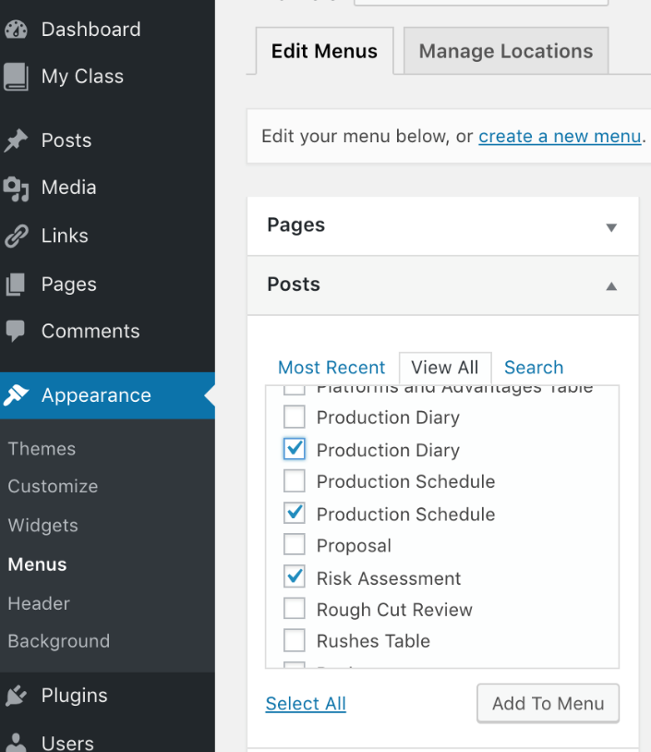

2. Go back to *‘****Dashboard****’* select ‘***Appearance****’* and *‘****Menus****’* then look at the *‘****Posts****’* section and ‘tick’ the post/s you want to be included in your menu.

3. Then select *‘****Add to Menu***

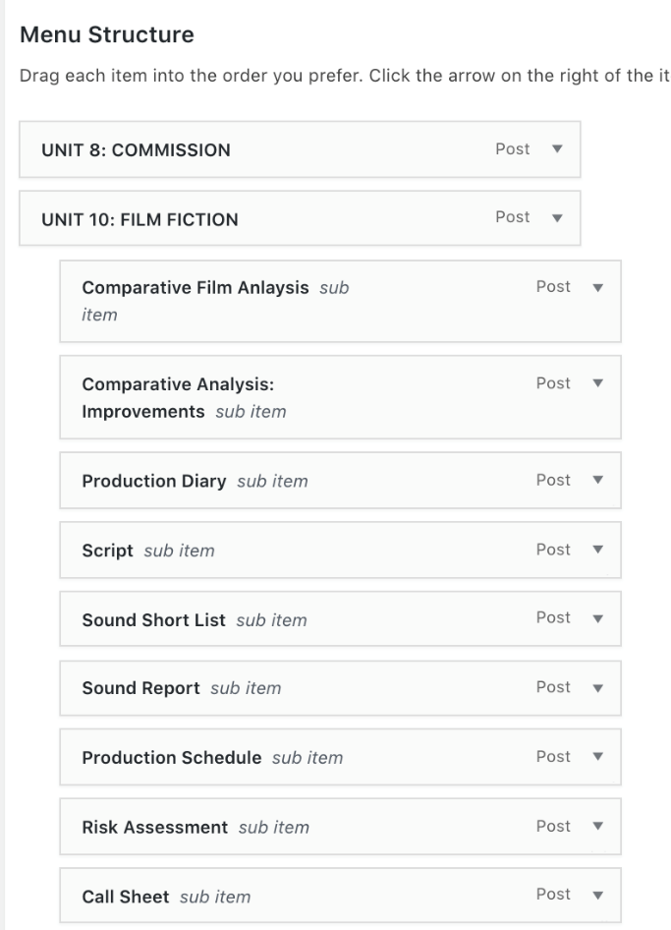

4. In the *‘****Menu Structure****’* Section on the right the posts you have selected will appear

5. **Drag and drop** to put your menu in the right order.

Make a note of the hierarchy of the menu, so work belonging to the corresponding unit needs to be dragged and dropped below and to the right.6. Then select *‘****Save Menu****’*

