Why Ultimate Software won the Fortune 100 ‘Best Company to work for’ Award 2018

**Perks and Programs**

We asked ULTIMATE SOFTWARE to share a few programs they feel really capture what's unique about their workplace. Here is what they had to say.

* **100%-Employer-Paid Premiums for Healthcare:** For employees and their family members, Ultimate pays 100% of the premiums for medical (PPO), prescription, dental, and vision coverage. Married same-sex employees enjoy this same coverage, as do part-time employees who average 30 work-hours per week for 9 months. Ultimate’s coverage includes IVF, or In Vitro Fertilization, which typically costs $20,000-$28,000 for each attempt to have a healthy baby. “I literally sat at my desk and cried tears of joy!,” said one UltiPeep after receiving CPO Viv Maza’s email about our IVF coverage. The UltiPeep had tried for 14 years to have a baby and, with IVF, she had a healthy baby girl in March 2018. IVF helped another UltiPeep have a baby girl, and she was so grateful she named the child Vivienne after our CPO Viv. A third UltiPeep was so inspired that she lost 95 pounds prior to treatment to increase her odds of success with IVF.
* **ALL Employees Given Ownership Shares:** All new hires are given restricted stock units (RSUs) when they join Ultimate, effectively making them owners of the public company. The RSU gifts tell all employees they are valuable. In June 1998, the shares were worth $9.69 each; in June 2018, they were worth $280.60 each. Throughout their careers at Ultimate, UltiPeeps continue to receive additional RSU awards, based upon their performance. UltiPeeps tell us often the great things they’ve been able to buy when cashing in shares, things they never expected to be able to afford—a college education for a child accepted to a wildly expensive school, dream home for their parents, vacation home in the Adirondacks, condo on the beach, trip to Egypt riding camels to the pyramids, family trip to Machu Picchu, BMW for a car-fanatic spouse, and so many more. Shares mean all have voting rights, and all are building equity for their futures.
* **Trust: Unlimited Paid Time Off:** Trust is an important concept at Ultimate. Our CEO Scott Scherr gives everyone a Trust Card to carry as a reminder of the importance of trusting one another. He gives the card to our customers too, as an emblem to them that we intend to earn their trust through our communication and behavior. One sign of how much our leaders trust us at Ultimate is our Unlimited Paid Time Off (UPTO) policy for rest, relaxation, and recuperation from illness. This trust goes beyond formal days off. On a routine basis, many of our mothers and fathers walk their children to school every day; others take their children to horseback riding or gymnastics lessons in the afternoon; still others randomly take time off to watch their child speak four lines in a school play. Many UltiPeeps have said that this trust and respect means more to them than their paychecks.
* **Two-Day, Expenses-Paid New-Hire Orientation:** Ultimate pays for all new employees to be flown to Weston, Florida, for a two-day new-hire orientation. After hearing formal presentations, new hires have an opportunity to meet CEO Scott Scherr, CPO Vivian Maza, and other executives one-on-one in casual venues like a barbecue tent lunch at headquarters and an old-school Italian dinner at Capriccio’s Ristorante, the restaurant where Ultimate has had countless celebrations since our founding 28 years ago. CPO Vivian treats new hires to a tour of the company headquarters that includes a visit to CEO Scott’s office, where he loves to chat about Ultimate’s history and the memorabilia from UltiPeeps on his walls. Somehow, Scott always turns the visit into a laugh fest, where everyone feels comfortable and a part of the UltiFamily. This fun-filled visit to headquarters follows their online Welcome through UltiPro Onboarding (Ultimate’s cloud HR solution), meetings with mentors, training, and department orientations.
* **Company-Sponsored Days at Luxury Locations:** All departments have reward days and trips that serve as a thank you for achievement of goals, and even includes UltiPeeps’ family members or significant others occasionally. Ultimate pays nearly all major expenses. Typical trip destinations are Disney World or Universal in Orlando, Atlantis Resort in the Bahamas, or a St. Regis hotel. Other off-site meetings focus on goal-setting while team members enjoy a Ritz Carlton, and leaders share achievements and objectives, recognize outstanding performers, and spend time with their teams. Fun activities always balance the work: fabulous food, dancing, scavenger hunts, an excursion to an aquarium, or competitive tennis matches or golf tournaments. Other times, it’s total relaxation on a beach with colleagues and their significant others—no business meetings—or it’s a weekend cruise with non-stop entertainment and relaxation. Every department does it differently, but it’s always a luxury experience, intended as a reward for good work.
* **40% 401(k) Match - No Cap:** Ultimate matches all employee contributions to the 401(k) plan at 40% with no cap on the matching amount (unlike some companies that, for example, may match at 50% but limit or cap the match to the first 4% of the employee’s salary, making the match effectively 2%). In 2019, the match will become 45%. Ultimate also gives this matching amount to employees every pay period rather than waiting until the year's end. Ultimate’s 401(k) match is a great example of “FOR ALL” rewards since Ultimate has over the years increased the matching percentage multiple times as a reward to all of our employees for an achievement we have all contributed to.
* **Communities of Interest: Including ALL:** Ultimate has companywide Communities of Interest (COIs), rooted in equality, diversity, inclusivity, and cultural intelligence, with the goal to promote specific interests—and including all. Our first COI was founded by and for lesbian, gay, bisexual, transgender, queer/questioning, intersex, and ally (LGBTQIA) team members, and is called PRIDEUS. The PRIDEUS acronym stands for: People Respecting Individual Differences Empowering Ultimate Software. Consistent with our objective of inclusivity, “allies” are welcome to join any COI, participate, and advocate. Last year, for Interoffice Pride Week, PRIDEUS streamed a course called Trans 101 that introduced relevant terminology, dispelled myths, shared results of studies, and increased overall understanding of LGBTQIA people. We now have four COI groups at Ultimate: PRIDEUS, Women in Leadership (WIL), UltiVETS for veterans, and UltiHOPE, which provides support for cancer patients, survivors, and caregivers. All these groups make education part of their mission, and they raise funds for relevant charities.
* **Three Paid Days for Charity:** At an estimated annual value of $7.9 million, everyone at Ultimate has 3 fully paid days a year to spend helping charities. UltiPeeps often donate time as a group, but they can participate in a program of their own choice alone. Many charities Ultimate supports were selected by employees. One employee lost her father to a drunk driver in 2009, and has since spearheaded Ultimate’s participation in Mothers Against Drunk Driving. In 2017, for the seventh year, Ultimate was the top fundraising MADD team in the nation. We have charity-oriented projects at team meetings, such as building bicycles, assembling backpacks with school supplies, or collecting shoes for needy children. 2018 is Ultimate’s 10th year working with Habitat for Humanity. Another of our many giving partnerships is Arc Broward, an organization that helps children and adults with developmental disabilities. Giving back is a high priority at Ultimate, and all offices participate.
* **Amazing, Frequent Celebrations:** Halloween is our most fun companywide celebration. All offices participate. Even our virtual employees get together to celebrate. Some traditional competitions are for best individual and team costumes, pumpkin-carving, workspace-decorating, apple bobbing, and mummy wrapping. At headquarters, our top executives participate, too, wearing comical costumes relevant to the year’s theme—last year was Dr. Seuss (so imagine the outfits!)—and we have a costume parade that children from our families join. The groups ham it up with music, dancing, singing, skits, and candy as bribes for the judges and audience. Other celebrations include: confetti-laden events for unfurling banners when we achieve financial objectives or win a place on the 100 Best Companies to Work For list, birthdays and anniversaries at Ultimate, baby and wedding showers, Thanksgiving and year-end holidays, and many others events like Black History Month, Pride Week, and even a “May the Fourth” Star Wars celebration with costumes.
* **Opportunities to Innovate:** At Ultimate, innovation springs from our fundamentals of collaboration, diversity, and inclusion. Ultimate believes that many voices make for stronger creative ideation than a singular, authoritative voice. We also believe that those to be impacted by an innovation need to be involved in ideating. Still, it is likely our culture of openness that makes innovation so unusually successful at Ultimate. For example, three UltiPeeps initiated out-of-the-blue a new process for brainstorming they call LightStarters, and leadership welcomed it. For years, our Product Development team has hosted a 48-hour coding event, where individual engineers and teams can work on an innovation of their choice. Our Innovation team now invites all UltiPeeps to suggest innovations for the teams to pursue, and the request for input is streamed to reach all UltiPeeps. All Ultimate departments now have similar innovation events, and all offer trophies and awards for the best innovative ideas.

COMPENSATION BY THE NUMBERS

|  |  |
| --- | --- |
| **40%** Match of employee’s 401(k)/403b contribution up to 100% of salary | **100%** Company-paid health coverage for employees |
| **100%** Company-paid health coverage for dependents | **100%** Company-paid health coverage for part-timers |
| **30 hours** Weekly hours required for part-timers to receive health insurance | **$3,690** Average Tuition Reimbursement |

COMPENSATION PROGRAMS

|  |  |
| --- | --- |
| * 401(k) or 403b Program | * Restricted stock units |
|  |  |

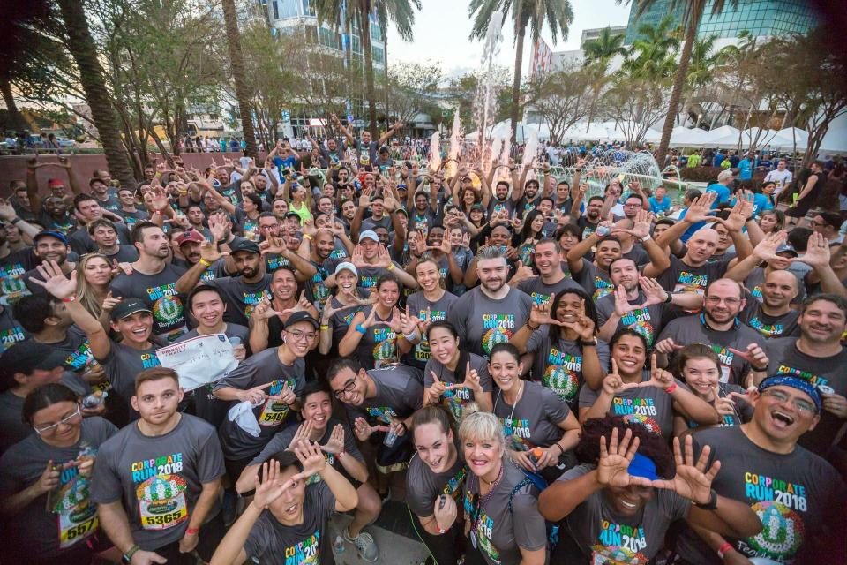

“Ultimate has largest team at Ft. Lauderdale Corporate Run” Courtesy: ULTIMATE SOFTWARE

WORK-LIFE BALANCE BY THE NUMBERS

|  |  |
| --- | --- |
| **Unlimited** Vacation Paid time off | **7 days** Paid time off after one year of part-time employment |
| **8 days** Paid sick days after one year of part-time employment | **Unlimited** Paid time off as of first day of full-time employment |
| **7 days** Paid time off as of first day of part-time employment |  |

WORK-LIFE BALANCE PROGRAMS

|  |  |
| --- | --- |
| * Flexible schedule (30% use it) | * Telecommute option (50% use it) |
| * Compressed work weeks (5% use it) | * Subsidized On- or Off-site Fitness (55% have access) |
|  |  |
| * Onsite Amenities (--Frequent free food [fresh, chef-prepared food at headquarters, food machines at all sites, frequent buffet breakfasts/catered lunches, periodic barbecues, food trucks, smoothie and ice cream trucks, lunches & dinners at upscale restaurant] --Free coffee, espresso, and Cuban coffee --Break rooms with televisions, food & drink machines, refrigerators, microwaves, Vitamix blenders for peeps to make their own smoothies, etc. --Farmers Market at headquarters for home meals --Starbucks location at headquarters in Weston --Subsidized massages on site [professional masseuse] --Acupuncturist onsite for periodic sessions --Yoga, meditation, and exercise classes on site --Many wellness classes, including cupping and stretching --Exercise bikes & treadmills on site [with trays to read or work while exercising] --Game rooms at all locations [e.g. foosball, bumper pool, ping pong, chess, etc] --Wii & Xbox setups Basketball court onsite Private, sound-proof room for practicing presentations Golf putting green onsite, inside Large fish tank for relaxing atmosphere at office Onsite ATM at headquarters Car washing available at some locations Onsite, immediate technical help via TechSpots set up at all locations) | |

FAMILY CARE BY THE NUMBERS

|  |  |
| --- | --- |
| **60 days** Job-protected maternity leave (including FMLA/STD) | **50 days** Fully-paid maternity leave (does not include personal vacation or paid time off) |
| **60 days** Job-protected paternity leave (including FMLA) | **50 days** Job-protected parental leave for adoptive parents (including FMLA) |
| **50 days** Fully-paid parental leave for adoptive parents (does not include personal vacation or paid time off) |  |

*Employees are not required to use all their personal paid time off before taking parental leave.

FAMILY CARE PROGRAMS

|  |  |
| --- | --- |
| * On-site or near-site backup childcare center | * Lactation room(s) |
| * Paid sick leave to care for a child or relative |  |

HEALTH INSURANCE COVERS

|  |  |
| --- | --- |
| * Mental health care | * Alternative treatments (such as acupuncture, homeopathy, or chiropractic) |
| * Fertility treatments |  |

Community and Environmental Impact

|  |  |
| --- | --- |
| **24 hours** Paid time off to volunteer | **$2,693,000** Philanthropic donations in last year |
| **$590,000** Total company-matched employee donations in last year |  |

Diversity

* DIRECTOR of Diversity, Equity and Inclusion---reporting to CPO, oversees diversity and inclusion practices
* Written policy prohibits discrimination based on (at a minimum) age, disability, race/ethnicity, religious beliefs, gender and sexual orientation
* Formal programs (such as resource groups, mentorship, networking, or other affinity groups) support professional development for: Under-represented racial/ethnic minority groups; Women; Lesbian, gay, bisexual or transgender employees
* 8 events a year connect employees with peers from different racial/ethnic, religious or country-of-origin identities
* Medical care covers gender confirmation surgery

Leadership Diversity

Female Executives42% Women58% Men

| **Women** | **Percentage** |
| --- | --- |
| 58% Men | 58 |
| 42% Women | 42 |

**Female Executives**

Minority Executives95% Non-Minorities

| **Minority** | **Percentage** |
| --- | --- |
| 95% Non-Minorities | 95 |
| 5% Minorities | 5 |

**Minority Executives**

Female Mid-Level Managers40% Women60% Men

| **Women** | **Percentage** |
| --- | --- |
| 60% Men | 60 |
| 40% Women | 40 |

**Female Mid-Level Managers**

Minority Mid-Level Managers24% Minorities76% Non-Minorities

| **Minority** | **Percentage** |
| --- | --- |
| 76% Non-Minorities | 76 |
| 24% Minorities | 24 |

**76 (76%)**

Female Frontline Managers or Supervisors45% Women55% Men

| **Women** | **Percentage** |
| --- | --- |
| 55% Men | 55 |
| 45% Women | 45 |

**Female Frontline Managers or Supervisors**

Minority Frontline Managers or Supervisors35% Minorities65% Non-Minorities

| **Minority** | **Percentage** |
| --- | --- |
| 65% Non-Minorities | 65 |
| 35% Minorities | 35 |

**Minority Frontline Managers or Supervisors**

Workforce Diversity

Race/EthnicityMinoritiesNon-Minorities

| **Workplace Diversity** | **Percentage** |
| --- | --- |
| Minorities | 44 |
| Non-Minorities | 56 |

**44 (44%)**

Gender49% Female51% Male

| **Gender** | **Percent male, female** |
| --- | --- |
| 51% Male | 51 |
| 49% Female | 49 |
| 0% Others | 0 |

**Gender**

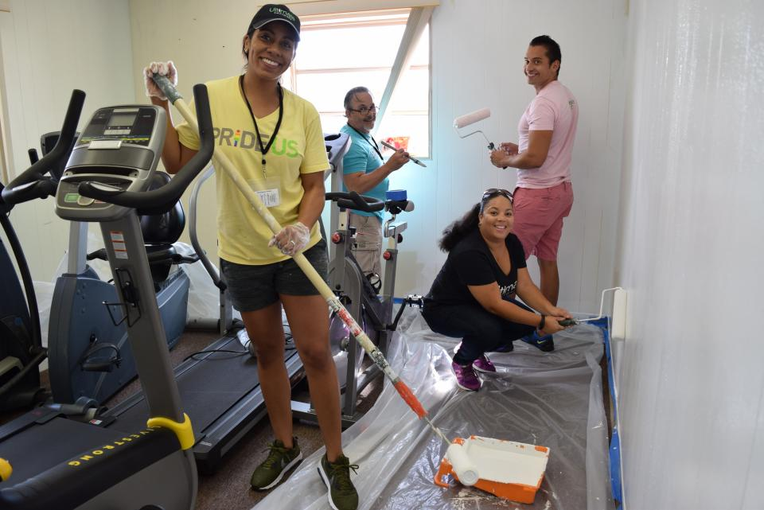

“Ultimate's PRIDEUS Group Volunteers at Poverello Center” Courtesy: ULTIMATE SOFTWARE

DEMOGRAPHICS

GenerationSilent GenerationBaby BoomersGen XMillennialsPost-Millennials015304560

| **Generation** | **Percentage** |
| --- | --- |
| Silent Generation | 0 |
| Baby Boomers | 14 |
| Gen X | 45 |
| Millennials | 42 |
| Post-Millennials | 0 |

**Generation**

Full Part Time97% Full Time

| **Full Part Time** | **Percentage** |
| --- | --- |
| 97% Full Time | 97 |
| 3% Part Time | 3 |

**Full Part Time**

Tenure< 2 YEARS2 TO 5 YEARS6 TO 10 YEARS11 TO 15 YEARS16 TO 20 YEARSOVER 20 YEARS010203040

| **COM_GPTW_VIEW_REVIEW_CHARTS_TENURE, true** | **Percentage** |
| --- | --- |
| < 2 YEARS | 35 |
| 2 TO 5 YEARS | 33 |
| 6 TO 10 YEARS | 20 |
| 11 TO 15 YEARS | 7 |
| 16 TO 20 YEARS | 3 |
| OVER 20 YEARS | 2 |

**Tenure**