Style | Place | Key artists | Aims | Characteristics | Key work | Influences
Academic | Paris  London | Alexandre Cabanel  Henri Gervex | - Academic artists followed the teachings of the academies (art colleges).  - An emphasis on accurate drawing  - Their works were conservative in subject matter and designed to inspire noble feelings, ‘grand’ thoughts | - Mythological, religious, allegorical, historical subjects- often linked to the classical era  - Idealised figures  - Polished surfaces with finely blended colours and a very ‘finished’ appearance. | 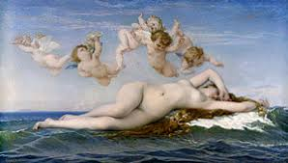 | Neoclassical forms combined with the warm colours of Romanticism
Realism | Paris | Gustave Courbet  Edouard Manet

Style | Place | Key artists | Aims | Characteristics | Key work | Influences
Impressionism | Paris | Monet  Renoir  Morisot
Victorian | Britain | Powell Frith  John Gibson  Gilbert Scott

Style | Place | Key artists | Aims | Characteristics | Key work | Influences
Pre-Raphaelite  Brotherhood/ | London | Millais  Holman Hunt  Ford Madox Brown  John William Waterhouse |  |  | 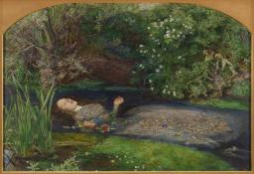
Pre-Raphaelitism | Britain
Pre-Raphaelitism | Britain

Style | Place | Key artists | Aims | Characteristics | Key work | Influences
Post-Impressionism | France | Gauguin
Other-  Avant-garde | Europe | Rodin | Art which often defies a specific stylisation or categorisation. Art which is ahead of its time and rejects the pre-eminent style of the period.

Art Nouveau | France, then internationally
Arts & Crafts | Britain, then internationally
Gothic Revival | Britain
Other-  Second Empire | Paris |  | Art and architecture in France during the period of Napoleon III’s reign Fromm 1852 to 1870. | - Classical motifs  - Large scale, epic architectural design.  - Ornate, elaborate decoration |  | 1. Baroque grandeur  2. Neoclassical symmetry

