**BTEC yr1**

Unit 8 prep

*This document will help you to get organised and remain productive over the Christmas break*

-Ensure your **Rationale** notes document is 80% completed [ ]

-You have created some notes regarding your **Pitch** [ ]

-You have created some notes regarding your **Proposal** [ ]

-You have created some notes regarding your **Justification** [ ]

- You need to source a **blank USB pen drive**, to use on 12th Jan. [ ]

PTO

*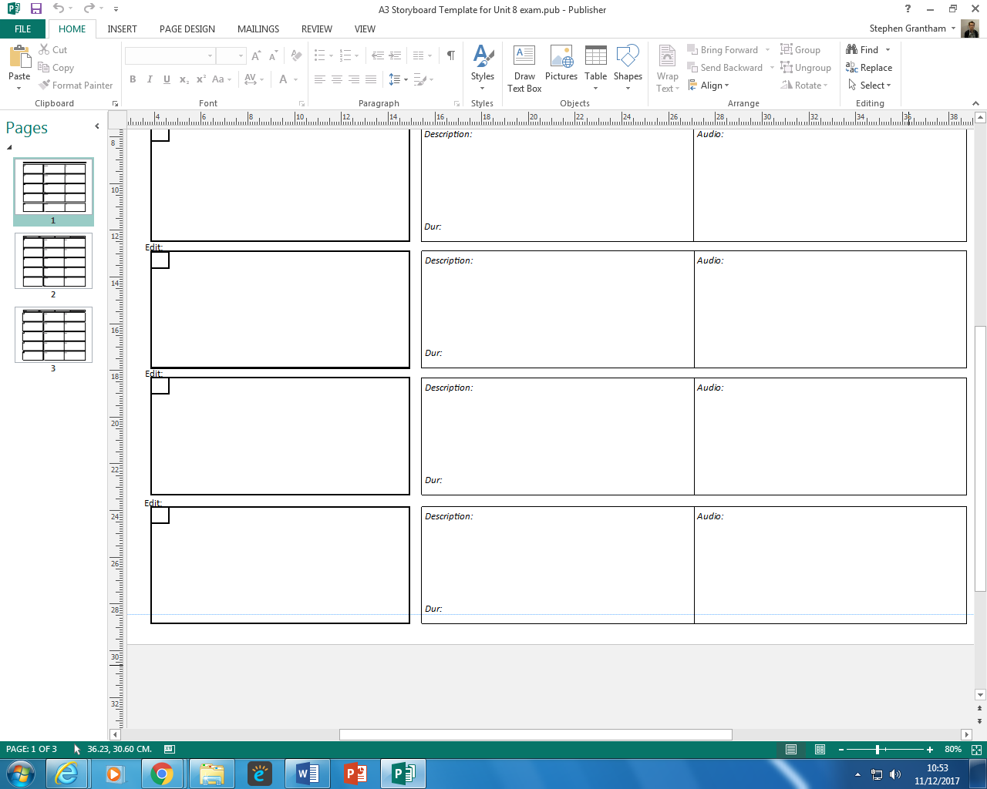You now have the opportunity to practice draw some* ***Storyboard*** *frames and handwrite some* ***Justifications*** *(Justifications will of course be* *typed in the exam).*

Justification:



Justification: