RESEARCH

**Columbine High School Massacre**

The **Columbine High School massacre** occurred on Tuesday, April 20, 1999, at Columbine High School in Columbine, an unincorporated area of Jefferson County, Colorado, United States, near Denver and Littleton. Two senior students, Eric Harris and Dylan Klebold, embarked on a massacre, killing 12 students and 1 teacher. They also injured 21 other students directly, and three people were injured while attempting to escape. The pair then committed suicide. It is the fourth-deadliest school massacre in United States history.

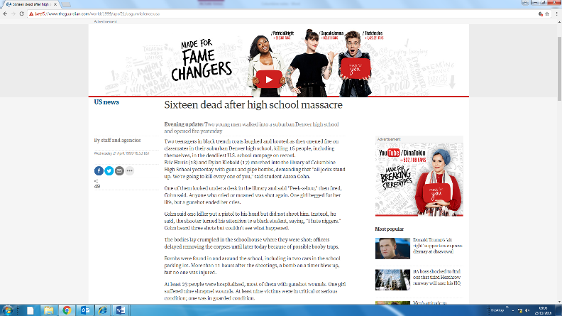[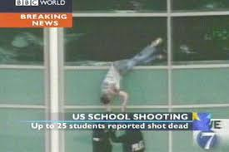](http://www.google.co.uk/imgres?start=387&biw=1280&bih=904&tbm=isch&tbnid=kbW9XlXOggb6IM:&imgrefurl=http://philadelphiareviewofbooks.com/2013/02/14/columbine-newtown-and-waiting-for-the-truth/&docid=zf8AZIVip5PuaM&imgurl=http://philabooks.files.wordpress.com/2013/02/columbine-500450019.jpg&w=615&h=409&ei=yxLgUqzOJOrR0QWgiIHQAQ&zoom=1&ved=0CKUCEIQcMGA4rAI&iact=rc&dur=573&page=15&ndsp=10)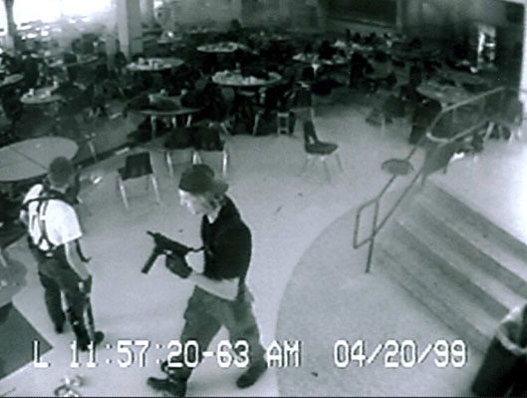

[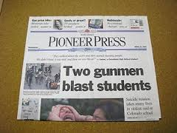](http://www.google.co.uk/imgres?sa=X&biw=1280&bih=904&tbm=isch&tbnid=Onh1IaffM1fa0M:&imgrefurl=http://www.ebay.com/itm/1999-newspaper-COLUMBINE-HIGH-SCHOOL-MASSACRE-Eric-Harris-Dylan-Klebold-/221094516925&docid=WPx6mRY_ahVfTM&imgurl=http://i.ebayimg.com/t/1999-newspaper-COLUMBINE-HIGH-SCHOOL-MASSACRE-Eric-Harris-Dylan-Klebold-/00/s/NzY4WDEwMjQ%3D/$(KGrHqV,!lcE%2B4MnPgSbBQFzBwKBBw~~60_35.JPG&w=300&h=225&ei=cRLgUvaGNcnN0QWF4YD4Ag&zoom=1&ved=0CJ8BEIQcMBU&iact=rc&dur=608&page=2&start=20&ndsp=28)