RESEARCH

**‘Hey Nostradamus!’**

*Hey Nostradamus!* is a novel by Douglas Coupland centred around a fictional 1988 school shooting in suburban Vancouver and its aftermath. It was first published in 2003. The novel comprises four first-person narratives, each from the perspective of a character directly or indirectly affected by the shooting. The novel intertwines substantial themes, including adolescent love, sex, religion, prayer and grief.

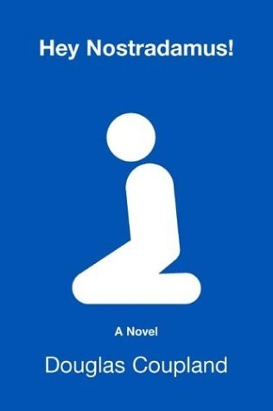

Other books by Douglas Coupland:

* [*Generation X: Tales for an Accelerated Culture*](http://en.wikipedia.org/wiki/Generation_X:_Tales_for_an_Accelerated_Culture)(1991)
* [*Shampoo Planet*](http://en.wikipedia.org/wiki/Shampoo_Planet) (1992)
* [*Life After God*](http://en.wikipedia.org/wiki/Life_After_God) (1994)
* [*Microserfs*](http://en.wikipedia.org/wiki/Microserfs) (1995)
* [*Girlfriend in a Coma*](http://en.wikipedia.org/wiki/Girlfriend_in_a_Coma_(novel)) (1998)
* [*Miss Wyoming*](http://en.wikipedia.org/wiki/Miss_Wyoming_(novel)) (2000)
* [*All Families Are Psychotic*](http://en.wikipedia.org/wiki/All_Families_Are_Psychotic) (2001)
* [*Eleanor Rigby*](http://en.wikipedia.org/wiki/Eleanor_Rigby_(novel)) (2004)
* [*jPod*](http://en.wikipedia.org/wiki/JPod) (2006)
* [*The Gum Thief*](http://en.wikipedia.org/wiki/The_Gum_Thief) (2007)
* [*Generation A*](http://en.wikipedia.org/wiki/Generation_A) (2009)

The story is loosely based on the Columbine High School massacre in 1999, which in itself has gone on to be documented in films such as *Elephant* (2003) and *We Need to Talk About Kevin* (2011).