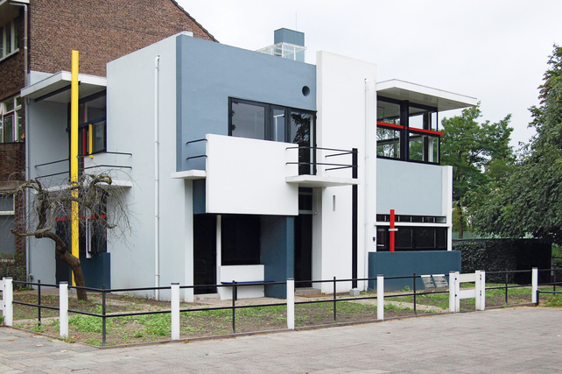Key work: Schroder House

* **Architect:** Gerrit Rietveld
* **Scope of work for Pearson A Level:** Private house by a non-French architect
* **Date**: 1924
* **Location**: Utrecht, Netherlands
* **Patron:** Truus Schroder
* **Research**: Use this website: <https://www.rietveldschroderhuis.nl/en>
* **Read** this article: <https://www.telegraph.co.uk/lifestyle/interiors/7036984/Interior-design-The-Schroder-House-in-Utrecht.html>

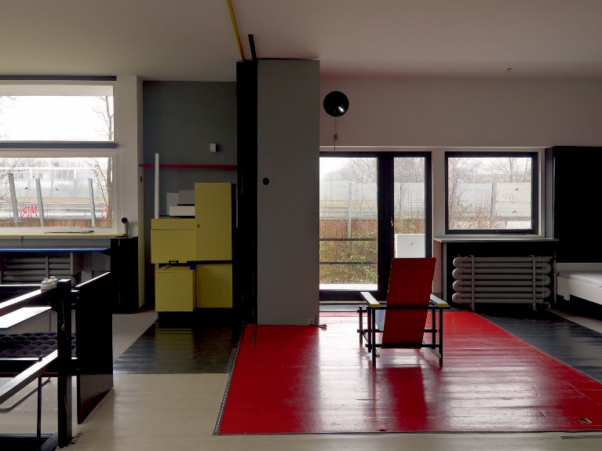**Critical comment:**

"Gerrit Rietveld worked closely in collaboration with the client for this house. More than any other, this is either—in Banham's words—'a cardboard Mondrian' or an enormous piece of furniture masquerading as a house. All windows could only be opened up completely, at right angles to frames, repeating the devices by which the upper floor could be transformed from one single space into a series of smaller ones—the point being that in either positioning of windows or moveable walls, the house retained its neoplastic hypothesis."

**—David Dunster.** Key Buildings of the Twentieth Century Volume 1: Houses 1900-1944. p24.

"...We didn't avoid older styles because they were ugly, or because we couldn't reproduce them, but because our own times demanded their own form, I mean, their own manifestation. It was of course extremely difficult to achieve all this in spite of the building regulations and that's why the interior of the downstairs part of the house is somewhat traditional, I mean with fixed walls. But upstairs we simply called it and 'attic' and that's where we actually made the house we wanted."

**—Gerrit Rietveld**

|  |  |
| --- | --- |
| The best known De Stijl ("the style") work was produced by [Gerrit Rietveld](http://www.greatbuildings.com/architects/Gerrit_Rietveld.html) (1888-1964), whose [Schröder House](http://www.greatbuildings.com/buildings/Schroder_House.html) at Utrecht is the most complete realization of the movement's ideas. It is a rectilinear block made up of complex, interpenetrating planes of wall, roof, and projecting decks, with voids filled by glass in metal sash.  The (upper) main living floor is divided by a system of sliding panels that permit rearrangement to achieve varying degrees of openness. Built-in and movable furniture of Rietveld's design is geometric and abstract in concept. Only primary colors and black are introduced within the generally white and gray tones of most surfaces.  Because of its few members, short life, and limited accomplishments, De Stijl influence in the development of modernism has been less obvious than that of the pioneers in Germany and France. **by John Pile** |  |