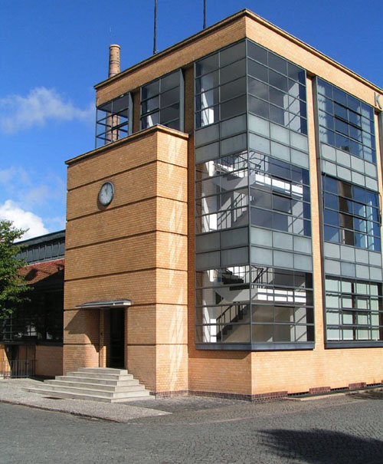The Fagus Factory

Walter Gropius

1911

The **Fagus Factory** (German: Fagus Fabrik or Fagus Werk) is a shoe factory in in Germany, an important example of early modern architecture. Commissioned by owner Carl Benscheidt, the factory was designed by the architect Eduard Werner, with facades designed by [Walter Gropius](http://en.wikipedia.org/wiki/Walter_Gropius) and [Adolf Meyer](http://en.wikipedia.org/wiki/Adolf_Meyer). It was constructed between 1911 and 1913, with additions and interiors completed in 1925.

For the first time a complete facade is conceived in glassflat roof has also changed. Only in the buildings by Adolf Loos which was done one year before the Fagus Factory, have we seen the same feeling for the pure cube. Another exceedingly important quality of Gropius's building is that, thanks to the large expanses of clear glass, the usual hard separation of exterior and interior is annihilated.

—Nikolaus Pevsner , *Pioneers of Modern Design*[[1]](http://en.wikipedia.org/wiki/Fagus_Factory#cite_note-0)

The building that had the greater influence on the design of Fagus was AEG’s Turbine factory designed by [Peter Behrens](http://en.wikipedia.org/wiki/Peter_Behrens). Both Gropius and Meyer had worked on the project and with Fagus they presented their interpretation and criticism of their teacher’s work. The Fagus main building can be seen as an inversion of the Turbine factory. They both have corners free of supports and glass surfaces between piers that cover the whole height of the building. However, in the Turbine factory the corners are covered by heavy elements that slant inside. The glass surfaces also slant inside and are recessed in relation to the piers. The load-bearing elements are attenuated and the building has an image of stability and monumentality. In Fagus exactly the opposite happens; the corners are left open and the piers are recessed leaving the glass surface to the front

[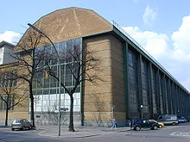](http://en.wikipedia.org/wiki/File:AEG_by_Peter_Behrens.jpg)

[http://bits.wikimedia.org/skins-1.5/common/images/magnify-clip.png](http://en.wikipedia.org/wiki/File:AEG_by_Peter_Behrens.jpg)

AEG Turbine Factory by [Peter Behrens](http://en.wikipedia.org/wiki/Peter_Behrens), 1910