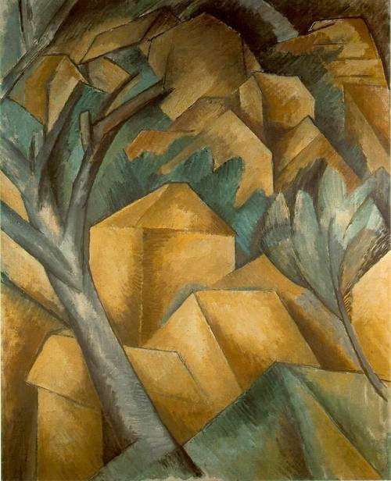

Explain the ways in which this painting is associated with Cubism *(5 marks)*

Braque’s Houses at L’Estaque (1908) is an example of Early or Facet Cubism. It takes the subject of the French village of L’Estaque as its starting point, but renders the landscape scene in a highly simplified and experimental way. (This choice of landscape as subject matter is itself typical of this first stage of Cubism which ran from 1908-10.) Braque had been inspired by the Cezanne Retrospective of the previous year and returned to his earlier, Fauvist haunt, to continue his search for a new pictorial language. He renders the space in a flattened way, with no horizon line or sky, nor any use of orthogonals or traditional linear perspective. Instead, he shows an awareness of the picture surface by modulating the rectilinear blocks of the houses with careful use of light and tone.

This shading highlights the Cubism interest in both multiple perspectives and multiple light sources and gives the work definition despite its (again typically Cubist) reduced colour palette of browns and greens. Here, though the facets are large and still easily readable as houses. At this stage, Picasso and Braque were signed up with Daniel Kahnweiler as ‘Gallery Cubists’ and were able to experiment freely on small scale works without worrying about sale or impact. The composition is Cubist in that it is complex, cluttered and uses extensive cropping: the tree to the left of the canvas is cropped at both top and bottom which serves again to flatten the space.