

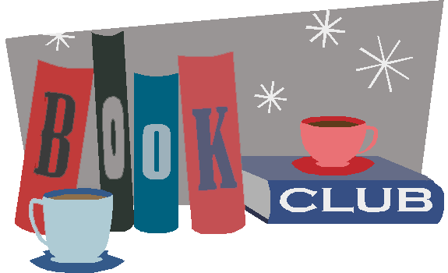

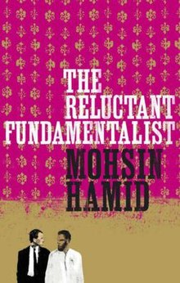**Monday 19 February 2018**

**‘The Reluctant Fundamentalist’** by Mohsin Hamid, first published in 2007. Selected by Harvard, Princeton and a string of other East Coast ‘Ivy League’ unis, as their Freshman text of choice, I was interested to hear the responses of 2018 Godalming College students to this frame story, recounting a single conversation between a young man from Pakistan and an American visitor.

The vote of approval was unanimous with the whole group participating in a challenging and thought-provoking discussion which spanned diversity, rights, reactions, literary techniques, politics, women’s rights and freedom of expression. Without giving the game away (and there is a fascinating finish to Hamid’s story), we would recommend this to all Godalming College students. Essential reading and, we are pleased to say, many parents got told to read it too…. Ideas like these are better shared.

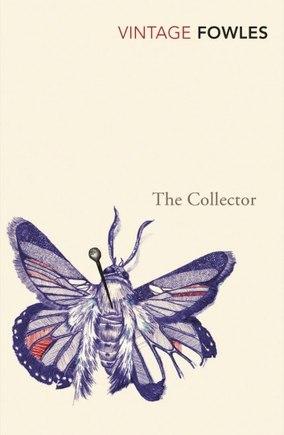Next up by popular vote:

**Monday 16 April 2018**

**John Fowles ‘The Collector’**

Withdrawn, uneducated and unloved, Frederick collects butterflies and takes photographs. He is obsessed with a beautiful stranger, the art student Miranda. When he wins the pools, he buys a remote Sussex house and calmly abducts Miranda, believing she will grow to love him in time. Alone and desperate, Miranda must struggle to overcome her own prejudices and contempt if she is understand her captor, and so gain her freedom.

If you have read the book, please join us….

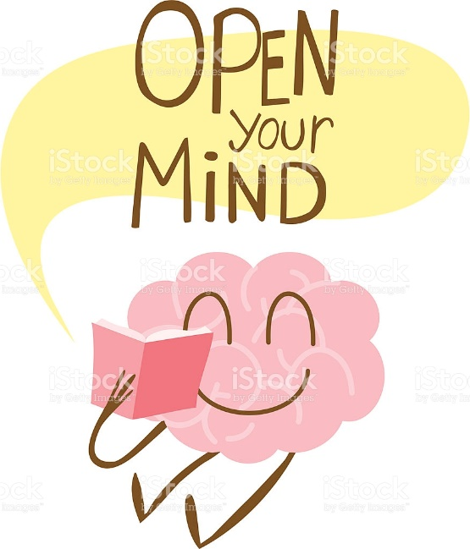**Inspiration in a weekend?**

Here are a string of Sarah’s recommendations for short novels that will get you thinking and will, hopefully, inspire you. They are all short and can be read in a weekend, so find a sofa or café near you and enjoy….. See how many you can get through? And then tell us which one/s you liked best?

* Edith Wharton ‘Ethan Frome’
* Ian McEwan ‘Amsterdam’
* Virginia Woolf ‘A Room of One’s Own’
* Ray Bradbury ‘Fahrenheit 451’
* Toni Morrison ‘Sula’
* Cynan Jones ‘The Dig’
* Chimamanda Adichie ‘We should all be feminists’
* George Orwell ‘Animal Farm’
* Brian Friel ‘Translations’
* Albert Camus ‘The Stranger’
* Aleksandr Solzhenitsyn ‘One Day in the Life of Ivan Denisovitch’
* Jean Rhys ‘Wide Sargasso Sea’
* Gabriel Garcia Marquez ‘Innocent Erendita’
* Italo Calvino ‘Invisible Cities’
* Herman Hesse ‘Siddhartha’
* Charlotte Gilman Perkins ‘The Yellow Wallpaper’
* Elie Wiesel ‘Night’

**Further recommendations from the Book Club crew:**

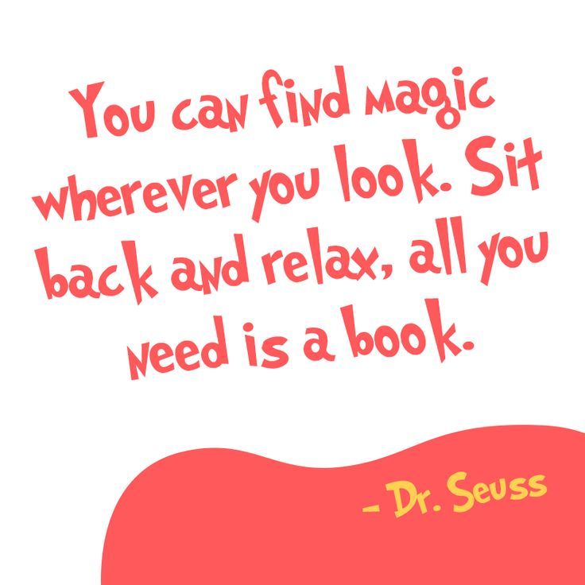And here’s a list of other texts we (as a group) have read and loved. We’d recommend any or all of them – follow your interests and preferences, or branch out and challenge yourself…..

* Gillian Flynn ‘Sharp Objects’
* Naomi Alderman ‘The Power’
* Philip Pullman ‘The Book of Dust’ AND ‘Daemon Voices’ (and obviously, the Northern Lights – if you haven’t read these yet, you are missing out!)
* George Orwell ‘1984’
* Craig Lancaster ‘500 hours of Edward’
* Hester O’Neill ‘Lullabies for little criminals’
* Kathryn Stockett ‘The Help’
* F Scott Fitzgerald ‘The Great Gatsby’
* Charlotte Bronte ‘Jane Eyre’
* Graeme Simsion ‘The Rosie Project’
* Emma Donaghue ‘Room’
* Iain Banks ‘The Wasp Factory’
* Dante Alighieri ‘Divine Comedy: inferno’
* Edward Albee ‘Who’s afraid of Virginia Woolf?’
* Michael Frayn ‘Spies’
* Neil Gaiman ‘American Gods’
* EM Forster ‘A Room with a view’
* Alice Walker ‘Colour Purple’
* Chimanada Adichie ‘Half a Yellow Sun’
* Sarah Perry ‘The Essex Serpent’
* Sebastian Faulks ‘Engelby’