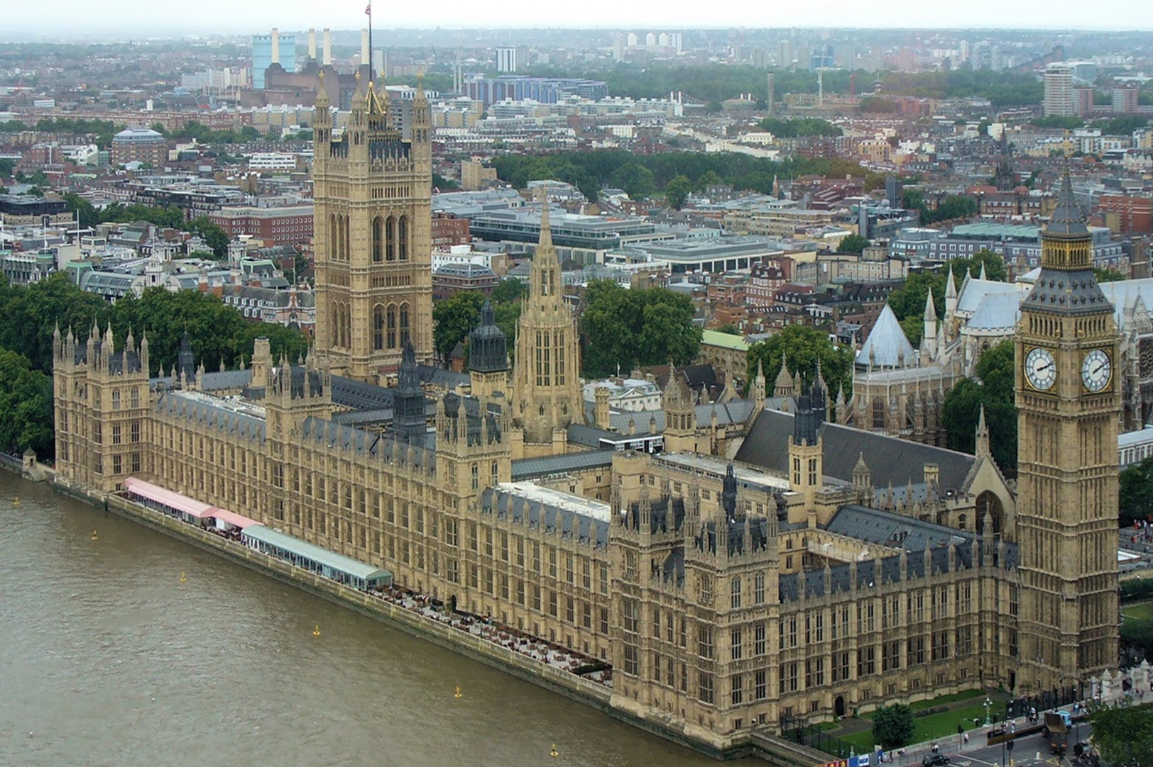

Charles Barry, *The New Palace of Westminster*, rebuilt 1840-1876, London. Interior by A. W. Pugin