Constructed 107-113AD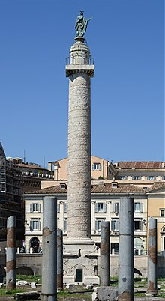

Location:

Commissioned by:

Era:

Material:

Height:

Category of sculpture:

Sculpture technique:

Who was Trajan:

Who was the leader of the Dacians:

How many wars did Trajan fight against the Dacians?:

Why did the Romans go to war against the Dacians?:

Outcome of each war:

Duration of each war:

Dacia is now known as:

Public buildings placed either side of column:

The purpose of those buildings:

Construction technique of column:

Description of frieze’s contents:

How many times does Trajan appear in battle scenes on the column:

Give an example of a more recent column celebrating military victory: