|  |  |
| --- | --- |
| Artist | Henri Matisse |
| Title | Blue Nude (Souvenir de Biskra) |
| Date | 1907 |
| Medium | Oil on canvas |
| Scale | 92.1 x 140.3 cm |
| Scope | Female figure |
| Style | (late) Fauvism |
| Patron | None |
| Location | Painted in Biskra (Algeria), currently held in Baltimore Museum of Art |
| Function | n/a |

|  |  |
| --- | --- |
| Formal features | |
| Composition | Cropped. Central figure is framed by flowers and plants. |
| Colour or texture | Emphasis on blue surrounding the figure. Otherwise colourful natural colours surround. |
| Light & tone | Heavy shading and outlines, mainly on breasts and legs. Light source seems to come from the top, suggested by lighter colours. |
| Space & depth or relief | Flattened pictorial space. |
| Line or brushwork | Visible expressive brushstrokes throughout. Heavy outline on figure. |

Image: 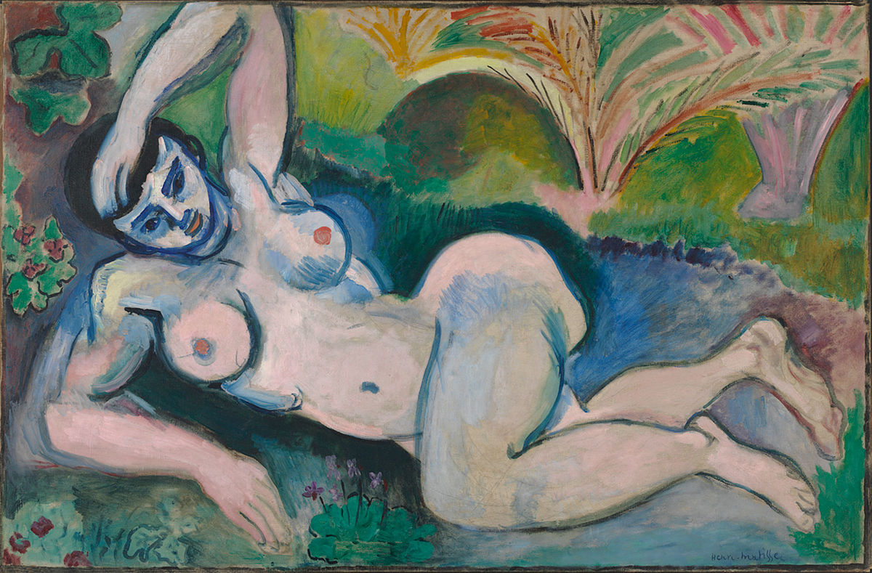

Use or development of materials, techniques & processes:

* Highly visible brushstrokes.
* Visible pentimento around left breast and elbow.
* Variation in facture, alternation between impasto and diluted paint at the figure’s feet.
* Preliminary sketch is left visible beneath left knee.

Stylistic comment and artistic influence:

Influence of primitivism shown: Exaggeration of buttocks and breasts, thick eyebrows, almond shaped eyes, plants suggest exotic location, blue hatching on left breast recalls striated African carvings, simplified and angular figure.

Critical text quote:

Perate – “Impetuous, violent, furious and outrageous painting.”

Influence from technological factors:

Turns away from machines and presentation of urban life.

Influence from political factors:

Initiation of the colonisation of Morocco – confronted the contemporary audience with a lack of racial identity. Not being able to distinguish race from appearance was a fear of the time due to colonialization and the lack of control they may have if they can’t identify race.

Influence from cultural/social factors:

Competitively influenced by Picasso at the forefront of modernism (Picasso painted Le Demoiselles d’Avignon in the same year).