|  |  |
| --- | --- |
| Artist | Constantin Brancusi (1876-1957) |
| Title | Adam and Eve (Adam et Eve) |
| Date | 1921 |
| Medium | Chestnut (Adam) and oak (Eve) on limestone base. |
| Scale | 238.8 x 47.6 x 46.4 cm |
| Scope | Sculpture. |
| Style | Modernism. (School of Paris movement) |
| Patron |  |
| Location | Guggenheim, New York. |
| Function |  |

|  |  |
| --- | --- |
| Formal features | |
| Composition | Wooden sculpture on a limestone base. |
| Colour or texture | The two different woods are complementary to each other, eve has a smoother surface – typically seen as more feminine. Adam is rougher, giving a more masculine feel. |
| Light & tone | Warm wood complements each other. |
| Space & depth or relief | Eve has 4 half-spherical orbs at the top, they suggest a head with lips and a mouth. A thin cylinder suggests a neck and two orbs suggest breasts. Adam is of a denser build and has a rectangular body. The neck has grooves which suggest muscles. |
| Line or brushwork | Adam is placed beneath Eve implying that he is holding her up. Adam was born from the earth (closer to the ground) and Eve was born from his rib (connecting to Adam). |

Critical text quote: Antony Gormley says his sculptural language ‘has to do with togetherness and apartness’.

Brancusi inherited ‘a familiarity and love of wood as a medium from his native [Romanian] tradition’ – Sidney Geist.

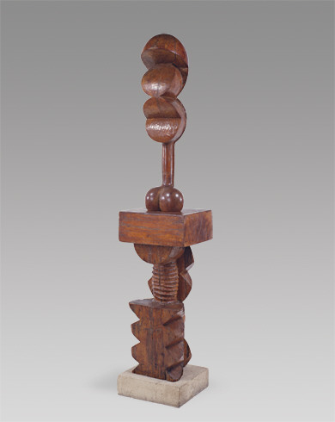

Use or development of materials, techniques & processes:

Direct carving, limestone is rough and earthy, it could refer to Adam’s birth from the dust. The two woods show different attribute to both Adam and Eve e.g. oak having a smoother grain. The two sculptures, when placed together, look as one.

Stylistic comment and artistic influence:

Influence from Gauguin’s use of direct carving. ‘Primitive’ serrated patterns typical of African carvings appear on Adam. Use of Rodin’s method of fragmentation, allowing him to eliminate parts of the anatomy for expressive purposes. Romanian wood carving.

Influence from technological factors: He was interested in photography, he photographed many of his sculptures and turned to Man Ray for guidance. He was interested in forms of flight but is not too relevant to this sculpture.

Influence from political factors: He was not a political activist.

Influence from cultural/social factors: He was a shepherd when he was 7! So according to a friend ‘his teachers were Life and Nature’. Paris was a decadent, free-spirited poor but irreverent world that was a magnet to artists, he was among the Fauves to Picasso.

He was interested in new theories of the fourth dimension, presented by Henri Poincare. Owned two of Henri Bergson’s books ‘Material and Memory’ and ‘The Creative Evolution’.