|  |  |
| --- | --- |
| Artist | Marcel Duchamp |
| Title | Fountain |
| Date | 1917 |
| Medium | Porcelain – replica is made from glazed earthenware painted to resemble the original porcelain |
| Scale | 360 x 480 x 610 mm (standard urinal) |
| Scope | Widely seen as the icon of 20th century art |
| Style | Dada movement |
| Patron | Marcel Duchamp |
| Location | Replica 1964 – Tate (original is lost) |
| Function | Taking an everyday object and turning it into a visual pun |

|  |  |
| --- | --- |
| Formal features | |
| Composition | Presented on its back rather than upright.  Symmetrical composition. |
| Colour or texture | The urinal is white, normally portraying purity which is mocking the idea of cleanliness. |
| Light & tone |  |
| Space & depth or relief |  |
| Line or brushwork | Duchamp applied a fake signature to it, of the urinal companies name, spelling it ‘Mutt’ instead of ‘Mott – the signature references to ‘poverty’ which also challenges the company. |

Image:

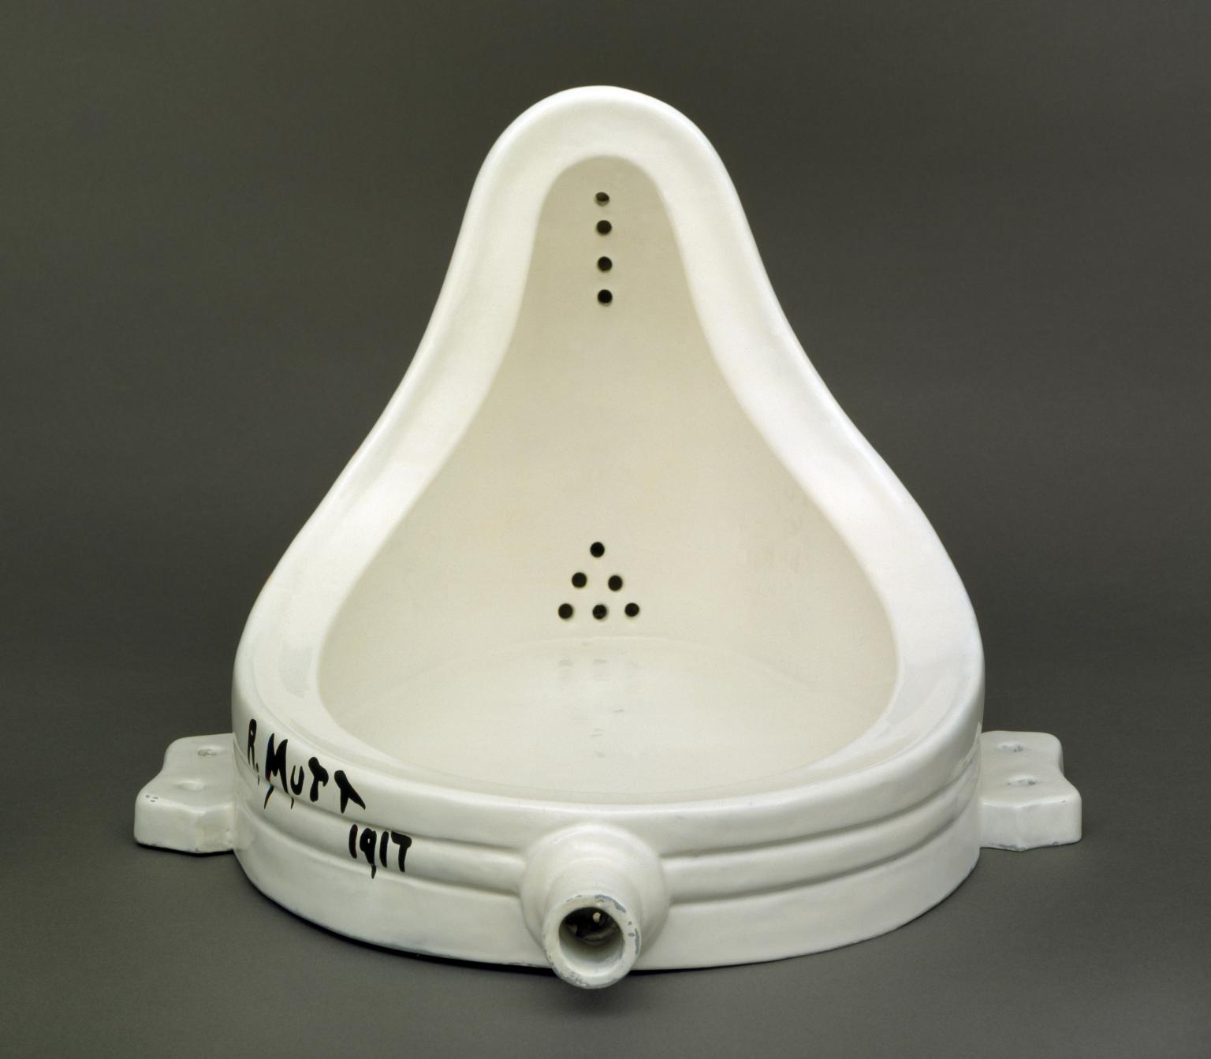

Influence from technological factors:

Critical text quote:

‘A piece of mischief at the expense of the art world’ – John Passmore

‘If *this* can be art, then anything can’ – Smith

‘Duchamp did not select just any ready-made object to display. In selecting the urinal, his message was clear: Art is something you piss on’ – Philosopher, Stephan Hicks

Stylistic comment and artistic influence:

This urinal inspired Andy Warhol and Tracey Emin to reconsider the traditional artwork. Instead of paintings and sculptures, art was suddenly everyday objects removed from their original contexts on display in art galleries.

Influence from cultural/social factors:

Duchamp set out to shock and disrupt the average.

He took delight in disturbing and outraging people with his radical approach.

Duchamp described his intent with the piece was to shift the focus of art from physical craft to intellectual interpretation

Use or development of materials, techniques & processes:

Duchamp took an ordinary everyday object, placed it so that its useful significance disappeared under a new title and point of view – which created a new thought for the object.

Influence from political factors:

Duchamp was anti-art and anti-war.

Fountain epitomises the assault on convention and accepted concepts of art for which Duchamp became known.

Duchamp’s declaration of war against the art establishment.