|  |  |
| --- | --- |
| Artist | Hannah Hoch |
| Title | Cut with a Kitchen Knife Dada Through the Last Weimar Beer-Belly Cultural Epoch of Germany |
| Date | 1919-1920 |
| Medium | Collaged, mixed media |
| Scale | 88.9cm x 144.78cm |
| Scope | No specific scene |
| Style | Dada |
| Patron |  |
| Location | Nationalgalerie, Staatliche Museen zu Berlin |
| Function | To encapsulate the political crisis of the time, respond to the zeitgeist |

|  |  |
| --- | --- |
| Formal features | |
| Composition | Scattered composition, no focal point- possibly commenting on the unstable political climate at the time in Germany. The pictures are arranged in a way, that means the piece can be split into quarters- top left, Dada Propagand, Lower Left, Dada Persuasion, Lower Right, Dadaists and Top Right, Anti Dadaists- referencing the division in the country at the time. |
| Colour or texture | The colour is relatively monochrome, this is due to the medium used, as coloured printing had not been popularized at that point. However, Hannah Hoch painted on to the base, yellow and blue |
| Light & tone | As the work is made up of black and white newspaper clippings the light and dark is more defined. Areas are made up of darker images- most noticeably in the top right corner- the anti-Dada, section. |
| Space & depth or relief | The piece plays with ideas of space and depth through proportions of the figures- as they are made up from multiple different photos, certain aspects of the figures are brought forward, making it appear incoherent and distorted. There is no space created around the images, therefore abandoning all ideas of linear and aerial perspective. These aspects all create a sense of chaos with in the peace- turbulent political climate. |
| Line or brushwork | There is a distinct line created between the images and the page they are stuck on, however there is no intentional outlines, this adds a feeling of uncontained energy to the work as they aren’t held with in lines. |

Critical text quote:

“energetically anarchic”

“praised as a great assault on German Politics”

“I would like to show the world today as an ant sees it and tomorrow as the moon see’s it”-Hannah Hoch

Robert Hughes “most aestheticallt gifted’ of her generation

Image: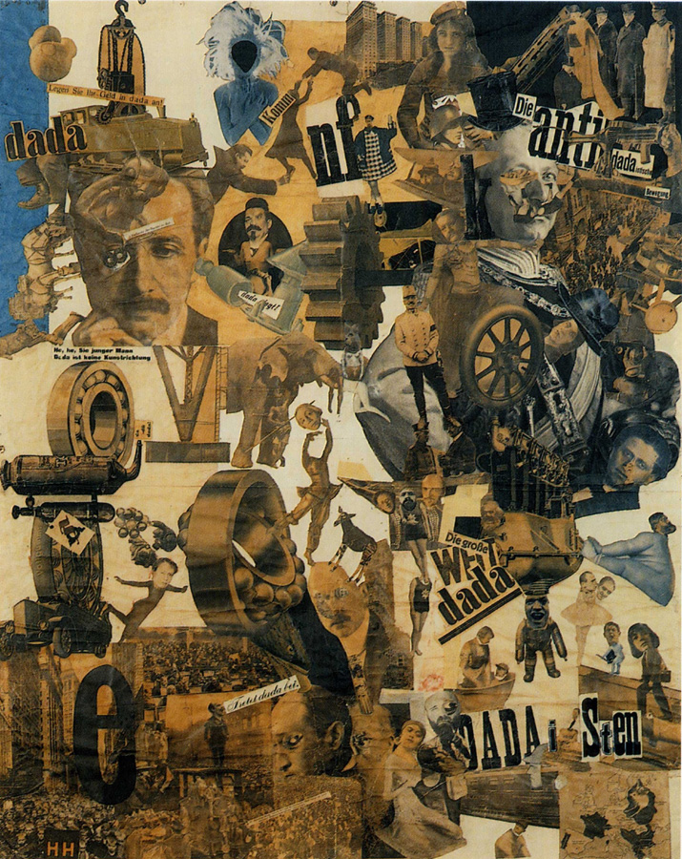

Stylistic comment and artistic influence:

-Raoul Hausman, her lover, also did collaged and mixed media works like Hoch and was also a Dada artist

-Is almost multifaceted and fairly monochrome as well as using ideas of collage from Cubism

- Kathe Kollwitz- similarly a female, German artist whose work reflected society in Germany at the time- focusing on the poverty.

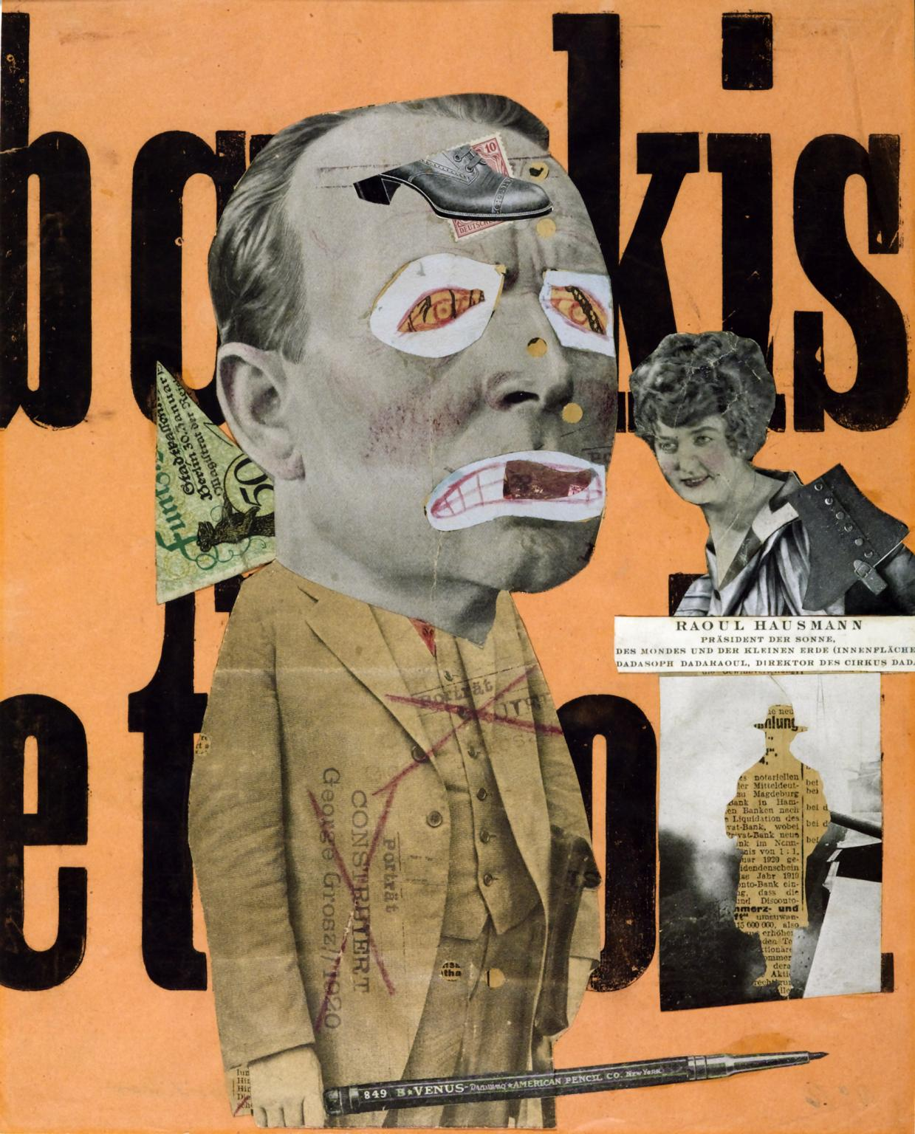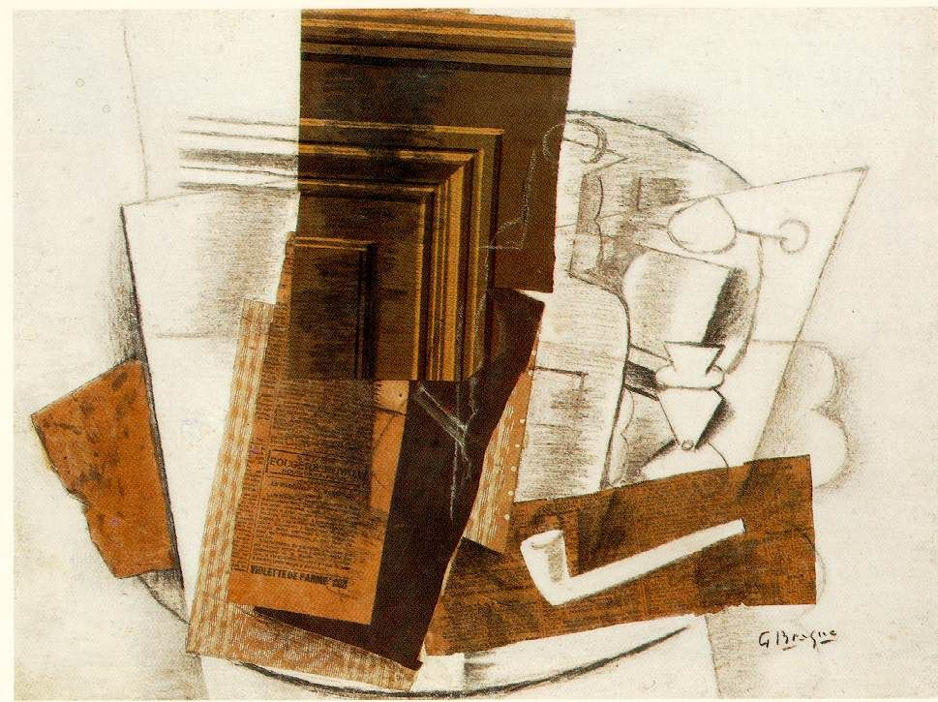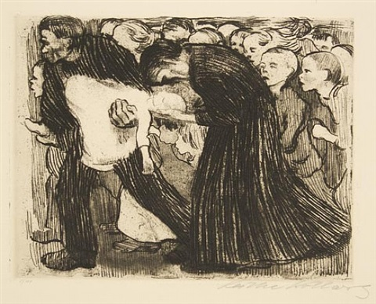

Use or development of materials, techniques & processes:

Hannah Hoch took the new technique of collage and using mixed media materials from the Cubists, however unlike, Hannah Hoch didn’t then work on top of them but instead made her clippings the art itself. As well as this Hannah Hock explored purely using clippings from the media, as this best reflected society at the time. This also fits with Dada’s ideas against ownership of art (anti artist) as she is in a way using other people’s art work as her materials for her own art work

Influence from political factors:

When this work was made-1919-20- there was political chaos in Germany, after losing WW1. The Treaty of Versaille meant Germany was in debt and still destroyed and required a new system of democracy in the Government. This was different to the ‘strong Leader’ they were used too- Kaiser Wilhelm II, who’s photo is the most prominent figure in the Anti-Dada section, with his mustache is replaced with wrestling legs. This led to instability with in the German Government, with many uprisings and attempted coups. This includes the Sparticist (communist, left wing party) uprising 1919, led by Karl Liebknecht- who was executed because of the uprising- and Rosa Luxenburg- who was murdered in the uprising by the Freikorp. Karl is in the top left corner- Dada persuasion- alongside Ebert the President of Germany at the time. In the Anti- Dada section, next to the Kaiser is General Hindenburg, a recognised war hero, and strong supporter of the Freikorp- a right wing group of ex-soldiers, used as a kind of police force. In the bottom right corner- Dadaist’s- the heads of Lenin- a communist, Russian revolutionary- and Karl Rabek- Communist party leader in Germany, are placed on the bodies of small female performers. Also in this corner is a cut out head of Karl Marx- founder of Marxism, left wing ideology- saying ‘the big Dada world’.

Many prominent, political male figures are put on the bodies of female dancers, playing with ideas of gender and emasculating and stripping them of their power.

Influence from technological factors:

Throughout the piece the cogs and parts of machinery are found exploding from the page. This references the booming industry at the time. But this isn’t shown off proudly but instead mocked, almost looking circus like. This could be in reference to the fact all this machinery had just been turned back at them in World War 1. Possibly as well it could be a reference to the German Government as a Machine that doesn’t work as all the cogs are unconnected and spread out over the page as if a machine has been taken apart

Influence from cultural/social factors:

The machinery featured in the piece references the booming development in technology. There are also many references to equality and women’s rights throughout the piece, through the map of Europe in the bottom, right hand corner, which highlights all the countries where women can vote, furthermore Kathe Kollwitz also a female, German artist’s head is placed at the centre of the composition, shown as beheaded and floating above a figure of a dancer. This shows the oppression that Hannah Hoch faced as a female artist and a woman in society. Einstein also features with in the work saying ‘Join Dada’, he was a very relevant German figure at the time as he had published his “Theory of Relativity” in 1905.