|  |  |
| --- | --- |
| Artist | Henri Matisse |
| Title | Joy of Life |
| Date | 1906 |
| Medium | Oil Paint |
| Scale | 176x240cm |
| Scope | The female figure (painting or sculpture) by a French artist  Landscape painting by a French artist |
| Style | Fauvism |
| Location | Salon des Indépendants, Paris, March 1906 |
| Function | To reject traditional academic art and emotional expression |

|  |  |
| --- | --- |
| Formal features | |
| Composition | A complicated composition, multiple groups of figures in fore, middle and background. Trees on far left and far right sides of composition which reach overhead. |
| Colour or texture | Use of bright, vibrant colour that has warmth. Use of reds and yellows, with soft pinks. |
| Light & tone | A lack of realistic light and tone to create depth. Use of light and tone on the bodies of the central figures. |
| Space & depth or relief | Groups of figures get smaller further into the background, creating an illusion of depth. Use of linear perspective in terms of a horizon line, use of orthogonal in the tree line to bring the viewers eye backwards. Lack of vanishing point. |
| Line or brushwork | Use of heavy outline on the figures. Brushwork is smooth and leaves areas of bare canvas. Not used to create texture, a flat surface but instead to celebrate the use of colour. |

Image: 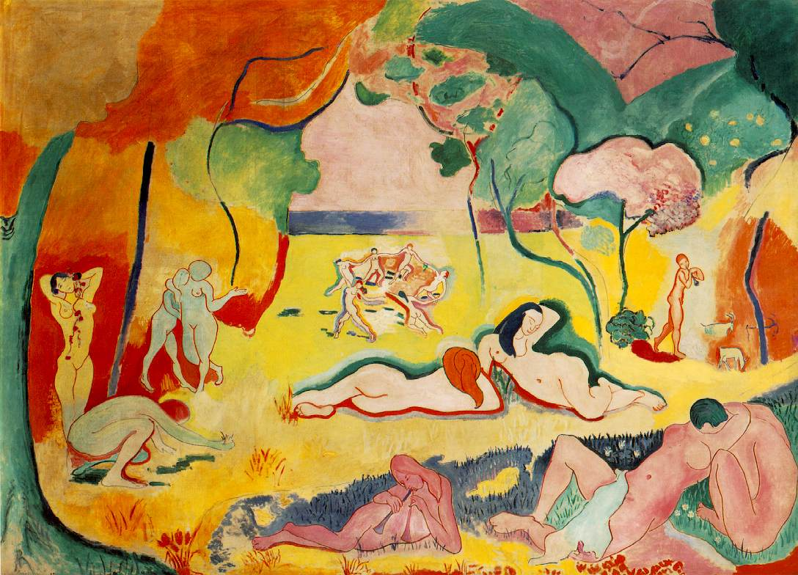

Use or development of materials, techniques & processes:

Develops on from early Fauvist work. Earlier Fauvist work used brighter and more vibrant colours, figures were more simplified and brushwork was thick and textured. This later fauvist work has developed stylistically. Use of colour is more balanced and figures have painted more stylistically.

Stylistic comment and artistic influence:

Artist has been influenced by his want to reject traditional academic art and way to make art that shows the modern age. He has also been influenced by earlier fauvist art.

Influence from technological factors:

Tubed paint

Wanting to turn the art away from the modern age where technological factors had such a huge influence on everyday life and art, and instead relating art that celebrated a simpler life based on happiness and love.

Influence from political factors:

N/A. Matisse’s art was not affected by politics. Instead he was influenced by other artists and following his own inspiration.

Influence from cultural/social factors:

Affluent middle and upper classes of 1905 were living a peaceful life, as was Matisse. He is projecting this content society through this painting.

Critical text quote:

What I dream of is an art of balance, of purity and serenity-Matisse, 1908