|  |  |
| --- | --- |
| Artist | Robert Delaunay |
| Title | Homage to Bleriot |
| Date | 1914 |
| Medium | Oil on canvas |
| Scale | 250cm x 250cm |
| Scope | Modern city |
| Style | Salon cubism/ Orphic Cubism |
| Patron |  |
| Location | Paris |
| Function | Celebrate the achievements of Bleriot |

|  |  |
| --- | --- |
| Formal features | |
| Composition | Full composition going to 3 corners unlike synthetic and analytical cubism where the focus was in the centre - You can see a glimpse of the plane 5 times throughout in different stages of flight. |
| Colour or texture | Bright saturated colours unlike in Cubism - Facets of colour – complementary colours and pairs of colours repeated throughout like orange and green in the background with the plane and in some of the rings |
| Light & tone | no tonal range within colours – because its abstracted there doesn’t need to be highlights to make it realistic – a bit of shadow in the background – still very flat perspective |
| Space & depth or relief | Cramped composition with little shadow so a flat perspective – there are no scale markers in the foreground – no horizon so no perspective |
| Line or brushwork | Flat facets of colour – visible brushwork in the background but still solid blocks of colour – no bare canvas or mark making visible |

Critical text quote:

"if there is a perceptible difference in dark-light value between the two colours, then the darker will appear to be even darker"

"all colours present in the field of vision at the same time mutually modify one another in specific ways"

Eugene Chevreul (chemist who influenced Delauney)

Influence from technological factors:

* Bleriot was an engineer and inventor
* He made the first airplane in 1909 and was the first to fly across the Channel in 1909
* Repetition of wheels and plane shapes, propellers are a recurring motif
* Eiffel tower – tallest building at the time – seen in the use of shapes

Influence from political factors:

Stylistic comment and artistic influence:

* Influenced by Fauvist and German expressionist use of bright colours
* Cubism influenced the fragments and idea of dividing the subject into facets
* Movement from Futurists
* Cezanne

Use or development of materials, techniques & processes:

* Salon Cubism was a bridge between Cubism and Abstraction. You can see him abstracting shapes and using colours across the spectrum.
* Oil on canvas

Image:

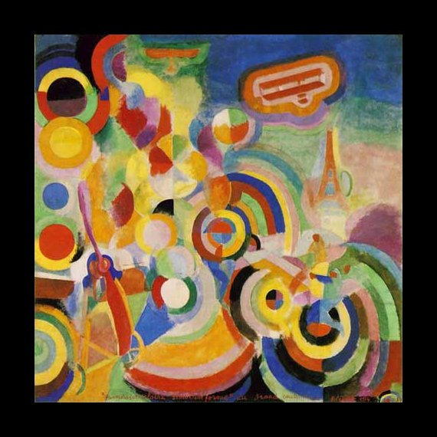

Influence from cultural/social factors:

* Salon Cubism was made to sell and exhibit so unlike the Cubists it was colourful and wasn’t made to be experimental.
* Orphists wanted to show a lyrical abstraction and saw art as bringing together the sensations of pure colour