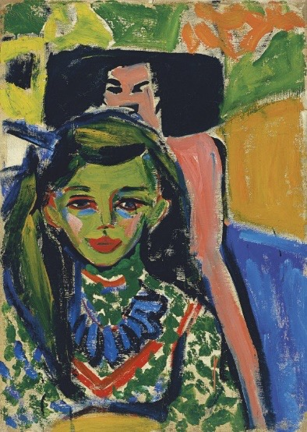

Stylistic comment and artistic influence:

The frontal placing of the sitter suggests the influence of Munch, Van Gogh and Gauguin, and also recalls primitive art.

Influence from cultural/social factors:

Die Brücke was formed in Berlin, with Kirchner being the key figure in the group. The characteristics of this style is using colour and brushstrokes to express the artists emotions. The angularity, almost gothic straight lines shows Kirchners background of being an architect. The influence from primitivism is shown through the raw painting of the chair behind Franzi, this can suggest power and become disruptive.

Influence from political factors:

Die Brücke wanted to reject German social conservatism and academic naturalism, creating this expressive style. The ideas of brutal simplicity and raw colours completely rejects traditional art at the time and offers a new way incite into art.

Influence from technological factors:

The development of photography meant that artists could use the technique of cropping to be more avant-garde.

Critical text quote:

“He who renders his inner convictions as he knows must, and does so with spontaneity and sincerity is one of us”-Kirchner

Use or development of materials, techniques & processes:

Impasto also meant that artists could become more expressive with their brushstrokes, as seen in Franzi and the background

|  |  |
| --- | --- |
| Formal features | |
| Composition | The composition is asymmetric with the sitter being in the lefthand corner of the canvas. The technique of cropping is also used so that the focus is mainly on the sitter. |
| Colour or texture | The lurid colours of greens, yellows and blues shows the rejection of idealism from traditional conventions. The face is green, the eyes and eyebrows are strongly outlined in black and the lips are bright red. All of these colours contrast with the flesh tones of the feminine silhouette around her. This is a carved chair, which is meant to symbolise a pink and black African mask. Texture is created by the harsh brushstrokes and blocks of colour. The colours in the sitter’s dress are echoed in the background to connect the elements together. |
| Light & tone | Light is created by using multiple shades of colour. For example, her face is coloured green but around the edge a darker green is placed. This sculpts Franzi’s face and adds more three dimensionality to the flat canvas. |
| Space & depth or relief | Little space and depth applied to this painting. The background consists of block colours of blue, yellow and green, which shows no sense of location. |
| Line or brushwork | Thick, unnaturalistic brushstrokes contrast sharply with theblack lines or bare canvas which accentuates the two dimensionality of the composition. There is more solid colours in her face with layers being created, evident in the sitter’s cheeks being pink over the green. Pattern is also used in Franzi’s dress and beaded necklace to show Kirchner’s experimentation with different techniques. |

|  |  |
| --- | --- |
| Artist | Ernst Ludwig Kirchner |
| Title | Franzi in front of a carved chair |
| Date | 1910 |
| Medium | oil on canvas |
| Scale | 71 x 49.5 cm |
| Scope | Portrait and German Expressionism |
| Style | Die Brücke (The Bridge) |
| Patron |  |
| Location | Thyssen-Bornemisza Museum, Madrid |
| Function |  |