Artist | Constantin Brancusi
Title | Mlle Pogany
Date | 1913
Medium | Bronze with Black Patina on Limestone Base
Scale | 43.8 x 21.5 x 31.7 cm
Scope | Female Figure, Non-French Artist
Style | Expressionism
Patron | Magrit Pogany
Location | MoMA
Function | Sculpture
Formal features
Composition | The head is considerably the largest element in the piece. Compositionally, the almond shaped eyes overwhelm the face to make Mlle Pogany seem innocent and almost ‘cute’ as the connotations with large eyes are with a baby or small, innocent child. The hands placed together as well as the head are the focal points of the composition as they are the largest most recognisable forms in the compact amount of space that this bust takes up.
Colour or texture | The bronze gives a metallic shine to the surface of the sculpture and enhances the idea of ‘reflection’ as the reflective surface mirrors the viewer as well as the actual bust being in a reflective and peaceful position. The contrast between the black and bronze make it seem stylised and bold.
Light & tone | The reflectiveness of the material adds to the light as it reflects light as well as the tone being seen through the fact that the sculpture is three dimensional and stands on its own as a form, thus showing tone.
Space & depth or relief | The sculpture is a relief sculpture as, again it stands on its own. However, the elements within that are tightly compacted with the hands in a prayerful position kept close to the face and therefore having a somewhat light relief as is also shown on the face where the eyes and nose as well as the mouth are.
Line or brushwork | The lines within the piece are mostly curved with almond like forms such as the eyes and head, with the hands almost curved around the face. These interestingly are perceived as peaceful lines with softness as opposed to harsh straight lines.
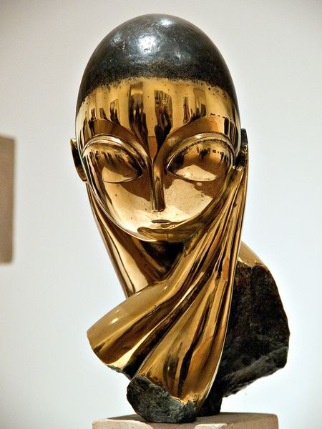
Use or development of materials, techniques & processes:
Originally, Brancusi used direct carving for this piece, there are many variations and replicas of this work. Some made of marble, some of stone and in this case; was cast into bronze. The bronze will have been made from a mould and then have had bronze poured into it. The series of works show a progression in simplicity of form and colour. The processes and materials slowly evolve over the years.
Stylistic comment and artistic influence:
The work is a significant departure from conventional portraiture. This piece may have been influenced by a religious statue like an early Christian statue similar to ones found within a catholic shrine or have a similar concept to a protestant ‘holding cross’. The sculpture is clearly a symbolic sign of peace and tranquillity.

Critical text quote:
Nothing says simplicity like the sculpture of Constantin Brancusi……paring subjects down to their barest essentials. – Ralph Blumenthal
Influence from technological factors:
This piece gives a nod to ancient materials – bronze casting, marble, stone etc. However, Brancusi uses direct carving and through showing the progression from one form to another, slowly shows the progression of life and natural movement.
Influence from political factors:
At the time (1913) War was brewing in Europe and so in a way Brancusi may have been trying to show the qualities of peace and tranquillity in an uplifting way as if to promote it during a time of unrest.

Influence from cultural/social factors:
Arguably, Brancusi sets out to ignore cultural or social influences, however, perhaps influences could include ancient marble busts as women were often idealised in these sculptures and in a way, Brancusi also does this as he makes the woman seem demure and doe eyed with a long elegant neck and passive hand gesture with a small mouth. All of these things arguably tie in with the idea of idealised beauty and Brancusi is clearly challenging this. However, this goes against what most would consider the norm at the time – Brancusi appears to be increasingly simplifying and pairing down to a ‘pure’ form – not what was happening in society at that time.

