Artist | Salvador Dali  Influence from political factors: ‘At that time, the Surrealist refusal was total, and absolutely incapable of allowing itself to be channelled at a political level. All the institutions upon which the modern world rested - and which had just shown their worth in the First World War - were considered aberrant and scandalous to us.’-André Breton The radical art movement Dada had a fierce hatred of authority and religion and was a natural ally. Dada, in many ways a precursor and influence on Surrealism, had emerged in Zurich in 1916 as a reaction to the savagery and slaughter of the World War. Dalí has long been alleged to have had fascist sympathies, a charge that goes back to the 1930’s and perhaps originated with his fellow Surrealists, especially André Breton, who put Dalí on “trial” in 1934 for “the glorification of Hitlerian fascism” and expelled him from the movement. The Surrealists, most of whom were communists, were provoked by Dalí’s disdain for their politics. It’s also true that Dalí seemed to publicly profess an admiration for Hitler.  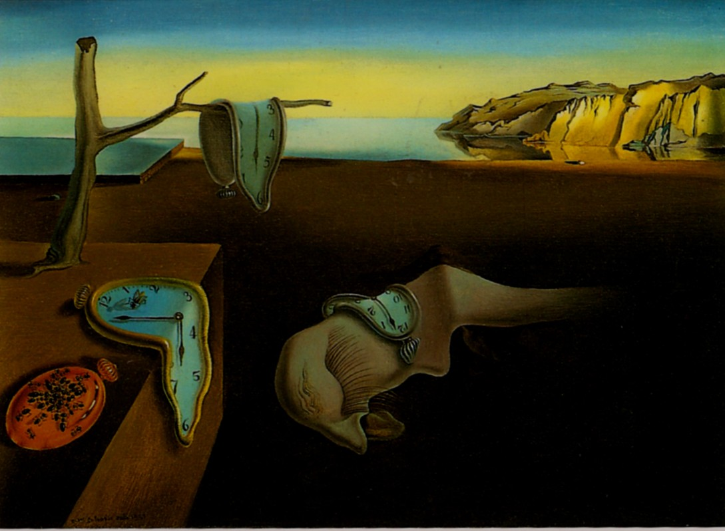
Title | The Persistence of Memory
Date | 1931
Medium | Oil on Canvas
Scale | 24 cm x 33 cm (small scale)
Scope | Dreamscape (evokes dreams and challenges perceptions)
Style | Surrealism
Patron | No patron ( he wanted to experiment without influence)
Location | ‎Museum of Modern Art, New York City
Function | To experiment with the new style (“Surrealism is destructive,” he explained, “but it destroys only what it considers to be shackles limiting our vision.”)
Formal features
Composition | The overall composition is spread out and objects are randomly placed within the painting. There are still life objects placed in the bottom right corner and cliffs in the background. There is no focal point but a hazy horizon line with more land than sky. It has an unconnected composition (flat beach but 3D objects). The figure in the middle of the picture symbolizes a fading creature, often when you dream you cannot pin-point the exact form of a creature.
Colour or texture | The colours are realistic, however slightly idealised and heavenly in the background relating to the sub conscious. The drooping nature of the clocks and the bright primary colours in the painting complement each other, giving it a dream like feel.
Light & tone | There is use of shadow in in the painting, showing the solidity of the objects. It is realistic but has inconsistent light and tone. There are shadows on the coffin from various viewpoints which shows no obvious light source. There is also strong light and tone on the horizon line in the background (merging it into a possibility of heaven, waves, sea and sky).
Space & depth or relief | There is a random juxtaposition of objects which is most likely inspired by the Dada movement. Blue sky and cliffs foretell objects to appear larger. The space between the objects represents the disconnection and lack of sense in dreams and that random things appear without any relevance.
Line or brushwork | Minute brushstrokes seen in eyelashes and ants. Lack of detail in the background and on the beach links in with the uncertainty of the unconscious and dreams. There is an accurate depiction of reality by his detailed brushwork in the cliffs which link to his clear memory of childhood.

Use or development of materials, techniques & processes:
When Dalí painted The Persistence of Memory, his artistic practice was guided by the peculiar “paranoiac-critical method.” Developed by the artist in 1930, the technique relies on self-induced paranoia and hallucinations to facilitate a work of art. This method was particularly instrumental in the creation of Dalí’s “hand-painted dream photographs,” a collection of works that are stylistically rooted in realism yet unrealistic in subject matter.
Dalí lends it material form through the double image, creates a representation which, without transforming its outer appearance, forms a second image, so that viewers looking at them can discern both of them.

Influence from cultural/social factors:
As they developed their philosophy they felt that while Dada rejected categories and labels, Surrealism would advocate the idea that ordinary and depictive expressions are vital and important, but that the sense of their arrangement must be open to the full range of imagination according to the Hegelian Dialectic. They also looked to the Marxist dialectic and the work of such theorists as Walter Benjamin and Herbert Marcuse.
The orange clock at the bottom left of the painting is covered in ants. Dali often used ants in his paintings as a symbol for death, as well as a symbol of female genitalia. The figure in the middle of the picture symbolizes a fading creature, often when you dream you cannot pin-point the exact form of a creature. The creature resembles the artist's own face in profile; its long eyelashes seem insect-like or even sexual. The iconography of this painting is of a dream that Dali had experienced. Freud's work with free association, dream analysis and the hidden unconscious was of the upmost importance to the Surrealists in developing methods to liberate imagination.
Stylistic comment and artistic influence:
Breton wrote the Manifesto in 1924 and in it he outlined the aims of the movement, the influences and examples of Surrealist works. Freud's work with free association, dream analysis and the hidden unconscious was of the utmost importance to the Surrealists in developing methods to liberate imagination. However, they embraced idiosyncrasy, while rejecting the idea of an underlying madness or darkness of the mind. (Later the idiosyncratic Salvador Dalí explained it as: "There is only one difference between a madman and me. I am not mad.”. He made many art works influenced by Picasso’s ‘The interpretation of Dreams’. His classical influences included Raphael, Bronzino, Francisco de Zurbaran, Vermeer, and Velázquez. The melting watches symbolises the irrelevance of time, and suggests Einstein's theory that time is relative and not fixed.
Critical text quote:
“I don't do drugs. I am drugs.”-Dali
"There is only one difference between a madman and me. I am not mad.”-Dali
“Surrealism is destructive, but it destroys only what it considers to be shackles limiting our vision.”-Dali
“Hand-painted dream photographs”-Dali

Influence from technological factors:
The painting can be seen as a landscape, still life and a portrait painting, showing how Dali’s sub-conscious mind incorporated various aspects of life. The Surrealists going into the unconscious allows them do depict a scene that the camera couldn’t.
Dali was fascinated by science, he was living at the Residencia de Estudiantes in Madrid, a centre whose mind-set advocated an ongoing dialogue between sciences and arts and acted as a place open to receiving the international vanguards. The Residencia was also a forum for debating and disseminating the intellectual life of between-wars Europe, presented directly by its main figures. We cannot be sure that Dalí attended those talks, but we can state that he was interested in such matters. This is shown by a photograph of Federico García Lorca with the painter, who is holding a copy of the journal Science and Invention from 1927.
The decade of the 1930s was marked by an interest in double images and optical illusions, an obsession that was to remain with Dalí throughout his work. Surrealism was also influenced by modern physics, developed over the preceding ten years and to become another key element in Dalí's painting and writing in the thirties.

