|  |  |
| --- | --- |
| Artist | Picasso |
| Title | Les Demoiselle d’avignon |
| Date | 1907 |
| Medium | Oil on canvas |
| Scale | 244cm by 234cm |
| Scope | Female nude, primitivism figure handling, avant-garde |
| Style | cubist |
| Patron | Bought but not made for Jacques Doucet |
| Location | Spain |
| Function | To experiment with a new way of painting |

|  |  |
| --- | --- |
| Formal features | |
| Composition | * It is an asymmetric and angular composition |
| Colour or texture | * The earthy, ochre and peach tones draw a correlation to cave paintings * The blue area which is highly scaffolded with white could be a curtain and starkly contrasts the rest of the components |
| Light & tone | * Tone and light come in from different places all over the piece * The darkest areas as a whole are coming from behind the curtain where the upper right figure stands |
| Space & depth or relief | * This scattered different lighting allows no 3D illusion but more of a 2D or flat crumpled appearance like foil |
| Line or brushwork | * He also uses dark black and grey/white lines to break up the composition and segments |

Use or development of materials, techniques & processes:

Taking paintings from different perspectives

Stylistic comment and artistic influence:

El Greco – Opening of the Fifth Seal

Gauguin’s – Oviri

Link made by Steinburg to Manets Olympia (gaze)

The second left figure has a similar pose to Titans Venus of Urbino

Image: 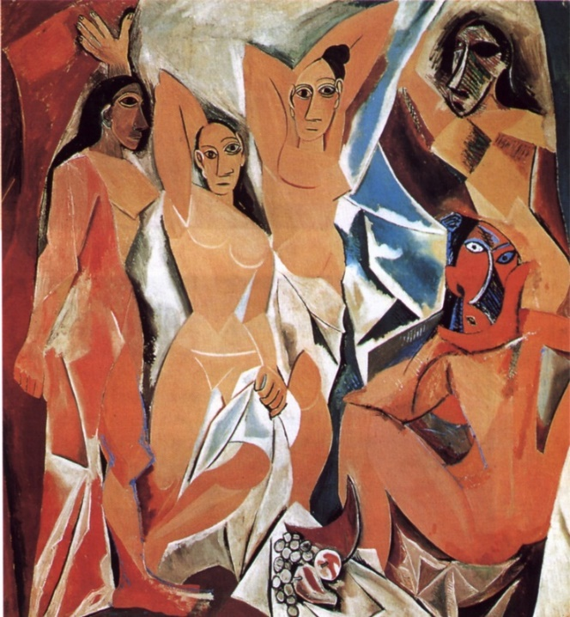

Critical text quote:

“This is the beginning of Cubism, the first upsurge, a desperate titanic clash with all of the problems at once”. - Kahnweiler

Influence from technological factors:

The creation of the camera and photography meant that it was no longer necessary or the trend to have a portrait done rather a photo taken so artist therefore had to find new ways and subjects to paint

Cubists focused on the idea that cameras could only capture one viewpoint and not the soul or the full object so the experimented with multiple perspectives on the same plane

Influence from political factors:

N/A

Influence from cultural/social factors:

Cave paintings - **Lascaux cave** (discovered in Spain in 1875)and other discovered around the time

Primitive artifacts easily accessible due to colonisation

* Iberian art