Artist | Brancusi  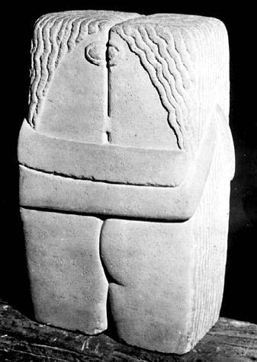
Title | The Kiss
Date | 1908
Medium | Limestone
Scale | Fairly small
Scope | Plaster sculpture
Style | Proto-Cubist
Patron | John Quinn (Brancusi’s Patron in New York)
Location | The Muzeul de Arta at Craiova, Romania.
Function | N/A
Formal features
Composition | Two simplified figures, kissing, with their arms around each other.
Colour or texture | Grey, no added colour.  Rough texture.
Light & tone | Shallow indents give off shadows, but no extensive detail.
Space & depth or relief | Retains the shape of a cube, very minimal additions to show they are two figures.
Line or brushwork | Pointed focus on horizontal and vertical lines.
Use or development of materials, techniques & processes: Brancusi’s change to more radical art coincides with the discovery of African art in Paris. It was suggested he was looking at Egyptian ‘Cube figures’ in the Louvre. He was more focused on conveying emotion rather than beauty-shown through minimal parts and use of appropriate materials. Primitive influence seen in the simplified, basic eyes.
Critical text quote: ‘a product of the primitivizing impulse of the opening of the 20th century’-Sidney Geist
Stylistic comment and artistic influence:
Brancusi’s fascination with both the forms and spirituality of African, Assyrian, and Egyptian art, led him to use direct carving to sculpt this piece.
Influence from technological factors:
-Direct carving rather than a traditional approach.
-Metro system in Paris was new and the entrances were Art Nouveau in style.
Influence from political factors:
-He’s not a political activist.

Influence from cultural/social factors:
-rejection of traditional training and Academic values (seen in direct carving, lack of decoration, his use of refinement and simplicity)

