|  |  |
| --- | --- |
| Artist | Boccioni |
| Title | The Street enters the house |
| Date | 1912 |
| Medium | Oil on canvas |
| Scale | 100 x 100cm |
| Scope | Modern urban life by an Italian painter |
| Style | Futurism |
| Patron | N/A |
| Location | Italy |
| Function |  |

|  |  |
| --- | --- |
| Formal features | |
| Composition | The composition is crowded and overwhelming it is as if the street is actually entering the house. |
| Colour or texture | Very simple but bold colours are used such as reds and blues as well as oranges and whites. |
| Light & tone | Light is directed onto the background of the composition and the viewers eye is immediately drawn to the white distorted houses in the background. |
| Space & depth or relief | The painting itself is quite flat, typical of the futurist style. The orthogonals of the construction poles lead the viewers eye to the back, they also line the sides of the painting. |
| Line or brushwork | The brushwork is mostly blended. The lines of the top of the houses draw the viewers eye back. |

Image: 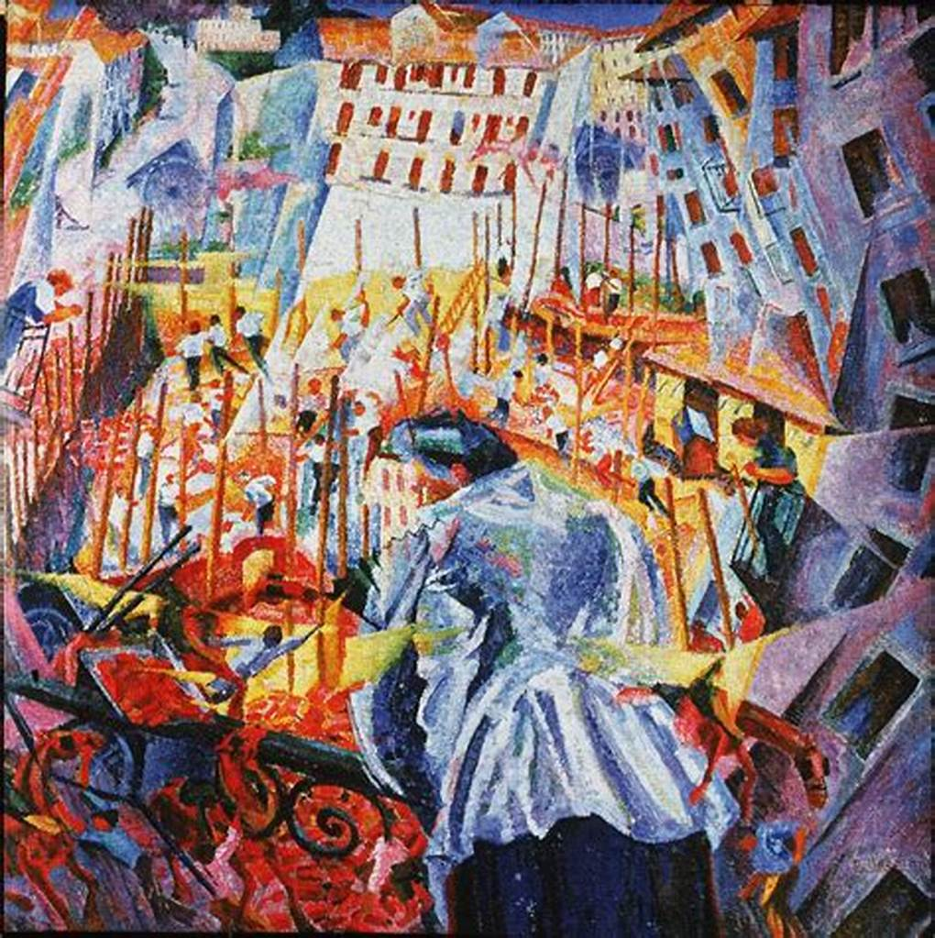

Use or development of materials, techniques & processes:

The scale of this work is small scale this may be because it was a very experimental style. They use oil on canvas.

Stylistic comment and artistic influence:

In the early days there is clear influence from the Italian divisionism this then evolves to a clear influence of cubism as the landscape is broken down into smaller cubes. Influences of Severini who introduced the futurist group to cubism in 1911.

Critical text quote: “We want to represent not the optical or analytical impression, but the psychical and total experience.” (Boccioni, 1911)

Influence from technological factors: The figure in the centre of the composition can be seen from behind and is seen in a multi-faceted view. This is because of the influence of Roentgen rays also known as x-rays which had been discovered in 1895. This is also as you can see other figures through her clothes and she is seemingly studied from all sides. There is also scaffolding surrounding the woman in the background this is to show the new buildings that were going up at this time.

Influence from political factors: in the 1860’s people protested against the unification of Italy. They assume as they’ve got a new unified country they can say goodbye to the old traditions. Mussolini also liked futurism as it was seen as a serge of modernity and a new Italy which was what Mussolini was aiming for.

Influence from cultural/social factors: Futurists wanted to celebrate the new industries and the new modern Italy and turn their backs on their old cultural heritage such as the Renaissance. They sought to depict, “universal dynamism” which is shown in this painting as the street is closing in on the figure on both sides. This shows that the future is coming, and everyone has to be a part of it whether they want to or not.