**Stylistic comment and artistic influence:**

* This confusing sense of spatial depth is a key characteristic of Fauvism and is a device observed previously with the Post Impressionists
* Pointillism is influenced by Signac
* Simplicity and deliberate naivety pushing further than Post Impressionists but clearly influenced by Van Gogh and Gauguin.

**Influence from cultural/social factors:**

* Andre Derain had caught the eye of the art dealer Ambroise Vollard at the 1905 Salon d’automne. At his request Derain undertook a trip to London to paint the city’s river and cityscapes. It was Vollard's intention that Derain would return to Paris with a collection of paintings which would be a Fauvist vision of London, to counter the Impressionist version Claude Monet had made of London in 1903 and which had also been commissioned by Vollard.
* Influence of Post-Impressionist and Japonisme to release modern art from traditional expectations

**Critical text quote:**

* “Les fauves” which translates to “the wild beasts”
* Derain searching for “the fixed, the eternal, the complex”
* Accused by Louvre guards of “assassinating beauty”.

**Use or development of materials, techniques & processes:**

* The river painting is Pointillist in technique but lacks the accuracy and clarity of painting with which the Pointillists were renowned
* Thick dabs to show movement of the water
* Colour are placed irregularly and the blank raw canvas underneath appears between them
* The bridge cleanly divides the picture plane in two, acting as a physical and visual barrier between the impasto effect of the water and the skyline which has been created in washes and blocks of colour.

**Influence from technological factors:**

* Cropping of the boats – influenced from photography

**Influence from political factors:**

* **This is not a good example for this**

**Image:**

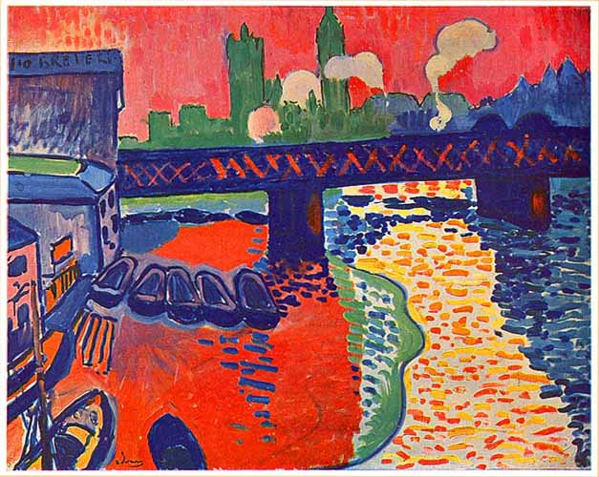

|  |  |
| --- | --- |
| **Artist** | [André Derain](https://www.google.com/search?safe=active&rlz=1C1GCEV_en&q=Andr%C3%A9+Derain&stick=H4sIAAAAAAAAAOPgE-LSz9U3MC4srCwyUeIAsTNyK0y0ZLOTrfTLMotLE3PiE4tK9IG4PL8o2wpIZxaXAACddaHhNwAAAA&sa=X&ved=2ahUKEwilhqf_34PgAhWMUxUIHX5CDrYQmxMoATATegQIBxAE) |
| **Title** | Charing Cross Bridge |
| **Date** | 1906 |
| **Medium** | Oil paint on canvas |
| **Scale** | 82 cm x 1.01 m |
| **Scope** | Urban life |
| **Style** | Fauvism |
| **Patron** | the art dealer Ambroise Vollard |
| **Location** | National Gallery of Art, Washington |
| **Function** |  |

|  |  |
| --- | --- |
| **Formal features:** | |
| **Composition** | * The composition and sense of perspective have likewise been simplified * The bridge acts as a horizon line while the Houses of Parliament silhouetted in bright green appear to lean dangerously to one side * There is no vanishing point and the upper half of the image appears flattened whereas below the bridge at ground level we see the river’s bank and boat houses. * Simple and asymmetric with angled train bridge providing manmade ‘horizon line’. Tug boats in foreground cropped. |
| **Colour or texture** | * Planes of broad flat colour are juxtaposed with rapid brushwork, giving the painting a lively energised feeling. * The colours are themselves bold and primary. * Thick daubs of brilliant yellow are countered by a vibrant blue * Sharp contrast between the smooth background skylines * Colour are placed irregularly and the blank raw canvas underneath appears between them. * Bright blocks of red left foreground, Parliament in vivid green, bridge, and water in blue with reflections shown in yellow |
| **Light & tone** | * Uses bright colours such ash yellow as highlights * Uses dark blue as shadowing * Mainly block colours so not much light and tone |
| **Space & depth or relief** | * Confusing sense of spatial depth. * Flattened composition * Viewpoint from adjacent bridge and naïve perspective on buildings. |
| **Line or brushwork** | * The brushstrokes in the upper half of the canvas are less visible than in the lower half, however those that are visible are vertical, thus further contrasting the visual effect of paint application in the lower half. * Thick dabs on the river to show movement (The buildings in the upper half show no movement) * Paint has been applied with speed and energy, establishing Derain’s spontaneous approach to painting. * Outline on tide mark and rough quick patterning on train bridge |