|  |  |
| --- | --- |
| Artist | Andre Derain |
| Title | *‘The Dance’* |
| Date | 1906 |
| Medium | Oil on canvas |
| Scale | 175 x 225 cm |
| Scope | Painting influenced by ‘primitive’ ideas |
| Style | Fauvism |
| Patron |  |
| Location | Private collection |
| Function |  |

|  |  |
| --- | --- |
| Formal features | |
| Composition | Three figures dance across the foreground of the composition. The setting appears to be an arcadian, perhaps jungle landscape. There is also a nude figure seated in the background, along with a brightly plumed bird and a serpent. In the background there are trees and foliage. |
| Colour or texture | Bold and flat colours are mainly used, showing influence from Gauguin. Unrealistic and vibrant colours are characteristics from the fauvist movement that are shown here, such as in the bold red of the figure’s skin. |
| Light & tone | Colours used are flat and show tonal difference; Derain has instead just layered colour to show tone. |
| Space & depth or relief | The nude figure in the background, along with the trees and surrounding nature, are the only aspect of depth in this painting, and Derain has played around with proportions with the figure. |
| Line or brushwork | Derain has used harsh, black outlines to emphasise the rhythmic and sinuous lines of the distorted figures. These outlines also show the large influence of the fauvist style in his work. |

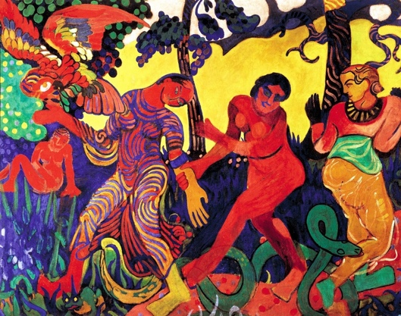

Stylistic comment and artistic influence:

Influence of Gauguin is shown, due to the use of bold, flat colours and the stylised elements such as the snake and the leaves. The choice to focus on an exotic landscape and the inclusion of a seated figure is identical to one by Gauguin. His emphasis on the wild nature of the female nude also suggests his interest in earlier romantic artists. He looked to The Louvre for inspiration, the right figure from a Delacroix painting.

Use or development of materials, techniques & processes:

Derain used bold and flat colours instead of using techniques that were popular at the time such as divisionist or pointillist techniques so as not to remind the viewer of Western developments in art. Derain was hoping to create an image free of any associations with Western art; Matisse had also stopped using the divisionist technique by this stage. This is because as there was a further emphasis on primitive sources, divisionist and pointillist techniques are based on colour theory and optical science; something ‘primitive’ cultures wouldn’t be aware of.

Critical text quote:

“Among the wild beasts” - Vauxcelles

Primitive and other influences on the figures:

The striped figure on the left may have been based on tribal dancers who wore body paint and also on primitive painted figures from 4000BC. These stripes may represent tattoos, body paint or are a naïve interpretation of folds and creases in fabric.

Recent research claims that the forms of the figures may have furthermore been based on Romanesque religious sculptures. Derain and Vlaminck would cycle in the countryside of France looking for Romanesque churches so they could sketch the sculptures.

Influence from other artists / other influences:

Nude dancing figures were a popular theme in Fauvist paintings during this period. These artists were all inspired by a shared interest in the primitive artefacts they saw in the Trocadero in Paris and objects they bought and kept in their studios.

After seeing the Gauguin retrospective in 1906, Derain trained himself in wood carving. He produced two wooden panels featuring nude dancing figures. These were inspired by Gauguin’s wooden sculptures.

Another key influence was Henri Rosseau, who was an untrained artist working since the late 1800s in Paris and achieved fame with his childlike depictions of wild animals and jungle scenes

Influence from cultural/social factors:

Influence from Cezanne’s retrospective in 1906. The inclusion of the serpent may reference the Garden Of Eden however in primitive societies, snakes were seen as fertility symbols, representing good and evil, rebirth, wisdom and various other qualities both positive and negative. These figures may be in a fertility dance. The faces of the figures are possibly based on the fang masks Derain had in his studio at the time, the work was painted after his return from London.