|  |  |
| --- | --- |
| Artist | Alberto Giacometti |
| Title | Woman with her throat cut |
| Date | 1932 |
| Medium | Bronze |
| Scale | 20cm x 88cm x 64cm |
| Scope | Death, sex and dreams |
| Style | Surrealism |
| Patron |  |
| Location | Paris |
| Function | Access the unconscious. Express dreams, sex, death and fears |

|  |  |
| --- | --- |
| Formal features | |
| Composition | Juxtaposition, distortion and displacement of body parts to express the fears and urges of the subconscious. The body is splayed open, disembowelled, arched in an outbreak of sex and death. The body appears thin and long making her look weak. Insect like form of the woman inspired by the praying mantis, which is said to devour its mate after copulation. The body parts are translated into abstract forms which include the spiky ribs which have been cracked open showing no protection, huge and exaggerated hands, long, thin legs which push off from the ground, a small head as thoughts are rational and shows you can’t have control of your body in your dreams. |
| Colour or texture | The dirty bronze colour doesn’t show purity as the woman depicts a powerful image of sexual pleasure and violence. The texture appears smooth as the light is reflected but also look grainy through the colour of the bronze. |
| Light & tone | Light is highlighted upon the woman’s curves like the curving of her spine. Shadow is captured in the hollow areas and edge of the sculpture creating depth and tone to the sculpture. The light and tone also highlight the forms of the shapes and lines making up the composition of her body. |
| Space & depth or relief | Intended to be on the floor, without pedestal, entirely in our space and goes against traditional sculptures which would usually have a plinth to add height and to make the sculpture look powerful and strong. Not on a plinth so we as an audience look down on the woman. |
| Line or brushwork | The lines of the woman appear curved and more rounded similar to a female body. The woman also appears to be dangerous and violent through her jaggered and sharp lines. |

Influence from political factors:

Influenced by communist and anarchist ideas

Influence from cultural/social factors:

Influenced by theories of psychologists such as Sigmund Freud (influenced also by his book ‘Interpretation of dreams), who was particularly interested in the subconscious sexual development which humans undergo. Here we are not looking at a real individual but personification of your nightmares. Here, time is non-existent where we are both alive and dead showing a lost timeline of time which creates a disturbing piece.

Image:

[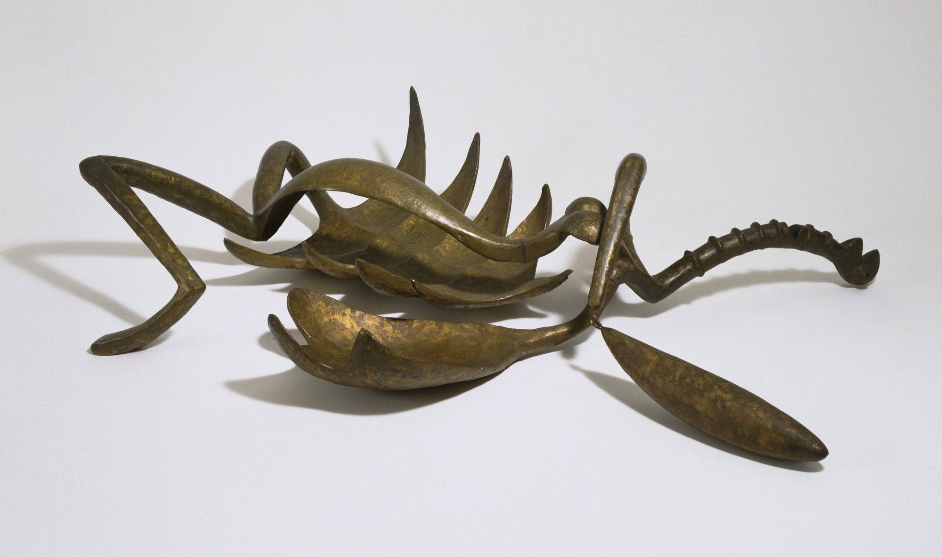](https://www.google.co.uk/url?sa=i&rct=j&q=&esrc=s&source=images&cd=&cad=rja&uact=8&ved=2ahUKEwikuqyi7pPgAhU9RRUIHSZKCBcQjRx6BAgBEAU&url=https%3A%2F%2Fwww.moma.org%2Fcollection%2Fworks%2F81796&psig=AOvVaw0uslyvKCHlZ2YZd71SVrrA&ust=1548881204642668)

Influence from technological factors:

One of the hands appears ready to lash out as the hand is able to move which shows the influence of machinery.

Critical text quote:

“Nothing was like what I imagined it to be”, he found “A head… became an object completely unknown and without dimensions.”

Herbert Read said it was an “emancipation of the visual imagination from the bonds of reason and convention.”

Stylistic comment and artistic influence:

The theme of violence and domination mingled with fear of a devouring female is shared by Picasso. Influenced by a Brazilian sculptor Maria and French born Louise Bourgeois explore the theme of psycho-sexual tensions between men and women.

Use or development of materials, techniques & processes:

The Bronze is strong and shows oxymoron as the woman has an open pose which is strong, but she is shown weak through her thin and long legs. Bronze would normally be reserved for strong leaders but her sexual desires makes the woman become strong. Bronze is expensive and reserved for powerful heroes and leader. By making this sculpture out of bronze we can see that the woman is shown as strong through her sexual desires. Bronze can be easily moulded into different shapes.