**COMPONENT 2**

**CHECKLIST**

**Examiner’s FEEDBACK**

**GENERAL COMMENTS:**

* LACK OF DEVELOPMENT
* TOO REPITITIVE
* LIMITED RESPONSE TO THE BRIEF
* LIMITED VOCAL PRODUCTION AND SAMPLING TECHNIQUES

Edexcel Examiners say:

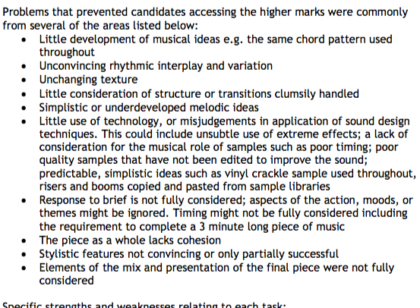

MUSICAL DEVELOPMENT

MUST HAVES:

1. TEMPO(BPM) AND METER(TIME SIGNATURE) CHANGES: Use the tempo track to add accelerando(speed up) and ritardandos( slow down) to your track especially in transition sections to add interest, a sense of urgency, impact etc. / have an entire section at a different tempo to create contrast/a rubato section(free time) contrasting your strict, mechanical, quantised sections. METER change from regular time(4/4) to irregular time(5/4, 7/4) for a few bars/ change from simple time(4/4) to compound time(12/8)
2. HARMONY: modulate i.e change key at some point or change for a section and return to the main key/Vary the chord pattern/use extended chords 7ths, 9ths , 13ths/change harmonic rhythm i.e 1 chord per bar to 2 chords per bar
3. MELODY: invert the melody i.e starts with a Perfect 5th above change it to a Perfect 5th below/ retrograde i.e. play it backwards/ use a different octave/ have more than one melody at the same time(polyphonic)/ regular 4 bar phrase to irregular 5 bar pharse/ scalic movement (stepwise) followed by disjunct movement(leaps bigger intervals)
4. FORM AND STRUCTURE: Regular phrase lengths to irregular e.g Verse consists of regular and irregular pharses( 4bar 5bar 4 bar 7bar) and Chorus is regular( 2x 8 bar)
5. Texture: Change from Homophonic( melody and chords) to Monophonic( Unison) sections. Polyphonic sections-more than on melody( counterpoint). Hetrophonic passages-same melody played at the same time, however, some parts play different rhythms( e.g the main melody plays crotchets and another part plays quaver triplets ) and/or different octaves.

*Comments:*

*“A little more rhythmic development would be good in the drum parts, some more drum fill parts would work well to signal the starting of new sections”*

*“More textural parts would be beneficial in areas apart from the chorus, but then it works really well in the bridge”*

*“Phrases are too regular, could though in an irregular phrase to add interest”*

*“One dimensional, doesn’t have a climax point. No contrast”*

*“ chorus melody is good the first time. Too much repetition. Needs variation”*

**CHECKLIST**

TEMPO(BPM) AND METER(TIME SIGNATURE) CHANGES

* Use the tempo track to add accelerando(speed up) and ritardandos( slow down) to your track especially in transition sections to add interest, a sense of urgency, impact etc.
* have an entire section at a different tempo to create contrast
* a rubato section(free time) contrasting your strict, mechanical, quantised sections.

METER

* change from regular time(4/4) to irregular time(5/4, 7/4) for a few bars
* change from simple time(4/4) to compound time(12/8)

HARMONY:

* modulate i.e change key at some point or change for a section and return to the main key
* Vary the chord pattern
* use extended chords 7ths, 9ths , 13ths
* change harmonic rhythm i.e 1 chord per bar to 2 chords per bar

Texture:

* Change from Homophonic( melody and chords) to Monophonic( Unison) sections.
* Polyphonic sections-more than one melody( counterpoint).
* Hetrophonic passages-same melody played at the same time, however, some parts play different rhythms( e.g the main melody plays crotchets and another part plays quaver triplets ) and/or different octaves.
* Add more instrument layers or drop out key parts(e.g. melody, drums, bass…

MELODY

* invert the melody i.e starts with a Perfect 5th above change it to a Perfect 5th below
* retrograde i.e. play it backwards
* use a different octave
* have more than one melody at the same time(polyphonic)
* regular 4 bar phrase to irregular 5 bar phrase
* scalic movement (stepwise) followed by disjunct movement(leaps bigger intervals)

FORM AND STRUCTURE:

* Regular phrase lengths to irregular e.g Verse consists of regular and irregular phrases( 4bar 5bar 4 bar 7bar) and Chorus is regular( 2x 8 bar)

Response to Brief

* Must be exactly 3 MINUTES long( not longer, not shorter)
* Minimum 6 samples

**English idioms and colloquial phrases:**

* + Short samples of individual phrases
  + Spoken text or lyrics developed from the chosen phrases
  + Feature phrases associated with a particular region
  + Feature phrases associated with literary figures such as Shakespeare or Oscar Wilde.

SAMPLING TECHNIQUES

Make sure you can tick off all of these techniques

* Created a new EXS24 instrument using your own samples( pitch key zones, single and/or multi sample instrument, real time triggering)
* Recorded at least 3 of your own samples
* Used synthesis parameters such as filters and envelope on your samples(EXS24, Ultrabeat or Alchemy)
* Pitch mapping
* Transposing using flex-pitch or pitch shift
* Time stretching( changing tempo using flex time or time and pitch machine
* Looping( crossfades, avoiding audio clicks, cutting at zero axis)
* Reversing
* Stuttering
* Editing(trim, move , cutting, copy)
* Automation
* Real-time manipulation

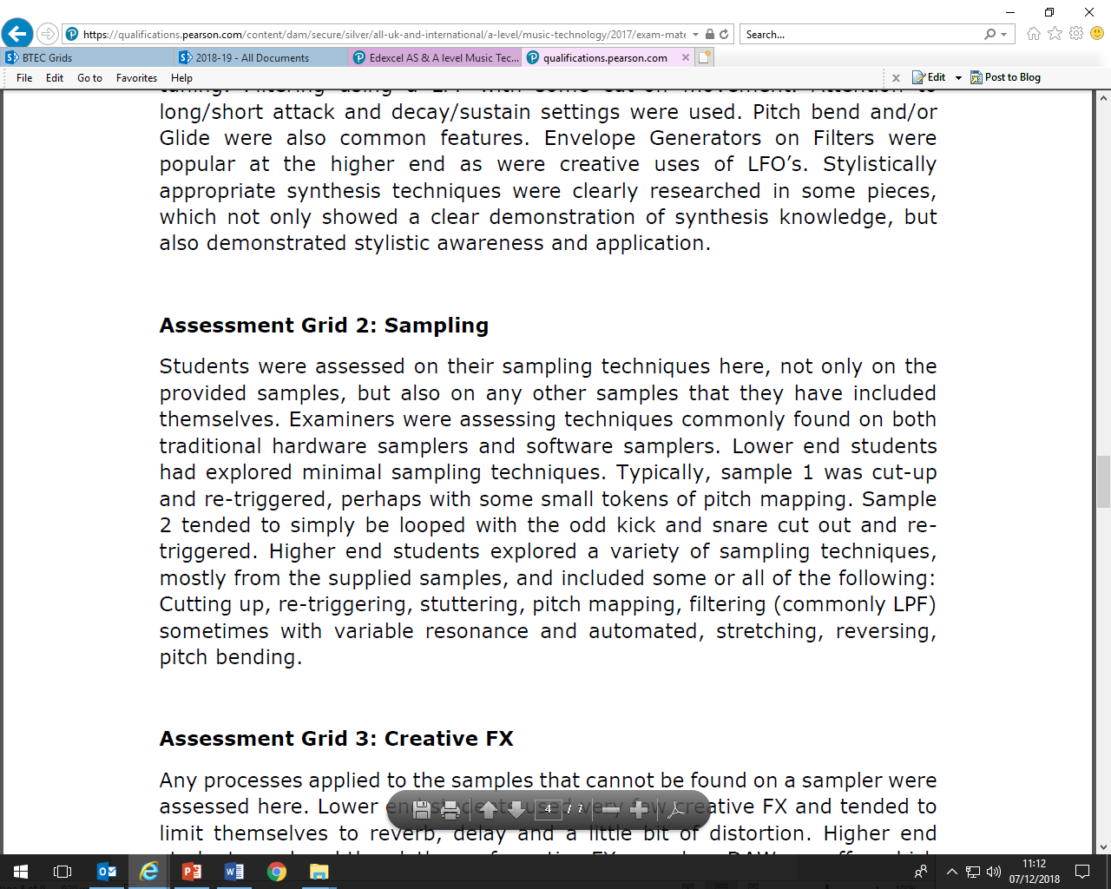

SYNTHESIS TECHNIQUES

Make sure you can tick off all of these techniques. Create minimum of 3 synths from scratch. Minimise use of preset sounds.

* Create a Lead synth using subtractive synthesis
* Create a Bass synth using subtractive synthesis
* Create a Pad synth using a hybrid synth( Alchemy or ES2)
* Use a variety of waveform combinations
* Blend 2x waveforms an octave apart
* Blend 3 Osc detuning 2 waveforms by cents( not semi-tones)
* Use LPF with subtle automated cut-off and resonance movement
* Adjust attack and release times of filter envelopes and amp envelops
* Use LFOs to modulate with the filter
* Use LFOs to modulate with the Osc

