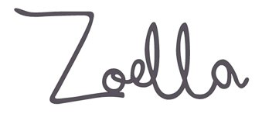

**AUDIENCE TARGETING AND ZOELLA**

|  |  |  |
| --- | --- | --- |
|  | ***Segment Zoella targets*** | ***How does Zoella target this audience through its content and the ways in which the product is marketed, distributed and circulated? Give specific examples to support your points*** |
| **Gender** |  |  |
| **Age range** |  |  |
| **Socio-economic group** |  |  |
| **Psychographics** | Lifecycle:  Activities and interests:  Psychometic grouping:  Youth tribe: |  |