Technique  Use the table to identify conventions/techniques used in the vlog and blog to target audiences and the effects these have on the audience. | 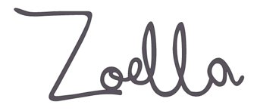  Definition | Example from Zoella | Effect on Audience
Jump cut | An editing technique that cuts material from single takes, giving the effect of jumping forward in time
Breaking the fourth wall | Where the presenter addresses the audience directly
Unscripted narrative | Improvised moments in narrator dialogue
Collaborative content | Where vloggers make co-productions
Audience engagement | Encouraging audiences to comment, share, like and even suggest ideas for future vlogs and blog posts
Amateur aesthetic | A deliberately non-professional filming style
Everyday mise-en- scène | Using costume, make-up and sets that appear natural
Presenter POV | Seeing what the presenter sees
High-key lighting | A lighting style that eliminates shadows
Invitation into private spaces | Filming that takes place in bedrooms, private houses, office spaces – places that are normally off limits to film crews
Narrative authenticity | Story structures that deal with real life – the intention to construct media that isn't mediated
Best friend characterisation | A presenting style that gives the audience access to details of the presenter’s life
Confessional narrative | Giving the audience access to inner thoughts – also allowing the audience to experience inner doubts and worries
Candid imagery | Photographs that aren’t posed
Sanitised story content | Content that avoids controversy, taboo language or material that may cause offence
Single camera edit | A production filmed with just one camera – usually very quickly
Codes of realism | Technical, narrative or symbolic devices that are suggestive of the real world
Aspirational narratives | Stories that inspire audiences to want a particular lifestyle or to change their behaviour in some way

AUDIENCE THEORY:
According to Lazarsfeld and Katz’s Two Step Flow theory, most people form their opinions under the influence of opinion leaders.
Evaluate this audience theory. Refer to Zoella to support your response.

