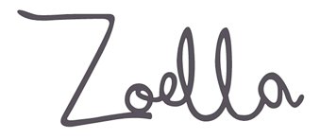**INDUSTRY: REGULATION and MONITISATION**

The Advertising Standards Authority (ASA) is the UK’s independent advertising regulator across all media platforms (TV, radio, press, billboards) and is responsible for regulating bloggers/vloggers.

The ASA makes sure ads across UK media follow the advertising rules (the Advertising Codes).

The Committee of Advertising Practice (CAP) is the sister organisation of the ASA and is responsible for writing the Advertising Codes.

Read the selected ASA articles on GOL, *The New Statesman* article *How YouTubers really make their millions* and *How vloggers like Zoella can boost your brand* and conduct your own research to answer the following questions:

**1. a)** Who are the ASA and CAP?

**b)** What do they do?

**c)** Why is it important, consider the audience in your response?

**2. a)** What constitutes an ad?

**b)** Can a blogger/vlogger get around these rules?

**c)** Should they?

**3.** What must bloggers/vloggers do to ensure they abide by the codes when advertising?

**4.** What is an advertorial blog?

**5.** What must a blogger/vlogger do if they are making a post advertising their own products?

**6.** What items aren’t controlled by the CAP code?

**7.** What is the difference between an advert and sponsorship?

**Now research into Zoella’s ads and sponsorship deals, and consider:**

1. **Who has sponsored her?**
2. **Who has she advertised for?**
3. **Find examples of her sponsored/advertising content**
4. **How much does she make from sponsorship?**
5. **Has she been at the centre of any controversy or rule breaking around #ads?**

**Anything else you find interesting**