|  |  |
| --- | --- |
| Artist | Sir George Gilbert Scott |
| Title | The Albert Memorial |
| Date | Opened 1872 |
| Medium |  |
| Scale | 54 metres high |
| Scope | Commemorative sculpture, materials in sculpture, patronage |
| Style | Gothic revival |
| Patron | Queen Victoria |
| Location | Near Museum Road that Albert was responsible for establishing |
| Function | Memorial for Albert |

|  |  |
| --- | --- |
| Formal features | |
| Composition | A Gothic style canopy over a gilded statue of Albert who looks in the direction of exhibition road. Along the base are life size figures of creative individuals such as Shakespeare and Van Eyck. A tympanum and pinnacles above the canopy and on the spire there are figures of fortitude, temperance and justice. Angels ring the top and a cross right at the top. |
| Colour or texture | Bronze figures, gilded bronze, gold to show grandeur. Mosaics are blue and gold. Marble. Red and black stone – Polychromatic |
| Light & tone |  |
| Space & depth or relief | Some high relief carving with the figures of the continents on all 4 corners and in the figures for medicine, astronomy and chemistry, and with the marble figures of the commerce and agriculture figures next to the canopy. Low relief figures of the intellectuals on the Parnassus Frieze (base) |
| Line or brushwork | Strict shapes and delicate details. Formal markings |

Influence from political factors:

The British Empire was growing. There are 4 figures representing the 4 continents the empire had spread to.

Influence from cultural/social factors:

During the Victorian era the industrial revolution meant people wanted Gothic revival buildings made as a reference to the past.

Looks towards Exhibition Road

Figures of Christian angels, symbols such as the Christian virtues (faith, hope, charity and humanity) fortitude, temperance and justice also depicted. Spandrels show poetry, faith and music.

Creative individuals along the base

Canopy shape based on a Ciborium found at the altar.

Parnassus frieze – a Parnassus is the resting place of the muses so seen as a resting place for the greatest creative individuals – classic Greek reference

Influence from technological factors:

Industrial revolution – a tribute to old Britain

Medicine and chemistry shown in figures – advancements

Use or development of materials, techniques & processes:

Gilded bronze, a new technique

Mosaics

Carvings in marble

Cluster columns show power

All materials make it look grand and powerful.

Stylistic comment and artistic influence:

It’s a classic Gothic style monument

Wanted to show greatest Victorian achievements

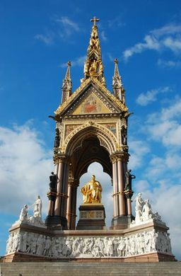

Critical text quote: