|  |  |
| --- | --- |
| Artist | Alexandre Cabanel |
| Title | The Birth of Venus |
| Date | 1863 |
| Medium | Oil on canvas |
| Scale | 130cm x 225cm |
| Scope | Mythological, female figure |
| Style | Academic |
| Patron | Bought by Napoleon III |
| Location | Paris |
| Function |  |

|  |  |
| --- | --- |
| Formal features | |
| Composition | Central composition, surrounded by the other figures. Clearly the most important part of the painting, very little else in the composition to distract from the main figure. |
| Colour or texture | Fairly muted colour palet, with the blues for the sea and sky, the hair of the woman and the skin tones.Again this doesn’t distract the viewer or really draw our attention away from the central figure. |
| Light & tone | Light evenly distributed throughout the painting, with no harsh highlights apart from perhaps the foam of the sea beneath Venus’ hair, which again draws attention to the central figure. Very few dark shadows. |
| Space & depth or relief | Not much in the background, and nthing of prominence, that can be used to distinguish space and depth or scale, all the attention is on the central figures. |
| Line or brushwork | Academic in style reflected in the fine brush work and horizon line on the third of the canvas. |

Critical text quote:

“*a goddess, drowned in a sea of milk, resembles a delicious courtesan, but not of flesh and blood – that would be indecent – but made of a sort of pink and white marzipan…*

(From Manet’s main supporter, Emile Zola

Influence from technological factors:

Stylistic comment and artistic influence:

Mythollogical subject matter, idealised figures, nothing avant garde about the painting, contrary to what was going on in paris at the same time, with impressionism and realism.

Use or development of materials, techniques & processes:

The inclusion of the putti is similar to those found in works by the 18th Century Rococo artist François Boucher. The pastel colouring and treatment of a mythological subject is likewise typical of Boucher.

Image: 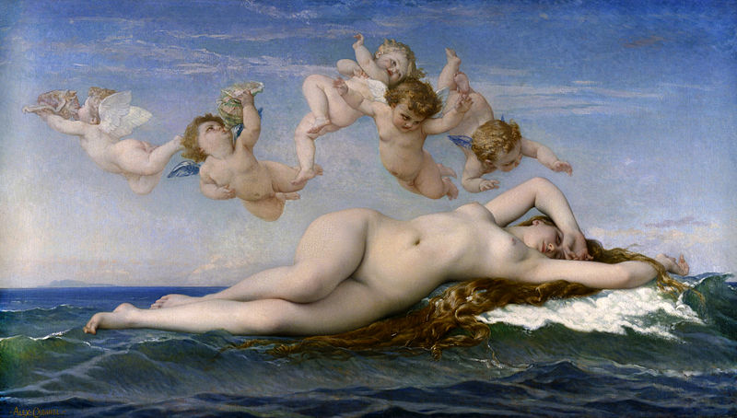

Influence from political factors:

There was a major revival of the Rococo style during the French Second Empire in painting and the decorative arts. Cabanel is responding to this taste for 18th Century art in *The Birth of Venus*

Influence from cultural/social factors:

Cabanel was seen as a quintessential Academic artist, but was also a strong opponent of the Impressionists and in particular Manet.

Manet painted *Olympia* the same year that Cabanel painted his *Birth of Venus*