|  |  |
| --- | --- |
| Formal features | |
| Composition | Panoramic painting, to be read left to right. Crowded composition, figures spanning the whole canvas. Take up the bottom half of the canvas, the sky takes up top half. Painting split into three sections, shown by the three groups of people in the foreground, then mass of unidentifiable people behind. |
| Colour or texture | Use of the colour red used across the canvas to help bring the viewers eye across the canvass. Use of realistic colour and neutral tones apart from the red. Painted academically so no texture to the paint. |
| Light & tone | Realistic use of light and tone, seen by the shadows cast by figures. No direct light source, covers the whole canvas. No strong use of light or shadow. |
| Space & depth or relief | Realistic use of space and depth. Figures in the foreground are larger than figures in the background, representing space. Figures in the background are painted with less detail. Use of orthogonals on the lines of the tent on left hand side, derby day building in the background and grass strip which leads to a vanishing point- use of linear perspective. |
| Line or brushwork | Flat brushwork in academic style. No use of heavy line. |

|  |  |
| --- | --- |
| Artist | Powell Frith |
| Title | Derby Day |
| Date | 1856–1858 |
| Medium | Oil Paint |
| Scale | 101 by 235 |
| Scope | Painting of leisure by British and French artists |
| Style | Victorian academic |
| Patron | Jacob Bell |
| Location | Royal Academy Exhibition, 1858 |
| Function | To criticise Victorian society |

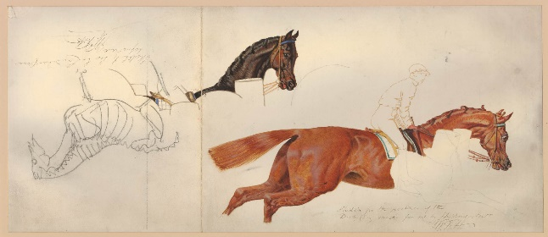

Critical text quote:

"greatest British painter of the social scene since Hogarth

“unique historical record of a significant social event” Mary Cowling

Influence from cultural/social factors:

Powell Frith was interested in the now disregarded sciences of phrenology and social type, which considered people's characters and social origins were visible in their physical features.

He wanted to depict what he saw to be a realistic society by painting figures which were stereotypical, such as the rich men and women and the poor beggars and entertainment acts.

Derby Day was an event which attracted everyone, so was the perfect location to attend to observe all of Victorian society.

This painting is a satire of society. Powell Frith aimed to enlighten the societal divide between the rich and the poor. The painting shows a rare occasion in Victorian society of the mixing of the classes and shows the depravity not often seen.

The painting was so popular in the gallery that a metal railing was put around it to protect it. This was because of the growing interest both the upper and lower classes held in the inner workings of the human mind and how that was reflected in one’s physical appearance, and the fact that the Epsom Derby, Victorian Britain’s leading sporting and cultural event, was being featured.

<http://mhm.hud.ac.uk/digitalvictorians/william-powell-friths-the-derby-day-1856-1858/>

Image: 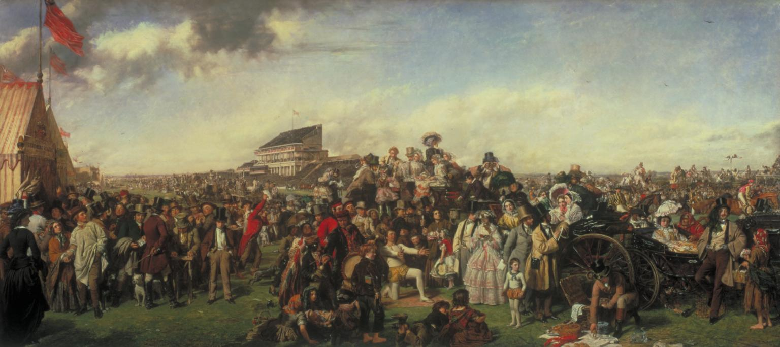

Use or development of materials, techniques & processes:

Powell Frith spent large amounts of time completing studies for his final painting. He visited Derby Day and sketched there, then hired actual jockeys, acrobats and models to draw from. It took him 15 months.

Stylistic comment and artistic influence:

Painted with academic style, with traditional methods.

The principal influence on his work was the hugely popular domestic subjects painted by Sir David Wilkie.

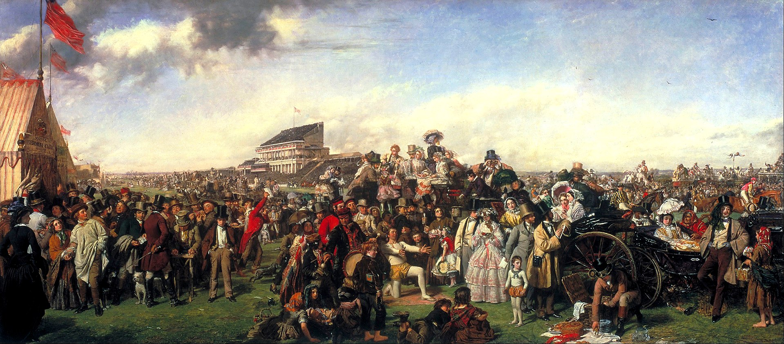

Man looking at woman in carriage, instead of the race

Fortune teller, with husband and wife.

88 foreground figures-a cross section of Victorian society.

Derby day race in the background- not the main event- instead the societal mingling.

Group of people looking away from race, towards acrobatic act.

Young woman vs old woman

Acrobat with his son, who are fixated on picnic being laid out for high class woman in carriage

Lower class with upper class

Thimble rigger, lower class

Prostitute, for high class men.

Gentlemen’s club tent, for high class men.