|  |  |
| --- | --- |
| Artist | Holman Hunt |
| Title | The Shadow of Death |
| Date | Finished in 1873 |
| Medium | Oil on canvas |
| Scale | Below life-size |
| Scope | Religious painting |
| Style | Pre-Raphaelite |

|  |  |
| --- | --- |
| Formal features | |
| Composition | Christ placed centrally in the canvas with an interior setting and the Virgin Mary in lower left side. |
| Material | Oil on canvas. |
| Style | Pre-Raphaelite- religious scene, attention to detail, bright vivid colour, symbolism |
| Space & depth or relief | Realistic depiction of spatial depth, Christ placed centrally. Props in foreground and a window in background providing a view of Nazareth outside. |
| Colour | Bright vivid colours, colour applied to a wet white background, allows us to see symbolic detail. Details include a red headband representing the Crown of Thorns. A plumbob hanging in the background symbolises Jesus’s heart in shape and position on the shadow. Red pomegranate on window sill symbolises the Resurrection. |
| Light | Evenly lit to show all details. Christ’s physique emphasised with the natural light. A window behind. Christ’s shadow cast on back wall which symbolises his crucifixion. |
| Figure handling | Christ shown as muscular and idealised- linking to the Victorian religious movement of Muscular Christianity. |

Influence from cultural/social factors:

-1. Muscular Christianity was a concept in the Victorian era which advocated work and physical strength to improve society and produce strong and moral individuals. Holman Hunt depicts Christ in this manner as someone to aspire to.

2. Because Holman Hunt followed Ruskin’s truth to nature belief he travelled to the Holy Land to find a location where Christ would have lived and worked. We see the actual land of Nazareth outside the window.

Use or development of materials, techniques & processes:

-Painted on a white background to make the colours of the painting more vivid. This then allowed the viewer to see all the symbolic details- helping explain the scene.

Critical text quote:

‘Perfect realisation of natural form’ – Hunt

Artistic influence:

-Pre-Raphaelite movement. Holman Hunt and the PRB were interested in religious scenes with an accurate depiction of figures and attention to nature.

-Northern Renaissance. Holman Hunt and the PRB inspired by artists such as Van Eyck from the era before Raphael who all painted in a direct and honest manner.

[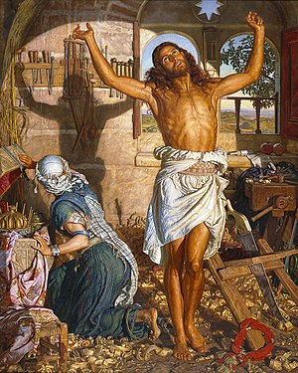](https://www.google.co.uk/url?sa=i&rct=j&q=&esrc=s&source=images&cd=&cad=rja&uact=8&ved=2ahUKEwir3dDxtvrhAhUu-YUKHXcWCIQQjRx6BAgBEAU&url=https%3A%2F%2Fen.wikipedia.org%2Fwiki%2FThe_Shadow_of_Death&psig=AOvVaw0oDapO5iEpv5Bl2xqh6lSj&ust=1556803437290938)

Symbolism:

-Shadow of Jesus = his eventual fate.

-Red circular headband (bottom right) = the crown of thorns.

-The plumb-bob (hanging on the wall) = Jesus’s Shadow’s heart.

-Pomegranates (On the window shelf) = Rebirth

-Star of David (above the window) = his religion.

-Objects in the box = the gifts he received at his birth.

- window in the shape of a halo