Artist | Edouard Manet, 1832-1883  Image: 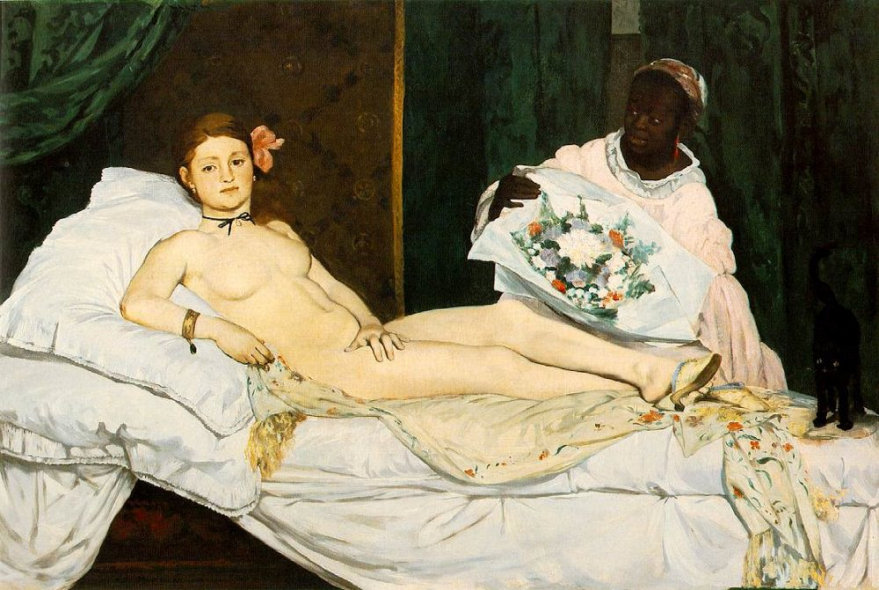
Title | Olympia
Date | 1863
Medium | Oil on canvas
Scale | 130.5 X 190 cm
Scope | Female nude
Style | Realism
Patron | -
Location | Musee D’Orsay, Paris
Function | To shock, scandalise.
Formal features
Composition | Nude woman lying on a bed being bought flowers by a servant, wearing an orchid in her hair, pearl earrings, a bracelet and slippers.  Horizontal emphasis on painting as she lies flat on the bed, sat stiffly upright.
Colour or texture | Large areas of colour, realistic application of colours.  Natural palette that contrasts with the large portion of white used for the sheets on the bed and the maids clothes.
Light & tone | No obvious light source, bright lighting, reflected in Olympia’s pale skin tone and the white bed sheets.
Space & depth or relief | Flat 2d appearance of the canvas due to the large areas of colour, and heavy outlining around the figure, especially her hand.
Line or brushwork | Broad quick brushstrokes, lacking depth in the canvas, creating a flat appearance.
Use or development of materials, techniques & processes:
Harsh outlining, seen clearly around her hand, that assertively covers herself makes her hand look more flat than other areas of the canvas, drawing attention to this point.

Critical she resembles a cadaver from the morgue”
A cadaver is a fancy way of saying a dead body, this is a quote from a newspaper critic, and it is suggesting that Olympia appears like a dead body due to her flat appearance and sickly skin tone.
text quote:

Influence from cultural/social factors:
The name of the painting is Olympia, referencing her name, a common name amongst prostitutes in Paris.
It is said that Olympia may have sat up due to a client arriving unannounced, which would indicate why she sits so stiffly with her hand covering herself.

Influence from political factors:
Ethnic presence, the black maid bringing Olympia a large bouquet of flowers, perhaps from a client.

Influence from technological factors:
Harsh lighting which may indicate the influence of photography, giving her a very pale skin tone interpreting a flash.
Stylistic comment and artistic influence:
Influence of Titian’s Venus of Urbino. Titian was a highly respected renaissance artist who was deeply admired by academic artists. By choosing one of his iconic paintings to reference, Manet is undermining and possibly ridiculing the importance of old masters in the 19th century.

