Artist | Charles Garnier  Image: 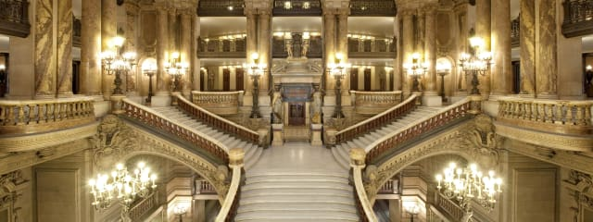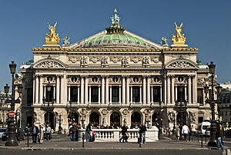
Title | Palais Garnier
Date | Completed 1875
Medium | Over 17 materials used (marble, bronze etc.)
Scale | Very big
Scope | Public Architecture
Style | Beaux-Arts
Patron | Napoleon III
Location | Paris
Function | Opera House
Formal features
Composition | A symmetrical building, split over a number of storeys.
Material | 17 different materials are used (including coloured marble, bronze and gilded metal)
Style (continued) | Beaux-Arts: the blending of the classical, Renaissance and Baroque architectural design. This was not Avant-Garde.
Space & depth or relief | Contains a series of corridors, stairwells and open areas which allowed for socializing during intervals.
Symmetry and lines | Building made to be symmetrical. Entrance on one side for the emperor, another made the other side and dedicated to members. (East side for Emperor, West for the rest)
Use or development of materials, techniques & processes: -Crystal Chandelier. For elegance. –Lavish decoration (Frieze decorated with allegorical figures (i.e. Poetry and Harmony)) to appeal to upper class. –Grand staircase made from marble with red and green balustrades. –Auditorium horse-shoe shaped, inspired by Greek amphitheatres to maximise sound.
Stylistic comment and artistic influence: -influenced by previous academic architectural styles (Classical, Renaissance and Baroque) -Designed to appeal to the tastes of wealthy Parisians.
Critical text quote: ‘Iron, iron, nothing but iron’ –Napoleon III

((
Influence from technological factors: -area below the stage left free, so that stage sets could be made and raised without being dismantled. –Chandelier able to raised into the dome when needed. –Electrical lighting. –Electrotype (A cheap, effective way of casting a sculpture in copper as opposed to bronze) -Auditorium made from a metal framework.
Influence from political factors: -The city was being rebuilt. Napoleon wanted to target wealthy people, and emit modern and progressive attitudes. –Separate entrance for the Emperor due to attempted assassination at previous theatre. –Apollo sculpture placed on the top in place of Napoleon III, due to him having been overthrown and exiled to England.
Influence from cultural/social factors: -Large central foyer used for socializing. Area took up a large portion of the building. - bronze busts of famous composers (Beethoven, Mozart) above the windows between columns. Used to reinforce theme of arts and function of the building.

