|  |  |
| --- | --- |
| Artist | Auguste Rodin |
| Title | The Burghers of Calais |
| Date | 1884-1889 |
| Medium | Bronze |
| Scale | Larger than life 200cm |
| Scope |  |
| Style |  |
| Patron | The city of Calais |
| Location | Place du Soldat Inconnu, 62100 Calais, France |
| Function | Commemorative piece |

|  |  |
| --- | --- |
| Formal features | |
| Composition | Rodin’s design consists of 6 figures that seem to be walking in a circle. The do not have the ‘overtly heroic antique references’ that the public considered an integral part of the public sculpture. (represented freedom from oppression) |
| Colour or texture | Dark brown bronze - not flashy or extravagant – not trying to show the Burghers in a heroic light. Brings them down to the same status of the public |
| Light & tone | Solid detail of the figures and so the natural light emphasises each detail that Rodin created. |
| Space & depth or relief |  |
| Line or brushwork |  |

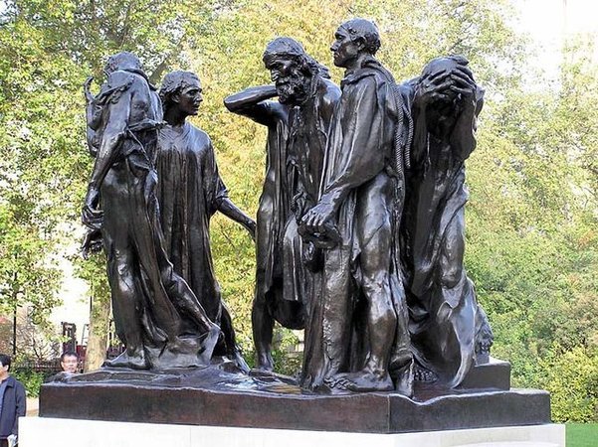

Image:

Use or development of materials, techniques & processes

Wax clay casting. Rodin specialised in it

Stylistic comment and artistic influence:

In 1895 the monument was installed in Calais on a large pedestal in front of Parc Richelieu, a public park, contrary to the sculptor's wishes, who wanted contemporary townsfolk to "almost bump into" the figures and feel solidarity with them. Only later was his vision realised, when the sculpture was moved in front of the newly completed town hall of Calais, where it now rests on a much lower base

Critical text quote:

Les Bourgeois de Calais: Essai sur un Mythe Historique (The Burghers Of Calais: An Essay On A Historical Myth).

Influence from technological factors:

N/A

Influence from political factors:

France was defeated in the Franco-Prussian war prior to the Burgher of Calais being made. Two previous artists were commissioned to create this sculpture but ended up not because one died and the other was in the war.

The 100 years’ war cause the subject matter of the sculpture.

Influence from cultural/social factors:

The city of Calais wanted the Sculpture to be placed on a pedestal above the public and make the figures almost god-like due to their importance in history, however Rodin created the sculpture with a low pedestal so that it would enhance the personal connection between the viewer and the 6 figures. Rodin's trip to Italy in 1875 would become highly influential in many of his early works. The Greek and Roman sculpture which would have undoubtedly been accessible to Rodin in Rome is often strikingly realistic but with exaggerated muscles and life-size male nudes.