|  |  |
| --- | --- |
| Artist | Auguste Rodin |
| Title | The Helmet Makers Wife |
| Date | 1887 |
| Medium | Bronze |
| Scale | Height: 50cm, Width: 30cm, Diameter: 26cm |
| Scope | Specified sculptor, female figure |
| Style | Avant garde |
| Patron |  |
| Location | Rodin Museum |
| Function |  |

|  |  |
| --- | --- |
| Formal features | |
| Composition | Doesn’t adhere to traditional values of beauty, with in in Classical sculpture, highlighted by the fact it doesn’t have a pyramid composition, links to the fact that Rodin is finding beauty in an unidealised figure, rather than traditional sculpture. |
| Colour or texture | The colour contradicts ideas of Classical beauty with in sculpture as it is made out of bronze and the surface is black contrasting to the white marble sculptures of idealised mythological figures such as Venus. The figure appears almost to be melting because of the texture of the bronze, this links to Rodin’s idea of reclining beauty to be replaced with a character, which he sees as more beautiful. |
| Light & tone | The surface of the bronze catches the light, which stands out against the dark of the bronze. This emphasizes the wrinkles on the of the figure. |
| Space & depth or relief | The undulating surface of the sculpture show the wrinkles of the figure indicating her old age. Her left side is supported by her left arm with a gap between her body and her arm showing her fragility. |
| Line or brushwork | Line is created through indentations in the bronze, furthering the texture in the figures skin, creating further impressions of wrinkles and the age of the woman. This is most prominent in the wrinkle lines in her stomach arching over her belly button. |

Critical text quote:

‘In art, only that which has character is beautiful. Character is the essential truth of any natural object.’ – Rodin

‘ugliness in nature can in art become full of great beauty’- Rodin

‘grotesque and heart-rending, a great sorrow breathes.’

‘wastes away, decays, ends in nothingness. the substance perishes, the flesh dies, but dreams and desires are immortal.’

- Gsell

Image: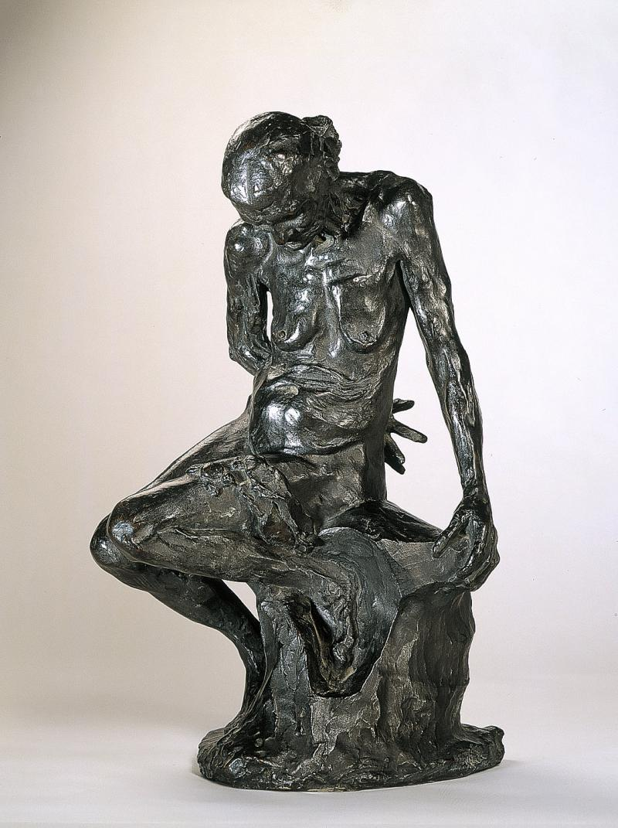

Influence from cultural/social factors:

This piece was influenced by the Poem by Francios Villon ‘a monologue of the expired beauty of the old helmet-maker’s wife’ clearly drawing upon lines from the poem to influence the work for example:

“When [I] look at myself completely naked  
And I see myself so changed.  
Poor desiccated thin, shrivelled,”

“completely hunchbacked.  
What breasts! All wizened  
Like my hips."

Also references to extreme poverty in Paris in the late 1800’s from the frailty of the figure. Infact one of Rodin’s assistants Jules Desbois, made a separate sculpture based off of the same model and instead titled it ‘Poverty’, in terracotta and later ‘Misery’, in wood.

It also comments on the cultural conception that ads you age beauty fades and the fact that Rodin views it differently. He views this fading of beauty as something that will be replaced with character.

Influence from political factors:

Could possibly be seen as a reference to the poverty in Paris at the time. This is hinted at due to the models story of poverty, clear from how skinny she is , with protruding ribs and hips.

Stylistic comment and artistic influence:

Rodin travelled to Italy in the winter of 1876 to study Michelangelo’s work. Rodin did not work under a master but instead viewed Michelangelo as his master, and did many studies of his works. This is evident in the contours of his figures, and the sharp angular positions they are in.

This work also clearly draws upon idea from Donatello, particularly it almost seems to reference the honesty and frailty of his sculpture of ‘Magdalena’ which Rodin probably had seen in Florence, in the *Museo Nazionale del Bargello.*

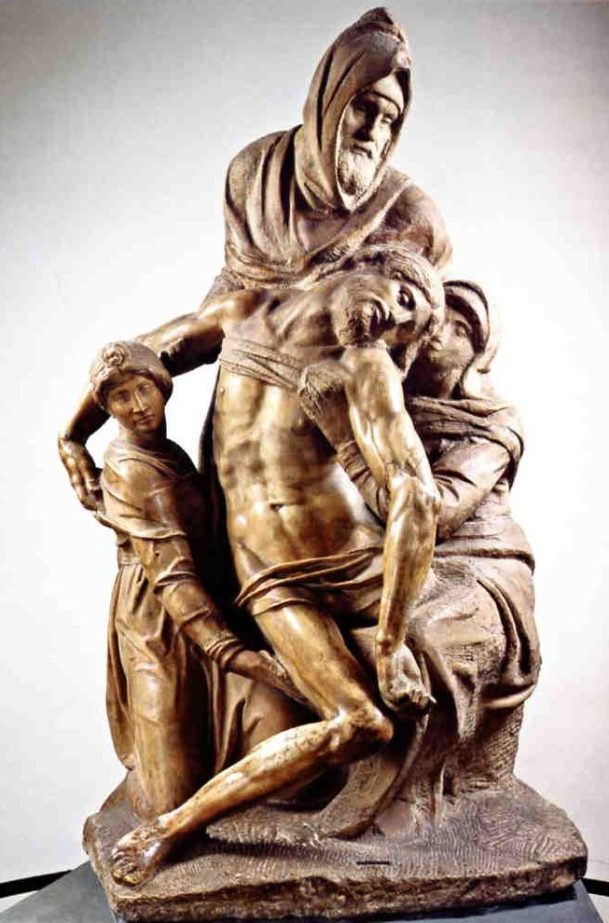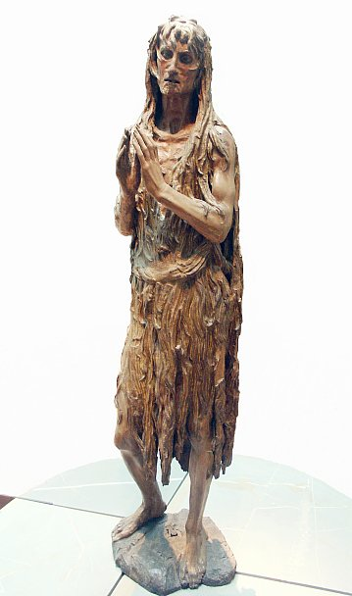

Use or development of materials, techniques & processes:

This work first appeared in Rodins ‘Gates of hell’, however this image was repeatedly worked with and developed, both by Rodin and his assistants.

This work was a work of a models mother 87 year old Caira, in bronze made from a cast. A later work of the same woman in the same pose was done by Rodin in plaster, with two of the same figure.

