|  |  |
| --- | --- |
| Artist | Holman Hunt |
| Title | Strayed Sheep |
| Date | 1852 |
| Medium | Oil on canvas |
| Scale | 76cm x 122cm |
| Genre | Landscape |
| Style | Pre-Raphaelite |
| Location | Hastings, England |

|  |  |
| --- | --- |
| Composition | Asymmetric composition (suggests instability) where sheep are packed onto uneven ground. Multiple viewpoints used to achieve composition. |
| Colour or texture | Intense colour produced by applying colour onto a wet white primed background. Natural and realistic colours. The colours juxtapose in order to intensify the clarity of the surface. |
| Light & tone | Sunlight illuminates the scene |
| Space & depth | Shadows suggest depth |
| Line or brushwork | Clear forms and realistic brushwork |

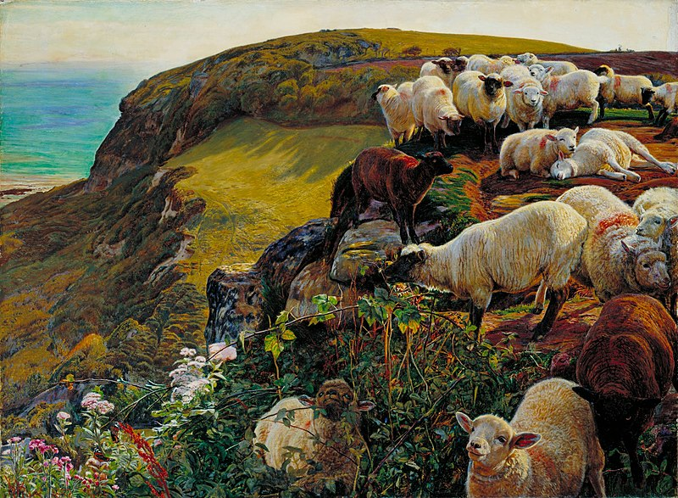

**Influence from technological factors:**

Using train to travel from London to the rural location

Lack of human life meaning there is a greater focus on nature.

Painted en plein air with tubes of oil paint, a recent development

**Critical text quote:**

*John Ruskin – “select nothing, reject nothing”*

**Stylistic comment and artistic influence:**

Influenced by social commentary of writers such as Caryle.

Artistic influences include Van Eyck, Early Renaissance works and his contemporaries such as Millais.

**Use or development of materials, techniques & processes:**

Intense colour, symbolism and realism.

**Influence from cultural/social factors:**

Concern about foreign invasion

Christian reference where sheep could be symbolic of the followers of Christ. Additionally, there were internal conflicts within the Church of England at the time and they were not taking care of their people.

**Influence from political factors:**

Sheep represent English people who are perched dangerously close to the edge and risk death due to no protection (linking to little defence England had).

Boat in background suggests a potential danger of French invasion (ruled by Napoleon III), looming in the haze.

The location is relevant and known for the Battle of Hastings in 1066, referencing historic defeat against France.